Upgrading your Google Analytics account.

Setting up your account
- Log in to your analytics account – if prompted to update automatically, please click ‘No thanks’.
- Select the correct UA property by clicking on the top bar next to ‘Analytics’ ‘All accounts’, then select ‘Properties & Apps’ and then select ‘Views’. A UA property is identified by a tag similar to UA-12345678-1.
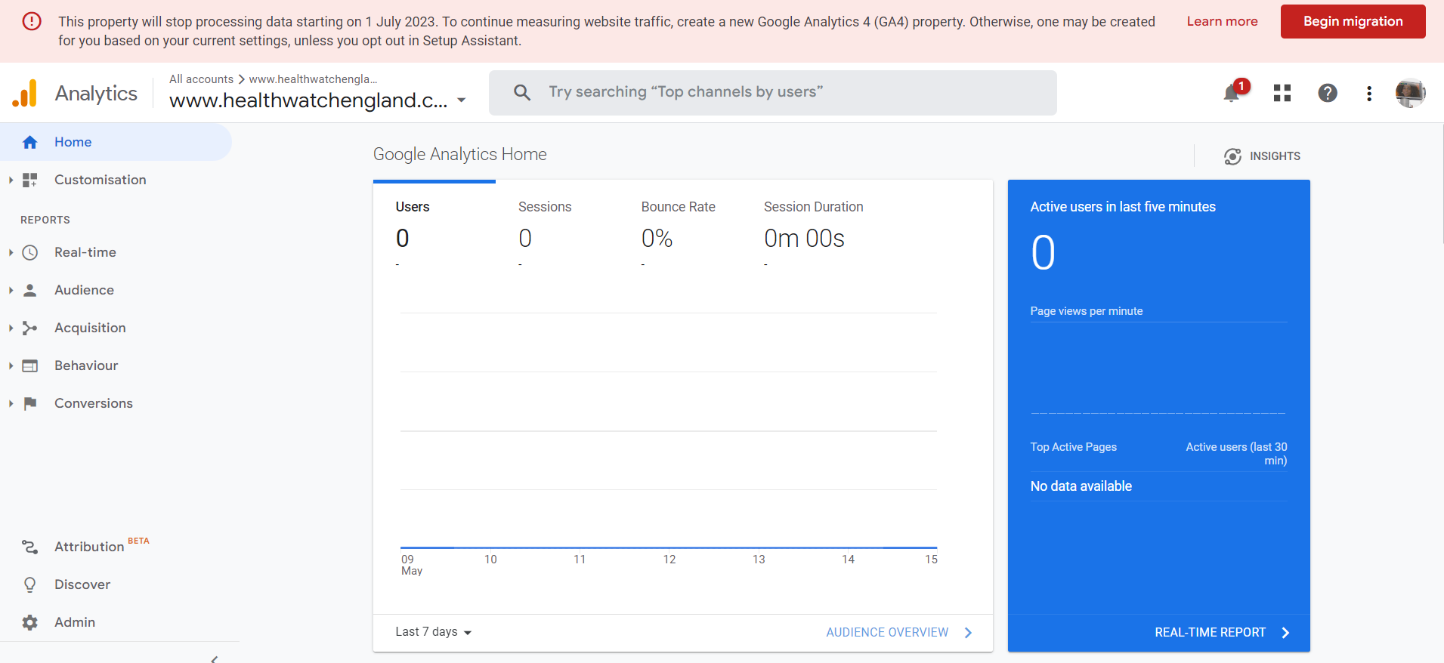
- Go to ‘Admin’ by clicking on the cog icon on the left corner of the screen.
- Find ‘GA4 Setup Assistant’ in the middle column of the screen and click on it. Select ‘I want to create a new Google Analytics 4 property’. Click ‘Get Started’. 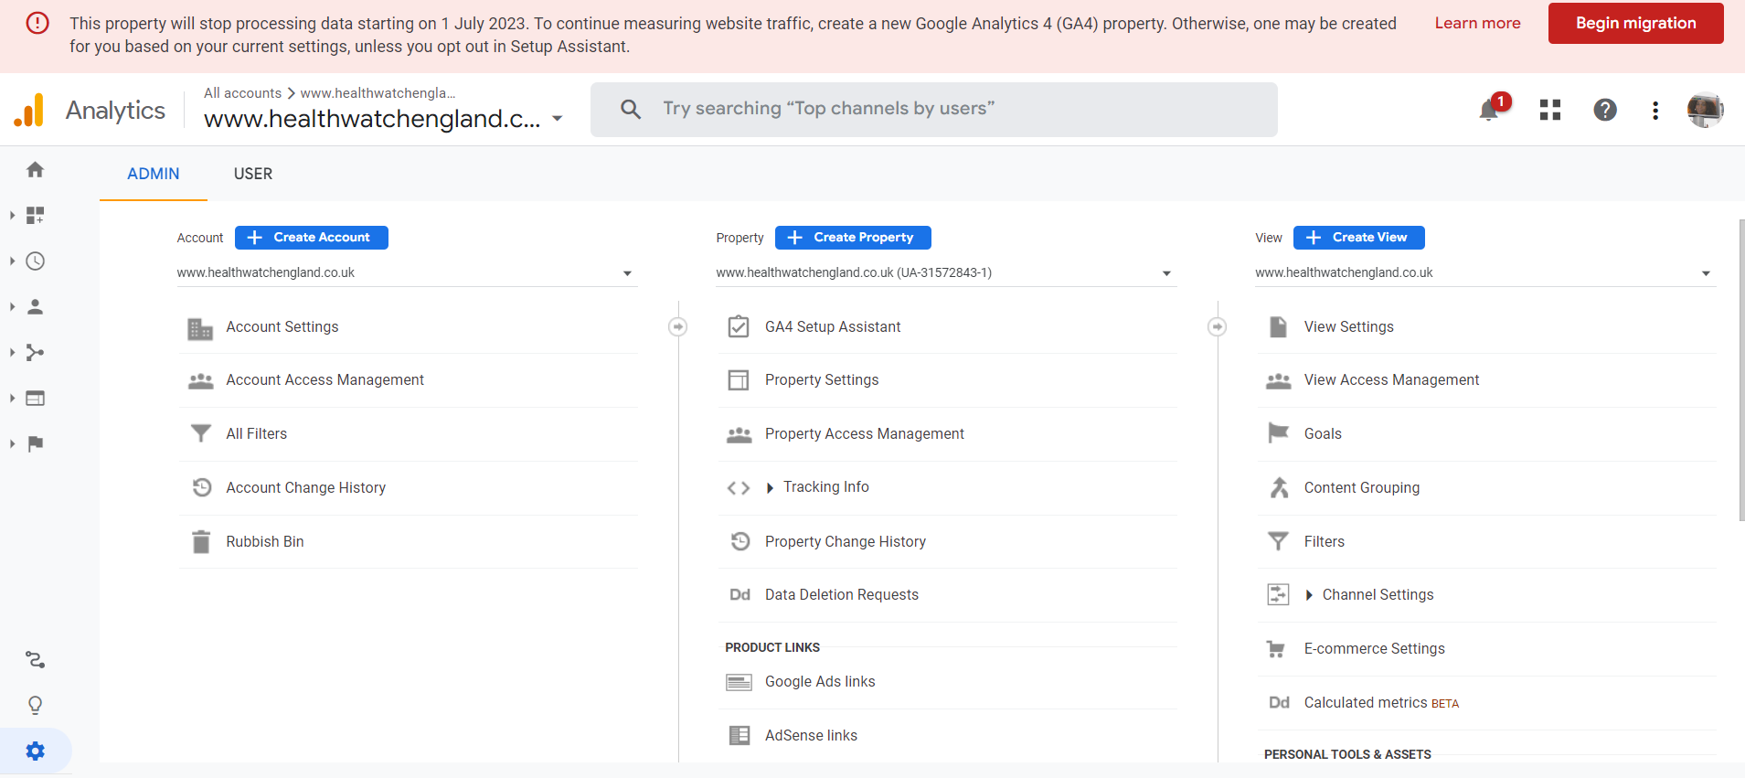
- You will be prompted to ‘Create a new Google Analytics 4 property’. Please click ‘Create and continue’ (do not tick anything else). Then click ‘Confirm’ to create your new GA4 property (you do not need to copy/insert any code). You have made your new GA4 property.
- Please click the blue button in the centre of the screen to ‘Go to your GA4 property’. 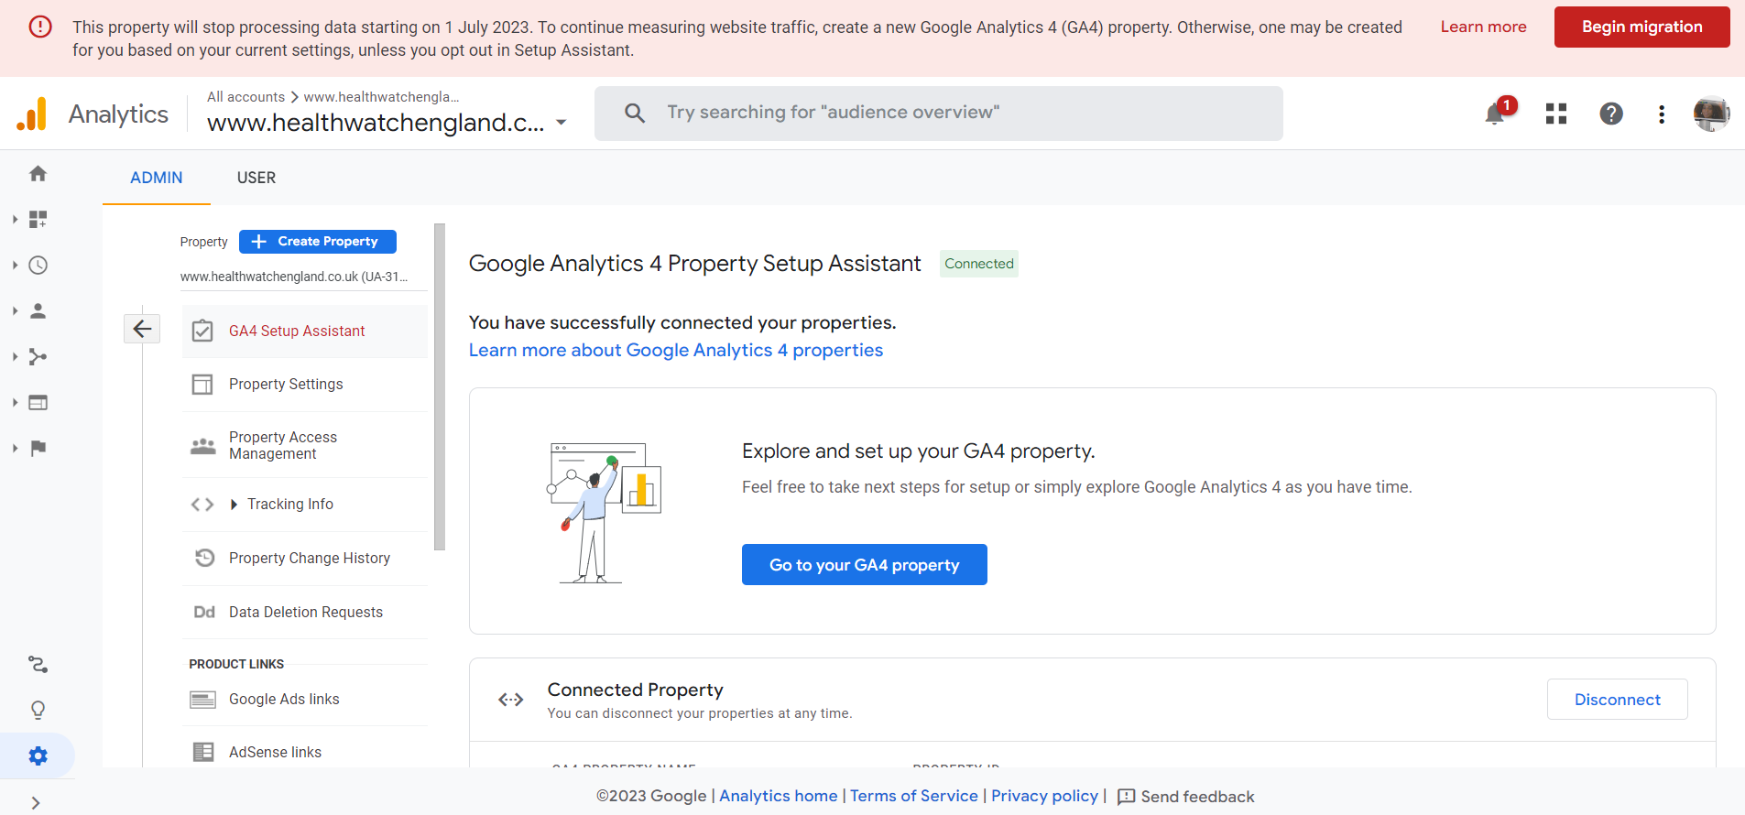
- Now you will finalise the setup of your GA4 property. Under the ‘Setup Assistant,’ you will notice the headers ‘Data collection’ ‘, Property settings’ and ‘Google Ads’.
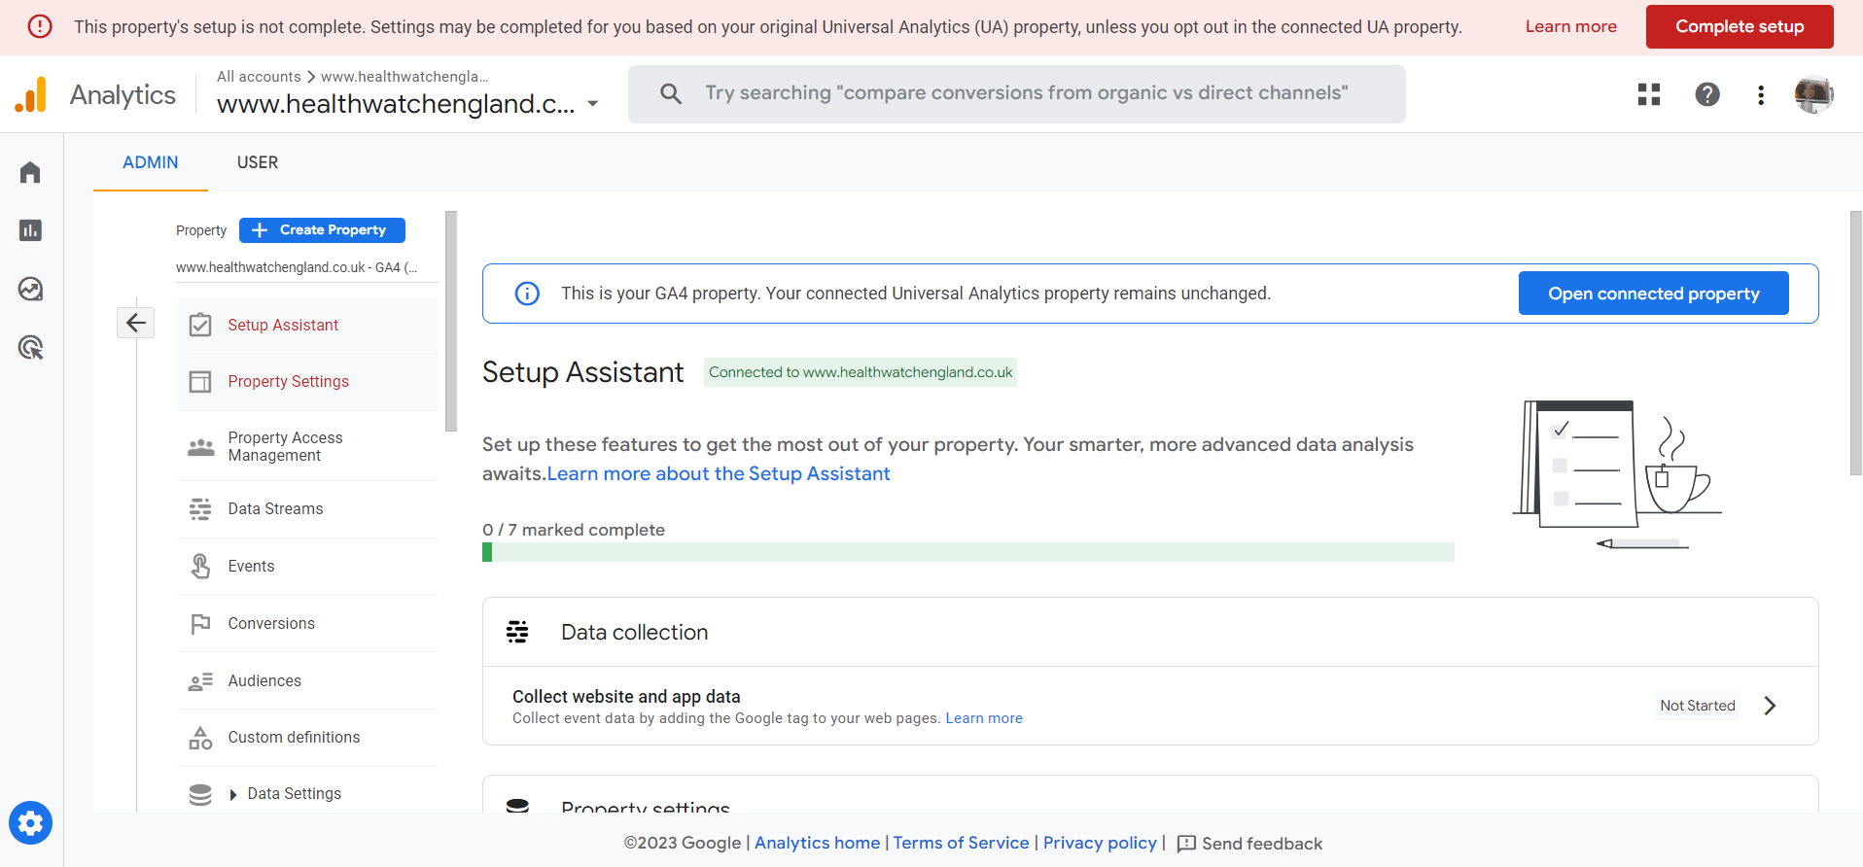
- Under each, there are seven properties in all listed. All properties currently say ‘Not started’. Please click on the chevron to the right and select ‘Mark as complete’. Please do not worry if the first property says ‘Data not flowing’ – that is correct for now. You have now completed the setup. 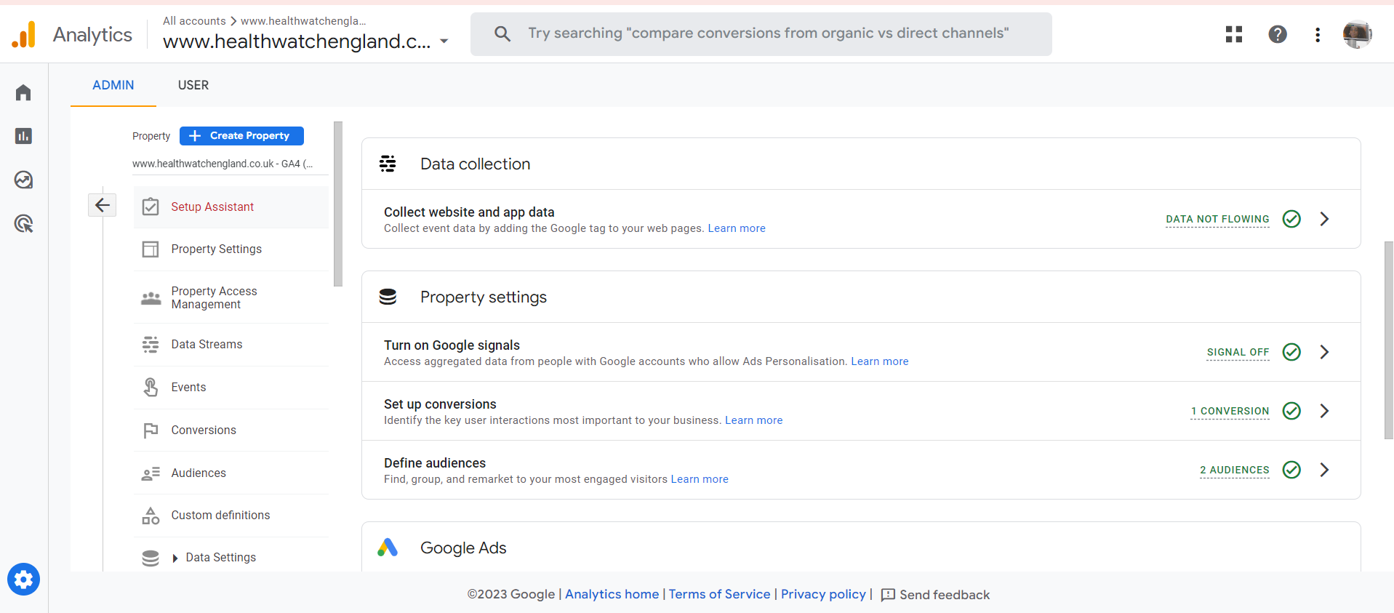

Sharing your account information with us
Please select from the menu to your left the 4th item called ‘Data Streams’,
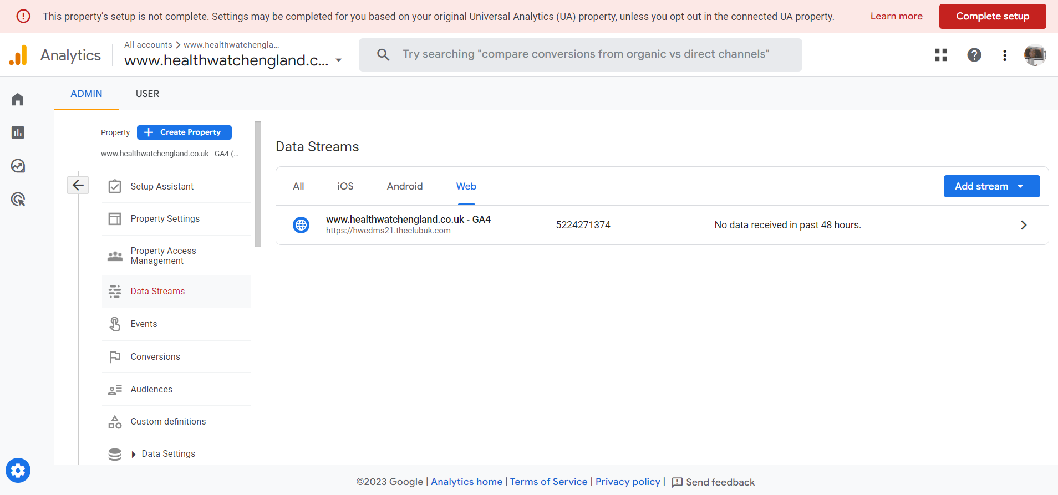
Select the ‘Web’ tab and then click on the chevron to the right. You should see the GA4 ‘Steam ID’ and ‘Measurement ID’.
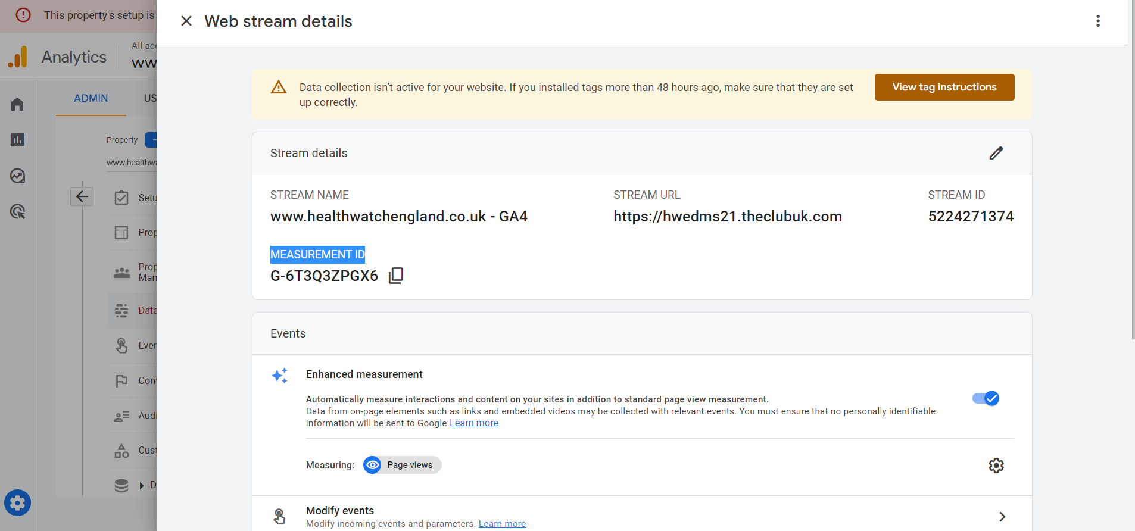
Please copy and paste your ‘Steam Id’ and ‘Measurement ID’ into an email and send it to us at digital@healthwatch.co.uk

