Website guidance
Using the Healthwatch website

Contents

About this guide 3
Accessibility 3
Language and style 3
Formatting your text 3
Adding hyperlinks 3
Updating your homepage 6
Updating the homepage carousel 6
Testimonials 8
Using the news alerts sign up webform 10
Articles 11
Adding an article 11
Using paragraphs 15
Style Guide 18
Promoting articles on the homepage and news and reports landing page 24
Call to action blocks 26
Events 28
Webforms 32
Pages 50
Using blocks 51
Block types 52
Image block types 61
Charts 67

About this guide
This guide explains how to use the different functions within the Healthwatch website. You can also view our video tutorials and ask any questions on the Website group on Facebook Workplace or email us at digital@healthwatch.co.uk.
Before we go on to the functionality of the website, here are some important pointers for you to consider when using your website.

Accessibility
For more information on web accessibility. Check out our short guide.

Language and style
As well as understanding the functionality of your website, it’s important that as the content managers of your website that you really focus on your language and styling.
The language you use on your website is important as it will impact how engaged your website visitors will be with your content and how long they choose to stay there.
- Write in plain English, avoiding jargon and acronyms to make your content easy to understand for as many people as possible.
- Keep your paragraphs short and use headings to make your content easy to scan and visually break up the page.
- Please do not refer to yourself repeatedly as Healthwatch X – instead you can say ‘we’ or ‘our’. Do not use abbreviations for your Healthwatch. For example, HWR could be used for multiple local Healthwatch across the country so try to name yourself fully if you need to when writing more formal content.

Formatting your text
It is important that your correctly format your text when writing online content. This is to ensure that your content is easy to understand for your readers and that it is accessible for those using screen readers.
If you are copying content across from another program, you will need to make sure that the formatting is correct, as problems can occur when copying and pasting. We recommend copying into notepad before moving across to the website.
- Make sure that you use your heading sizes in order. For example, if you start a new paragraph with Heading 2, your subheadings for that topic should be Heading 3 etc.
- Use the built-in bullet points and numbering options in the text editor

Adding hyperlinks
You will often want to link to other pages on your website, or to external sites.
- Type the text you want to want to make the button, highlight it and then select the hyperlink icon. 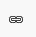
- A box will appear. If you are adding a link to a webpage, keep the ‘link type’ box set to URL.
- If you are linking within your own site, you only need to add everything past your domain name. For example for this link www.healthwatch.co.uk/page-title you would only need to put in /page-title.
- This should automatically change the protocol to <other>.
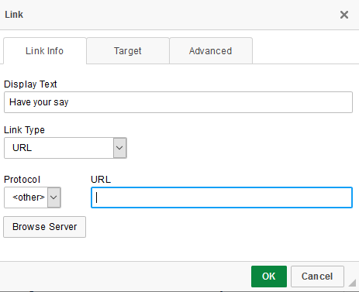

- If you are linking to an external site, you will need to add the full URL. You then need to click ‘Target’ and select - open in new window. This will encourage people to stay on your site after having looked at what you’re directing them to.
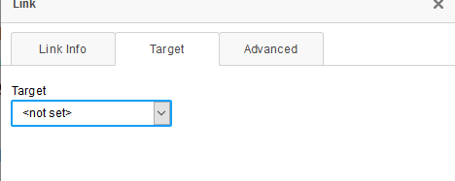
- If you are linking to an email address, change the link type to E-mail. Here you’re able to copy and paste the email address in you want the email to go to. If you would like, you can also define the Message Subject.
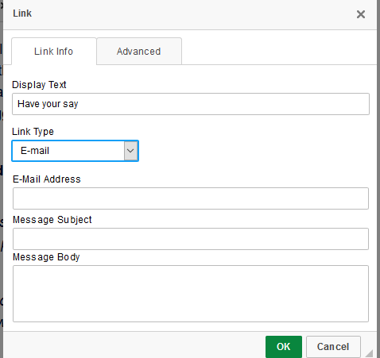

For any of these options, then click the ‘advanced’ tab and enter an ‘Advisory title’. This would be a short explaination of the link the would show if someone was to hover their mouse over the link. EG – Download the Healthwatch England report.
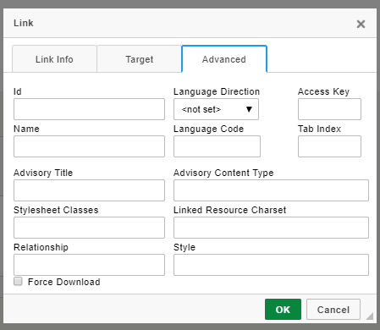

Creating an action button
Each article should have a clear action that you want people to do. This is usually directing people to somewhere else on your website to download a report, encouraging people to share their views or to get in contact.
Once you have created your hyperlink, click on the link and then press ‘styles’ and select select Button: Pink.
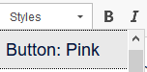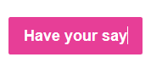

Updating your homepage
Your homepage pulls through content from other areas on your website. It will automatically update when you add news and reports. The only things you need to update on your homepage is the carousel and testimonials.

Updating the homepage carousel
The homepage carousel appears at the top of the homepage, they are the full width images with calls to action. Use this to encourage people to take a survey, read an article or report, or attend an event.
To add a homepage carousel slide go to:
Content → Add content → Homepage carousel slide
- Title: This title will appear on the screen so needs to be short and snappy.
- Scheduling options: Choose the dates and times that you would like your carousel to run for. This is a useful feature for when you run a campaign as you can prepare content and schedule it to auto publish or auto unpublish for a specific time. Using this feature will help ensure your content is current.
- Body: Give a short description of what you are asking of people or the information that you are providing. This text will appear in the box on the carousel.
- Find out more link:
  - Title: This is the button text and should be a clear call to action e.g. ‘Sign up’.
  - URL: Add the node number from the page. Find the page you want to link to and enter ‘edit mode’. Take the node number from the URL.
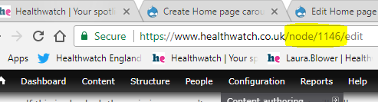 → 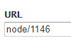

- Image: Look for images that include space on the left where the main object of the image is in the centre or the right-hand side. Files must be less than 8 MB and larger than 1440 x 540 pixels. Remember to include Alt text for accessibility.
Top Tip: Make sure that you can still read the text and that the text box hasn’t obscured an important part of the image. The text needs to be legible.
- Revision information: This is only relevant if you are making changes to a homepage carousel slide.
If you have made changes, you can save this as a revision by ticking the ‘create new revision’ box. You can also leave a comment explaining what you have changed. This would only be visible in the back end to other editors and administrators. Once you have saved the changes, you’ll be able to click ‘revisions’ and see the previous version. This is useful if you want to make some updates but keep a history of what was on the site beforehand in case you need to revert to a previous version.
- URL pathway settings: You don’t need to change this
- Meta tags: The meta tags are already pre-populated.
- Authoring information: This is generated automatically when you save. It will show you who added the content and when.
- Publishing information:
  - Published - this needs to be selected to publish this. If you do not tick the box, it will save the content as a draft.
  - Promoted to front page - doesn’t need to be selected
  - Sticky at top of lists - doesn’t need to be selected

Managing your homepage carousel slides
Make sure that you remove a carousel slide if no longer relevant e.g. event has passed or a campaign has finished. To do this you will need to untick the ‘published’ box under publishing information.
The homepage carousel slides are ordered by publish date, with the most recent carousel item appearing first. If you need to re-order your slides, you need to edit the ‘authoring information’ and change the date so that they are in the preferred order.
Top tip: Remember that you can also add an ‘unpublish date’ when creating your homepage carousel slide. This is useful to ensure that the slide of a campaign no longer runs after the campaign ends, or if you just wanted to feature a section of your site or report for a limited time.

Testimonials
Testimonials are the quotes that appear on the homepage. If you have more than one testimonial, a different one will load each time you refresh the page.
These are a great way to highlight people’s experiences and the feedback you’re receiving and encourage people to find out more.
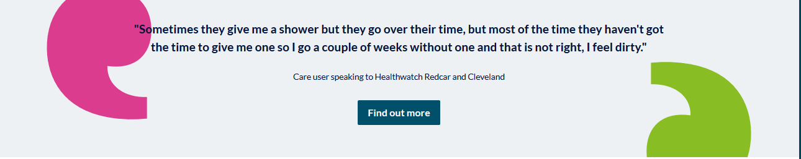
You could use this to:
- Encourage more people to share their views on a particular topic
Include an example of feedback you’ve received about a specific topic and a link to where people can share their views. This could be to a survey or the ‘have your say’ page.
- Encourage people to find out more about your work on a particular topic
Include a quote from a report and then link to your report on the issue. The quote could be from a member of the public, your CEO, Chair or service. This could then link to a report or the news story promoting the report.
- Encourage people to get in touch for advice and information
Include an example of the type of queries you receive or from someone that has received advice and information from you. This could link to the information and advice page.

Adding a testimonial
To add a testimonial, go to:
Content → Add content → Testimonials
Edit the fields below:
- Admin title: This title is only for you to view on edit mode and will not be visible for users.
- Scheduling option: You can schedule a testimonial to publish in the future by selecting your chosen date. If you do not select a date and publish the testimonial, it will be published straight away.
- You can schedule the testimonial to unpublish on a specific date.
- Quote: Add your quote text into this box here. This should be a short and punchy quote that inspires people to take action.
- Author: Add the author of the quote if appropriate.
- Find out more link: This isn’t compulsory; however, it’s a useful way to give people the opportunity. You need to add the node number into the box. Find the page you want to link to and enter ‘edit mode’. Take the node number from the URL.
- →
- URL pathway settings: You can ignore this field as this is done automatically.
- Meta tags: You can ignore this field as this is done automatically.
- Revision information: This is only relevant if you are making changes to an existing testimonial.
If you’ve made changes, you can save this as a revision by ticking the ‘create new revision’ box. You can also leave a comment explaining what you have changed. This would only be visible in the back end to other editors and administrators. Once you have saved the changes, you’ll be able to click ‘revisions’ and see the previous version. This is useful if you want to make some updates but keep a history of what was on the site beforehand in case you need to revert to a previous version.
- Authoring information: This is generated automatically when you save. It will show you who added the content and when.
- Publishing information:
  - Published - this needs to be selected to publish this. If you do not tick the box, it will save the content as a draft.
  - Promoted to front page - doesn’t need to be selected.
  - Sticky at top of lists - doesn’t need to be selected.

View existing testimonials
Easily edit or view the testimonials on your site by going to the main content screen in the admin menu and then filtering by the content type Testimonials.

Using the news alerts sign up webform
The news alerts webform is at the bottom of the homepage. It’s a great way for people to let you know they’re interested in hearing more about your work.
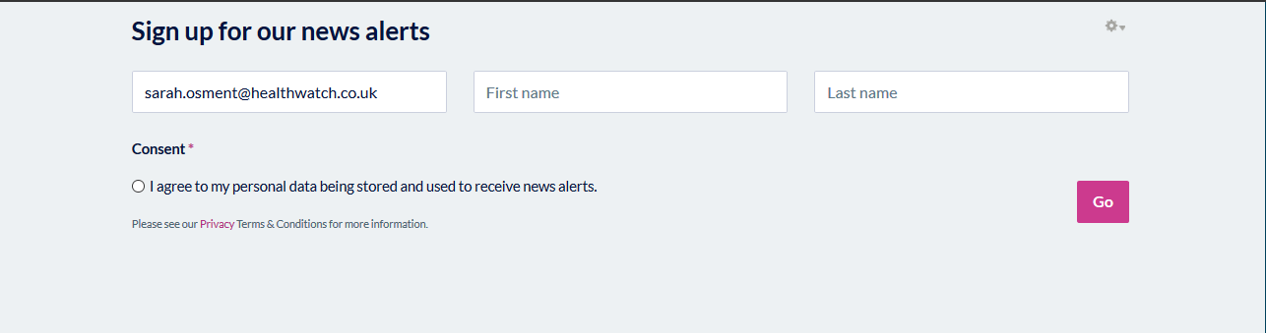
This webform has been set up for you to capture people’s details in a GDPR compliant way.
Currently, the webform doesn’t automatically sync with MailChimp or CiviEvent, so it is important that if you’re using this webform you put in place measures so that you’re regularly checking the webform for any subscribers, exporting the results and updating your mailing lists appropriately. You will need to add an email address to the webform (we recommend the info@ address)
To view all results:
Edit the block by clicking the wheel on the top right-hand side Click ‘results’. Here you’ll have the option to export all the results to a csv file. You’ll be able to use this information to update your existing mailing list.
Please note: Only ‘Editors’ have permissions to edit and manage webforms.
Top Tip: Put in a recurring reminder to the webform results once a week to check sign ups and clear out any unnecessary data. Under the ‘View results’ tab, you’ll have the ability to clear all of the results. This action cannot be undone, so make sure you have the information you need before clearing the responses.

Articles

What is an article?
This is the content type that you will use most regularly on your site. There are five different article types intended for different purposes. The functionality on each of these article types are the same, the main difference is where they appear on your site.
These are outlined below:
- News - Tell people about your latest news. This might be related to a recent report or publication or changes happening locally or nationally.
These will be shown in your latest news section and pulled through to the ‘news and views’ section on your homepage.
- Response - Tell others your views in response to a decision or report that has been published. For example, you might be responding to a local consultation. Upload any supporting documents that you might have e.g. letters you have sent or consultation responses.
These will be shown in your latest news section and pulled through to the ‘news and views’ section on your homepage.
- Report - Showcase your impact by uploading your reports and publications.
These will be shown under latest reports and publications on your news and reports page and on your homepage.
- Advice and Information - Help people get the information they need to live well. Any content aimed at providing advice and information to the public should be categorised as this article type.
This will then be pulled through to the advice and information section of your website and advice and information section of your homepage.
- Blog - This should be used when you are telling a personal account of a situation or event. E.g. an article from your CEO or one of your volunteers

Adding an article
- Go to Content → Add content → Article and edit the fields below.
- Title: Your article title should be clear and engaging. People should know what the article is about from the title.
- Article type: Select the type of article it is from the drop down.
- Author: If your article is written from a specific person, you can attribute it to them using the Author field. To add a new author, go to Structure Taxonomy Author Add term.
If it’s a generic article - leave this blank. Most of your content probably will not need an author, however you can use this for blogs from Volunteers or your CEO or guest blogs from another local organisation or individual.
- Scheduling options: Choose the date and time that you would like you publish your article. This is particularly useful if you’re report or article is embargoed until a specific time.
- Tags: Use tags to help categorise what the article is about. These tags are not shown publicly, but this information is what is used to work out ‘related information’ at the bottom of an article.
You can find a list of tags by going to: /editor-guidance/using-tags
- For example, if your article is about carers, you would use the tag for carers and as a result, three other articles that also cover that topic would appear.
- Themes: Choose the themes that relate to the content within your article.
Themes are how people can search through your content via the drop-down menus.

Top tip - knowing the difference between a tag and a theme
A theme is how the article is categorised publicly. A visitor to the website can select a theme from the drop-down menu to bring up all the related articles to that theme. The themes you choose are visible.
A tag is how the article is categorised in the back end of the website. Tagging works for choosing what content is related to one another. This informs how the ‘related content’ feature works where it automatically selects other content which the viewer might be interested in. It is important to select both a theme and a tag when publishing your content.
- Lead paragraph: Summarise your article in 250 characters. This text will be pulled through as a teaser for the news and reports landing page. This should be short and snappy and make people want to read more.
- Main image: Click ‘Browse’ to upload or select an image to best illustrate your article.
If you upload a new file, the minimum dimensions for this image are 780x500 pixels. Make sure you include alternative text and an image description (e.g Patient speaking to doctor). You need to do this for accessibility purposes to ensure that screen readers can read the page properly.
If you click ‘Library’ at the top right-hand side, you will be able to view images already uploaded to the site. This prevents duplication of content and helps you source the images more easily.
- This image will appear under the Title and Lead paragraph when on view.
The image will also be pulled through to the News and Reports landing page. We recommend you always use an image to make your content more visually engaging. It also will be pulled through when you share content on social media. If you haven’t got a suitable image try and find a suitable graphic to accompany your article instead, or take a look at our Flickr library.
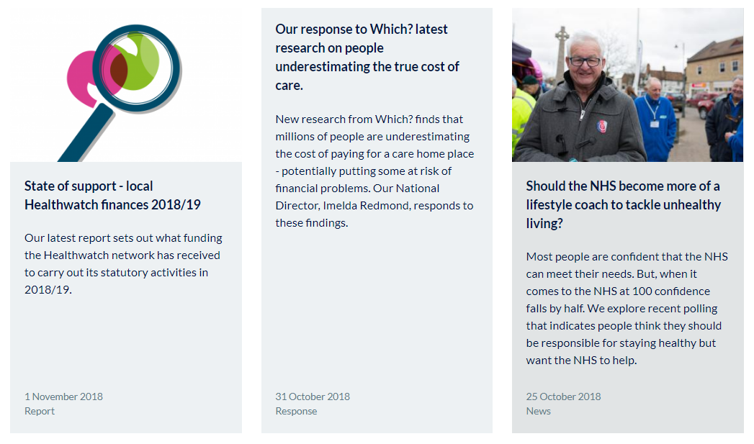
- Second paragraph summary: If there is no main image, you will need to add another paragraph of summary text. You will also need to include this paragraph if you want to promote this article to be the lead article on the news and reports landing page. This is to avoid having a lot of white space on the news and reports page.
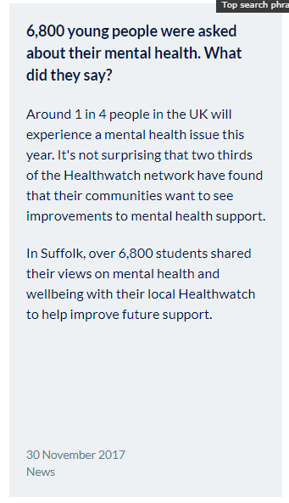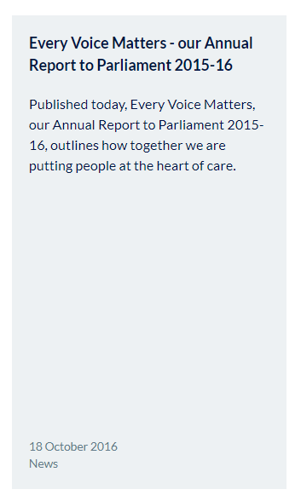
Example on the left as the lead and second paragraphs complete.
Example on the right only the lead paragraph completed and no picture.
- Paragraphs: You then add the bulk of your content using paragraphs. There is more detail below on the type of paragraphs you can use and what they look like.
- Related content: Three related items will automatically show up at the bottom of the article based on the tags that you have applied. If you did not tag your article, no content will appear here.
If you want to highlight specific bits of content, you can use the related content block at the bottom of the page. Start typing in the name of the bit of content you want, and it will prefill. You can fill up to three items. (Looks best with three but does work with less if needed).
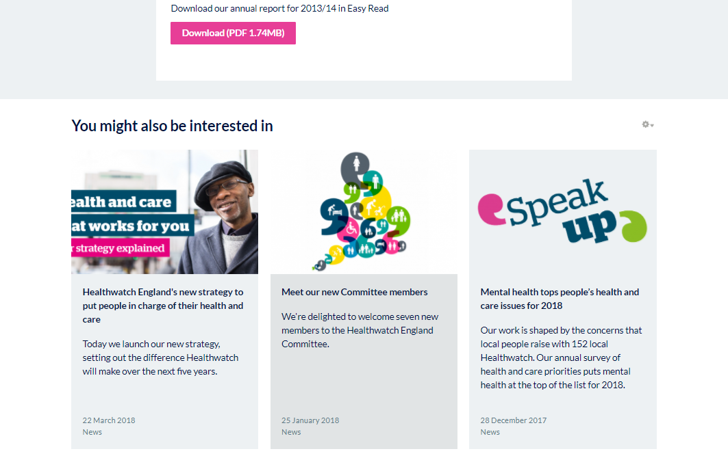

Call to action block - Select a call to action block to display at the bottom of your article and extend the user journey. We have pre-populated some of these; however, we would advise you to adapt these to your local Healthwatch. See the call to action guidance to create your own call to action block.
- URL path settings: This will be set to generate an automatic URL alias by default. Leave this information.
- Options: The promote to carousel option is ticked by default. If this box is ticked, this will make the featured on the news and reports landing page.
If you tick ‘Promote to homepage’, this will push it through to the homepage.
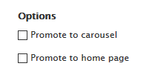
- Meta tags - You do not need to worry about this.
- Revision information
This is only relevant if you are making changes to an article.
If you have made changes, you can save this as a revision by ticking the ‘create new revision’ box. You can also leave a comment explaining what you have changed. This would only be visible in the back end to other editors and administrators. Once you have saved the changes, you’ll be able to click ‘revisions’ and see the previous version. This is useful if you want to make some updates but keep a history of what was on the site beforehand in case you need to revert to a previous version.
- Comment settings - You do not need to worry about this.
- Authoring information: You can use this functionality to backdate content. For example, when you’re transferring your content across, you will need to backdate your news articles to the real date they were published. The format for this is YYYY-MM-DD
- Publishing options:
Published - if this is not ticked, it will save the article as a draft. If it is ticked, the article will publish.
Promoted to front page - If you tick this, it will be pushed through to homepage.

Using paragraphs
The main bulk of your article will be built using the paragraph functionality. You can add multiple paragraphs and order in whatever way you would like to best display your content.

Image full width
This paragraph displays an image that fills the width of the news article.
- Choose the image you want to upload. It must be a minimum of 750x386 in pixels.
- Remember to add your Alt text and title to increase the accessibility of your site.
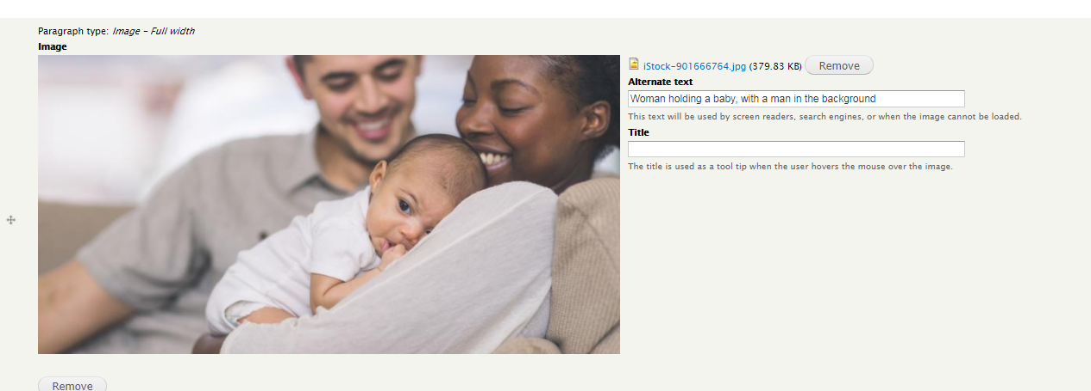

Text
This will probably be the paragraph that you use the most. This paragraph is for adding text to your article. You can also use this paragraph type for:
- Embedding tweets - click the video reel in the editor (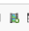) Here it will ask you to add an embed code. Paste your Embed code from Twitter or Facebook into this box and it will pull through to your web page like this.
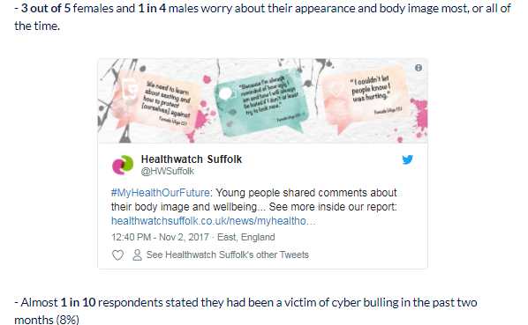
- Long quotes - Using the quote function within the WYSIWYG is a good way to show a long quote. Highlight the text you want to appear as a quote and click on the quote mark within the text box
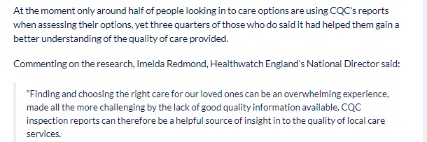

Text in grey box
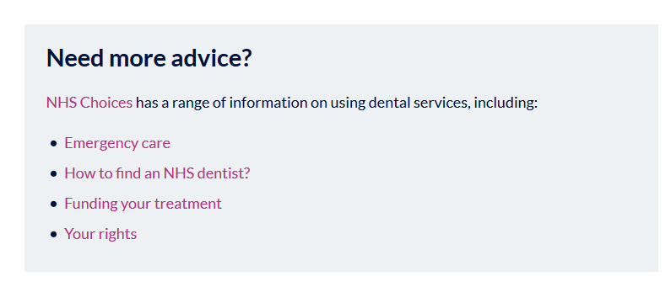
This works in the same way as the text box. It’s a great way of making content stand out and highlighting key points. You should use this to highlight your main findings you want to pull out or a link to an external report.
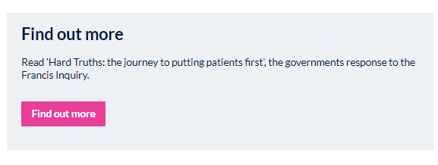

Downloads
You should only use the Download paragraph when adding any articles that are ‘reports’. This covers all publications, insight and briefings.
Do not attach Downloads to Articles that are ‘responses’ ‘news’ or ‘advice and information’. If you add reports to a news item, they quickly get lost over time.
For example, you’ve just finished your annual report. You should add a Article Report to your website with the download attached. This means that it’s easy for people to find.
You may then also want to create a news story and link to your report from there.
In the general description text box, you might want to provide details as to how people can get in touch if they need the information in another format or contact details as to who is best to talk to about the specific bit of work.
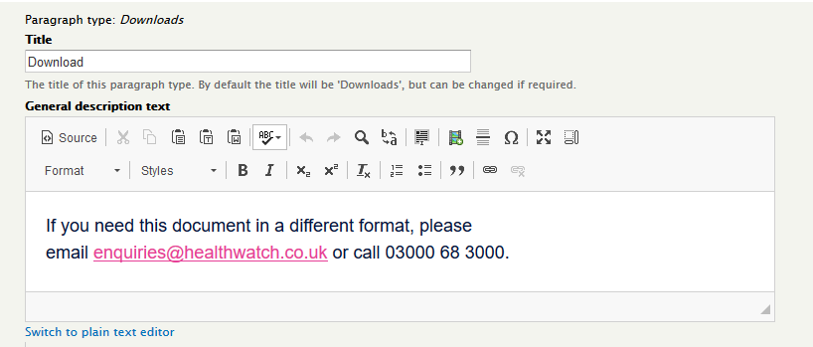
In the File Download section, browse for the file on your computer and upload it to the site. You can add multiple items here by selecting ‘Add another item’.
You would use this if:
- you had produced multiple versions of the same document (Easy Read, Large Print, Executive Summary)
- you had a number of documents relating to the same thing. For example, a board meeting, where you might have an agenda, minutes and discussion papers.
If you do upload multiple files, make sure you include a file description so that on view, people understand what each document is.
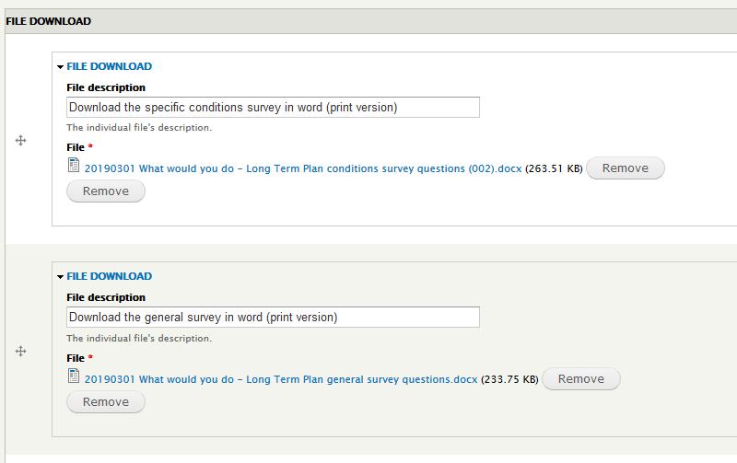

Video
Add the URL of the video you want to share and include a title. This will automatically resize it to fit the article.
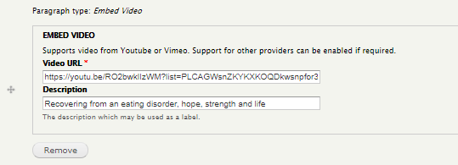
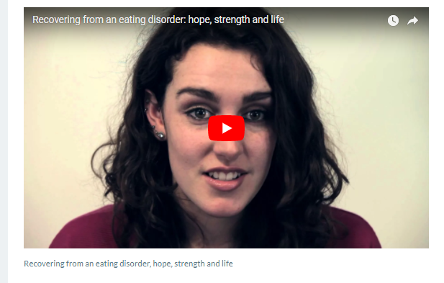
Top Tip: Remember that not everyone who visits your page will stop to watch your video. Take out a couple of the key points to help explain this content.

Quotes
If you have a great quote about your work, make it stand out using the quote block. Just add in the text and who said it.
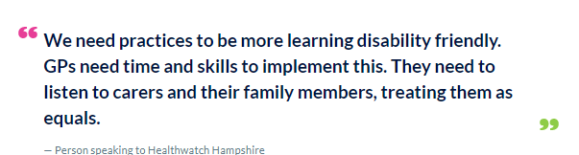

Style Guide

Adding News articles
How you choose to structure your news articles will depend on the type of information you have. For example, you might have a news article which is more image or video based, or another which embeds posts from social media.
Make sure that you have used the appropriate tags and themes to make sure that people are able to find it easily on your website.
Here we have suggested a few key ways to consistently showcase your content:
- Use grey boxes to highlight key facts/findings/bulleted lists OR links to external content (reports etc). Choose whichever you think is the most prominent.
- Do not upload reports or publications to a news story. If you do this, the report will not appear in the reports section. Upload the report as an Article/Report and then link to this report from the news story.
- Use the quote function within the text box paragraph (in the WYSIWYG) for longer quotes.
- Use the quote paragraph type for short, snappy quotes, or to pull out the most important part of a longer quote.
- Include Action buttons to make it clear what you want the user to do.
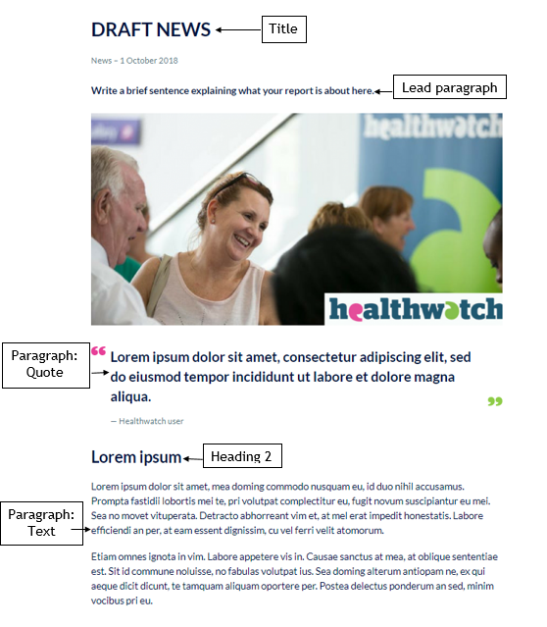

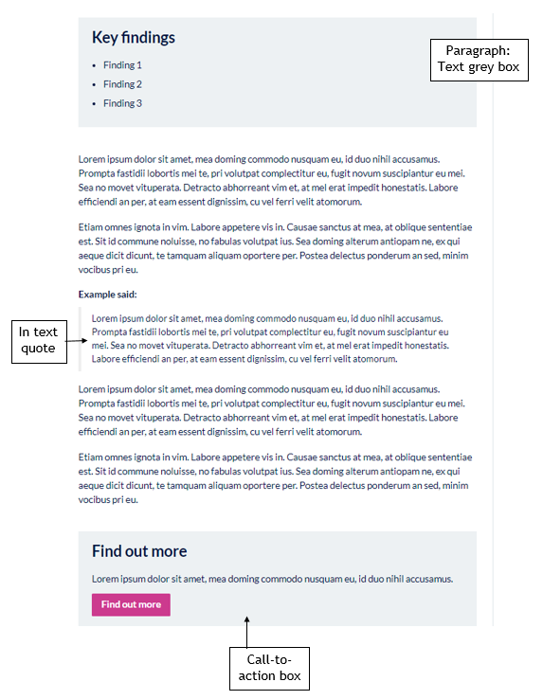

Adding Reports
A ‘report’ includes any type of downloadable publication that you have produced. This will cover your insight reports, such as Enter and View reports, as well as things like your policies and procedures.
Your reports should be short and simple and should clearly articulate what the document is about and highlight any key findings.
Make sure that you have used the appropriate tags and themes to make sure that people are able to find it easily on your website.
Try to use the same structure for each of your reports e.g.
- Lead paragraph
- Summary
- Key findings
- Download information
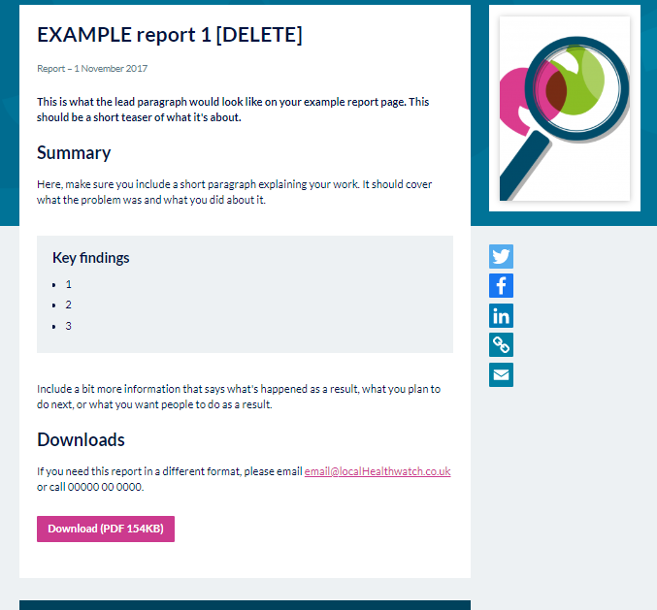
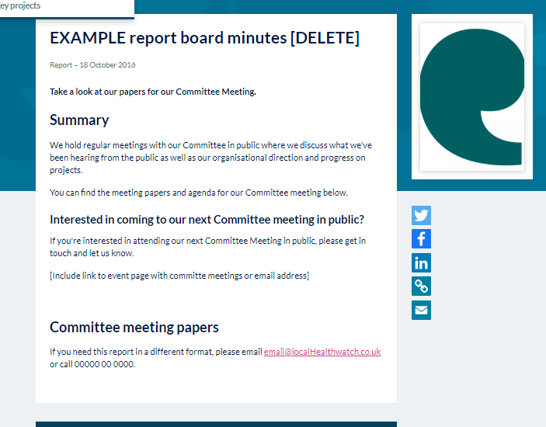

Adding a response
Add a response when you want to respond to something publicly, but you don’t have enough text to create a news article.
Here would be the most common use of the in-text quote. Keep in mind that you do not want to lay the full quote out as a paragraph type, this would be appropriate to pull out and highlight a part of your quote.
Make sure that you have used the appropriate tags and themes to make sure that people are able to find it easily on your website.
See example of a response layout below:

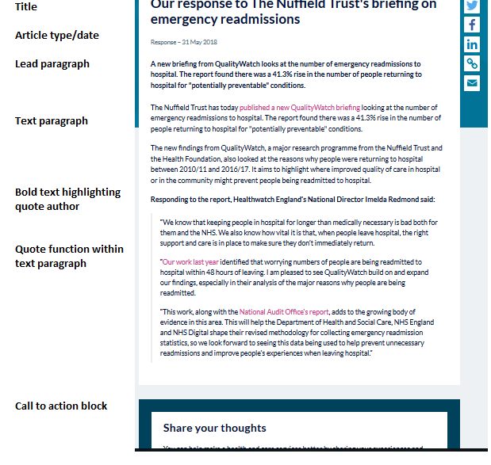

Adding Advice and Information
Advice and information content should be easy to read and to the point. People should be able to scan the content easily to see whether it solves the problem they’re having, and where to go for a solution.
Here we have suggested a few key ways to consistently showcase your content:
- Use grey boxes to highlight facts and figures or to signpost to where people can find out more. Choose whichever you think is the most prominent.
Top Tip: Don’t overuse grey boxes on the page. They should be used to break up content, don’t use one grey box after the other
- Use the quote paragraph type for short, snappy quotes, or to pull out the most important part of a longer quote.
Make sure that you have used the appropriate tags and themes to make sure that people are able to find it easily on your website.
Take a look at an example of an advice and information piece, and how the different paragraphs are used to display the information in an eye catching and informative way.
Top Tip: Look at the advice and information content on the Healthwatch England website. We have created this as useful content that should be relevant anywhere in England, but you may wish to adapt it for your local community.
https://www.healthwatch.co.uk/advice-and-information

Adding a blog
A blog should be used to display a real-life case study or personal story. It could be an article about your CEO, or perhaps one of your volunteers. This should link to a relevant area of your site so that people can clearly see where to go should they feel inspired/want to know more on the topic.
Make sure that you have used the appropriate tags and themes to make sure that people are able to find it easily on your website.
Top Tip: Be mindful not to overuse the quote paragraph when creating a blog. Use this feature to pull out interesting information.
Here is an example of a blog on the Healthwatch England site.

Promoting articles on the homepage and news and reports landing page

News on homepage
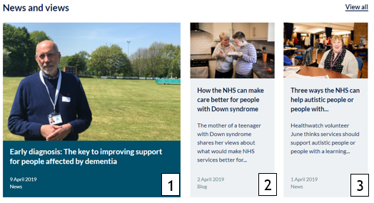
1.You can choose which article you display here. Think of this as a promotional spot. The article displayed here could be a news article in line with a campaign that you’re running, or a report that you have released.
How to display
Go to the article that you want to promote → Edit → Scroll down to ‘Options’ → Select ‘Promote to homepage’ → Save
How to change
If you no longer want this article to be the focus there are two ways to change this.
The first is to uncheck the ‘Promote to homepage’ option.
The second is to select a newer article with the ‘Promote to homepage’ option. This will automatically take the place of the previous article.
2. This is automatically pulled through based on the date of publication. The newest article (if not already selected as the promotional article) will be pulled through here. You do not need to do anything.
3.This is automatically pulled through based on the date of publication. The newest article (if not already selected as the promotional article) will be pulled through here. You do not need to do anything.

News and reports carousel
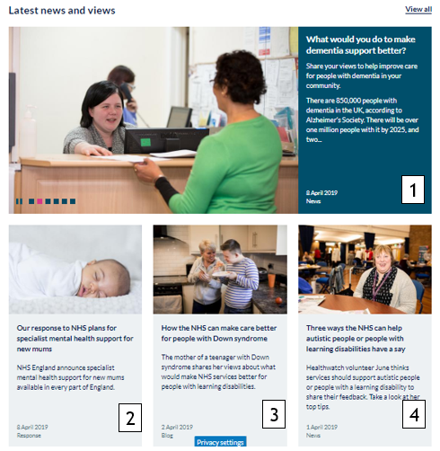
1.You can choose which article(s) you display here.
You can have multiple articles on rotate at any time, they will displayed in order of date publication.
How to display
Go to the article that you want to promote → Edit → Scroll down to ‘Options’ → Select ‘Promote to carousel’ → Save
How to change
If you no longer want this article you will have to uncheck the ‘Promote to carousel’ option.
2.This is automatically pulled through based on the date of publication. The newest article will be pulled through here. You do not need to do anything.
3.This is automatically pulled through based on the date of publication. The second newest article will be pulled through here. You do not need to do anything.
4.This is automatically pulled through based on the date of publication. The third newest article will be pulled through here. You do not need to do anything.

Call to action blocks
A call to action block appears at the end of an article, once selected. These are to encourage your web visitors to spend longer on your site by signposting them to actions that you want them to take.
These should be broad and used to link to key call to actions within your organisation. For example, you wouldn’t look to create a new very specific call-to-action block each time you did an article.
Top tip: We have already created some call to action blocks for you to use. Feel free to adapt these or create your own.
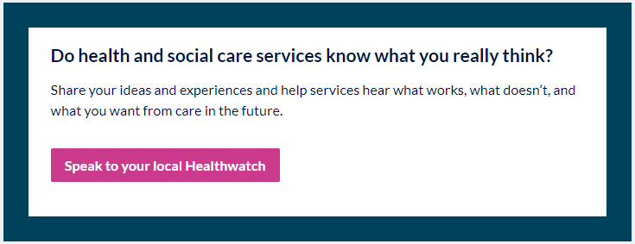
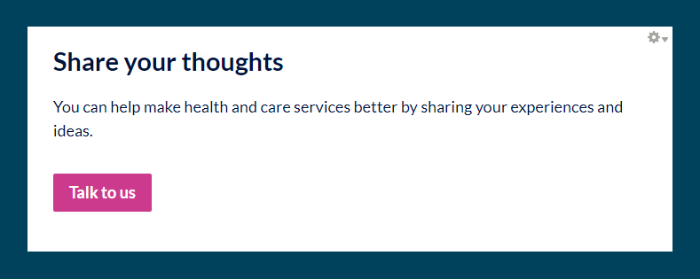
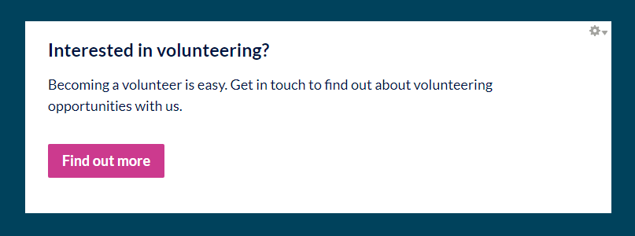

Adding a call-to-action block
To add a call to action block:
Content → Add content → Call-to-action block
Fill out the fields below.
- Admin title: Name the block to describe the call-to-action. This will appear on the back end of the site for your reference only and will not be visible to the public.
- Body text: Explain what the call to action is. We advise using this structure:
  - Clear title. This should be in Heading 2 and should either be a question or a statement.
  - A sentence or two explaining more about the action you want the person to take.
  - An action button, linking the person to where they can find out more, take a survey, download a document etc.
- URL pathway settings: Ignore this field as this is done automatically.
- Meta tags: Ignore this field as this is done automatically.
- Revision information: This is only relevant if you are making changes to an existing call to action block.
If you have made changes, you can save this as a revision by ticking the ‘create new revision’ box. You can also leave a comment explaining what you have changed. This would only be visible in the back end to other editors and administrators. Once you have saved the changes, you’ll be able to click ‘revisions’ and see the previous version. This is useful if you want to make some updates but keep a history of what was on the site beforehand in case you need to revert to a previous version.
- Authoring information: This is generated automatically when you save. It will show you who added the content and when.
- Publishing information:
  - Published - this needs to be selected to publish this. If you do not tick the box, you will not be able to select this when choosing a call-to-action block for your article.
  - Promoted to front page - doesn’t need to be selected.
  - Sticky at top of lists - doesn’t need to be selected.

Events
Events are a great way to show people in your community what you are up to and ways that they can get involved.
Examples of these could be: holding an information stand at a local hospital, an opportunity for people to take part in an online focus group, or your annual general meeting.
You should also use the events function to promote any board meetings where the public is able to attend.
You can also use the events function to promote broader awareness days that your community may be interested in. We have populated the base site with a few to get you started, but you can find more of these events on the Healthwatch England site, or somewhere like: https://www.awarenessdays.com/

Adding an event:
Content → Add content → Event
Edit the fields below.
- Title: Your event title should be short and simple. It should describe what the event is about so people have an idea of whether it’s something they’d be interested in attending.
- Main image: Either upload an image or select one from the image library. It’s good to have pictures of your local area where possible.
- Event type: We have pre-filled two options for you. If you require a new event category to be set up, just get in touch.
  - ‘Our meetings’ for meetings held by your Healthwatch – for example, focus groups, board meetings, volunteer meetings etc.
  - ‘Community events’ for events happening in your local area.
- Event location: Here you can include the location of where the event is taking place. If the event is something like an awareness day, you can choose ‘various’ as the location. If the event is something people can join online, change the event location to ‘online’.
- Event dates: You must enter a start date and time for your event to save. If the event does not have an end date, you can un-tick the ‘show end date’ box. If the event lasts all day, don’t forget to tick the ‘All day event’ box.
- Tags: Tags work here in the same way that they do for articles. This helps events be linked together. Make sure that you tag your event appropriately.
- About this event: This should be a short summary to describe to the person reading what the event is about, who it is for, and why they should attend.
- Contact details: This should be a short paragraph that explains how people can sign up or find out more.
- Link to booking form: Here you can add a link to where people can book by entering the appropriate URL. If the link takes you to a new website to book (Eg Eventbrite) tick the box which says ‘Open URL in new window’.
- No event booking text: If there is no booking page for them to be led to, amend the button to a contact us button that links through to an email address.
To add an email address as a link, add ‘mailto:’ before the email address so that it registers as a link.
- Related report: Your event might be a focus group on your recent report findings. You can enter the report here so that people can read up before they attend. Do you have an agenda? You can add this here too.
- Options: Tick the box which says ‘Promote to banner’ if you want this to be the lead event on your events landing page.

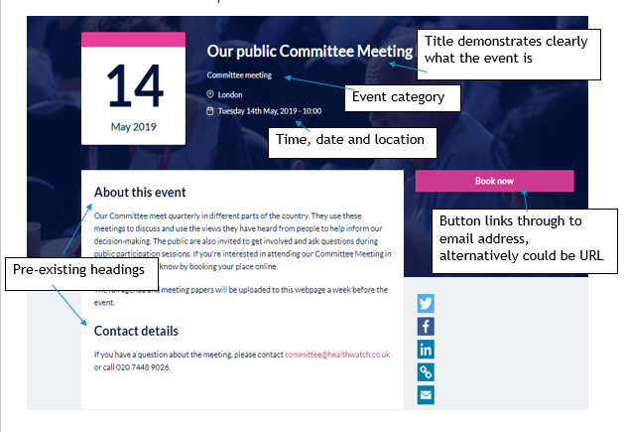
Event style guide

Cloning an existing event
This is a particularly useful feature if you have a series of events where most of the content is exactly the same. Go to the event you want to copy and click ‘clone event’ in the top left hand corner.
You then need to make sure that you:
- Amend the title (it will now say ‘clone of…)
- Change the date to the correct date
- Look at the copy to make sure that it still applies
- Publish the event

Promoting events on the events landing page
- To create a lead event on your events landing page, select the event you want to promote and make sure the tickbox ‘Promote to banner’ is ticked under ‘Options’. It will show like this:
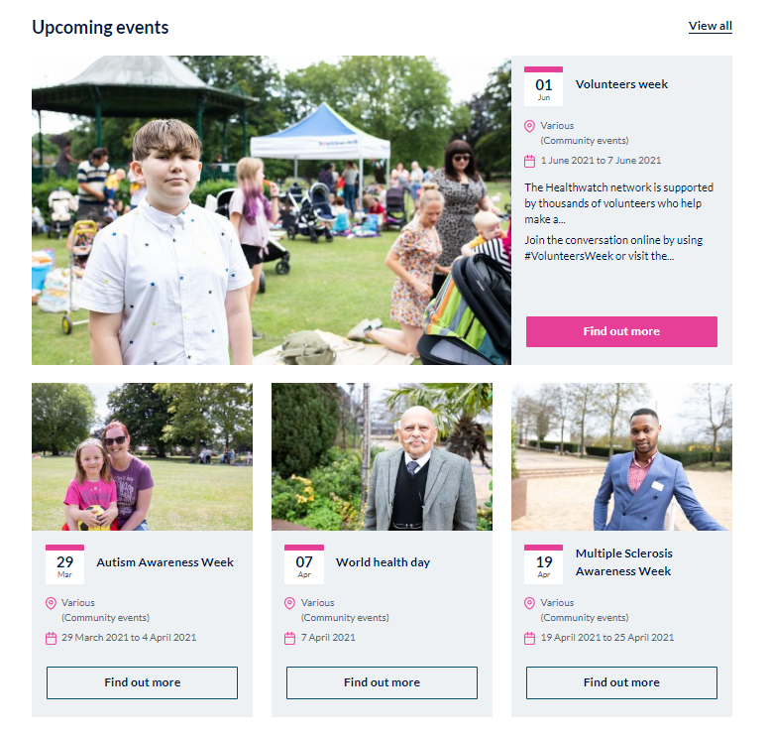
Once the event has passed and you no longer have a promoted event, the view will automatically switch back to show the three closest events.
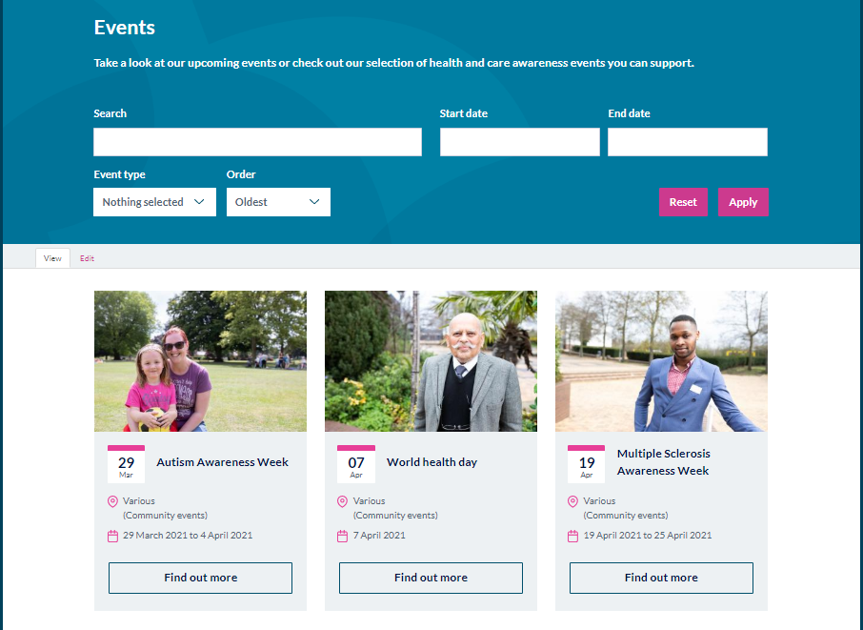

Webforms
Webforms are a great way to gather information from your community. This could be to contact you for information about a future event, or to help you understand people’s experiences of a health and social care project.

Creating a web form
There are four key stages to creating your webform.
1.Creating the webform
2. Adding the questions
3. Configuring the webform
4. Accessing the results.

Creating the page
To start creating your webform, go to:
- Content → Add content → Webform

This is the page that your webform will sit on. It’s important here that you include a bit of contextual information about what the survey is about, how the data will be used and why people should share their views.
Edit the fields below:
- Title: This should make it clear what information you are intending to collect using this form.
- Lead Paragraph: This is an optional paragraph that you can use to provide further information about the form and what it is going to be used for.
This will appear in the blue strip above your webform:
- 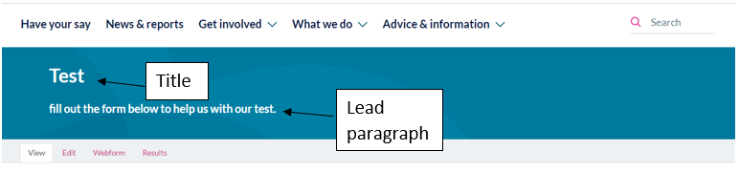
Paragraph type: Add paragraphs to explain more about the form and what it is going to be used for, perhaps linking to an article of the project.
- Main image: Upload an image here into your image browser, to be displayed on your webform.
- Second paragraph: This content will only appear if you haven’t uploaded an image. This should include more information about the webform.
- You need to ‘save’ these details before you can move onto the webform.

Adding the questions
Once saved, you will be taken to the ‘Form components. Here, you need to insert your questions.
- Underneath ‘label’ you will need to add a ‘new component name’.
- Select your question type using the dropdown
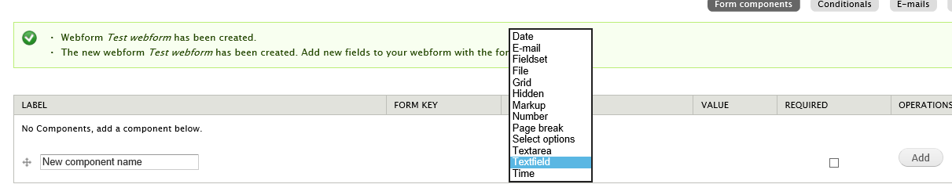
- If you must have a response to this question, tick the ‘required’ box. This will mean that people will not be able to progress in the form or submit their response unless this is completed.
- Select ‘Add’
- This will then take you through to a screen where you’ll need to add more detail about the question. (Please see question type guidance below for more information).
- After adding each question, remember to regularly save the form.

Configuring the webform
Once you have added your questions, you can then move on to configuring the form. You can see the different sections of how to do this in the top right of the screen.
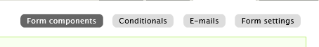

Conditionals
The Drupal webform module is not as sophisticated as other survey tools, such as Survey Monkey. Conditionals can be incredibly complex, and we would recommend that you aim to keep your survey as simple as possible.
The conditionals section allows you to trigger additional questions to be shown, if a certain option is given on the webform.
In this example, we want to know what people’s experiences of booking a GP appointment are like. We only want to hear from people who have been to their GP in the last 12 months.
- Question 1 asks – Have you visited your GP in the last 12 months. The choices are Yes or No.
- Question 2 says – What was your experience of booking an appointment like? The answer option is a free text box.
On the conditionals screen, go to Add a new condition.
Here you would select: If ‘Have you visited your GP in the last months?’ is YES, then ‘What was your experience of booking an appointment like? Is SHOWN.
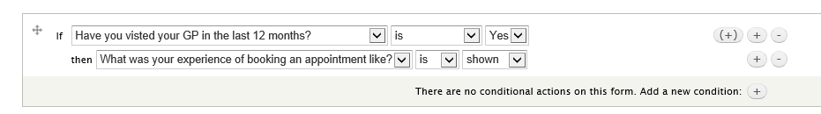
Click ‘Save conditions’.
Go to ‘View’ and test the conditions to make sure they’re working properly.
Initial question:
If Yes is selected – the additional text box appears.
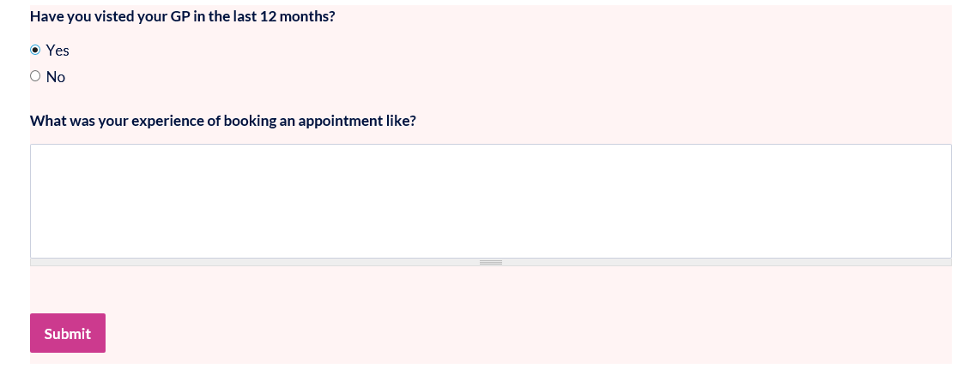
If no is selected:

Emails
You can set up your webform to send emails automatically when someone completes the form. This is useful if you want to be kept up-to-date when a new submission is made. For example, for your ‘Contact Us’ webform, you would want to see these submissions as they come in, to make sure you’re being as responsive as possible and dealing with any safeguarding issues.
Other forms, such as collecting email sign ups, you might want to just download once a week, and not have these automatically sent to an inbox.
To set up all submissions to be directed to an inbox:
- Add the email address you want in the box, and then click ‘add’.
- Email to address: This is the address where you would like the email to be sent:
- Email subject – you can either keep the default title, or specify by selecting the ‘custom’ option and entering your own subject.
- Email from address – A default address this will already be configured in the back end of your site from setup. However, you can change this by selecting the ‘custom’ option by entering a different email address here.
- Email from name: A default name will appear here – it should be your local Healthwatch name. You can change this by selecting the ‘custom’ option and choosing a different name.
- Email template: Leave this as the default template. This will include all the fields that are included in the webform. If you wish to, you can also customise this.
To enable a copy of the submission to be sent back to the person submitting it
- You can only do this, if you have asked the person in the webform for their email address. We would only recommend doing this if you really need their email address. You could have this as an optional field.
- Select ‘component value’ and then ‘email address’ and then ‘add’.
- This is what it would look like in the back end.
- 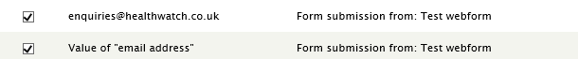

Form settings
- Confirmation message
Add a confirmation message that will appear when someone has submitted their response. This should thank people for participating and inform them about any next steps (how you’ll be using the information, what happens next, how they can find out more or get in contact).
- Redirection location
- Confirmation page – this is the default setting. With this ticked, it will show the confirmation you have entered above.
- Customer URL: you can direct people to a specific page after filling in your webform. Include the URL here.
- No redirect (reload current page) – I wouldn’t recommend this option, as it may be unclear to the user that the survey has been submitted.
- Total submission limit
This by default is set to unlimited. You would only need to limit this if you were looking a certain amount of people to share their views.
- Per user submission limit
This by default is set to unlimited. This is best as will allow you when you’re out and about to use the same device to collect multiple responses.
- Status of this form
Select open or closed to either allow submissions or that the form is closed. Once you have finished your survey, make sure you change this to ‘closed’. This will mean the link is still live, but people will see that you’re no longer collecting submissions.
- Submission access
You can leave this section.
- Progress bar
If your survey is quite long, you can select different settings to help people understand how far they’re through the survey.
- Preview page
If you tick this box, when people get to the end of the survey, people will be taken to a screen where they can review their entry before submitting it. If there’s anything they want to change, they can then click ‘back’ and edit it before submitting.
- Advanced settings
You do not need to worry about these as they are unlikely to be applicable.

Accessing results
The results tab is where you can view and access the results of your webform.

Submissions
This tab has a full list of all the submissions. At the top it will tell you how many submissions are on the webform. The number on the left-hand side will tell you the total number of submissions.
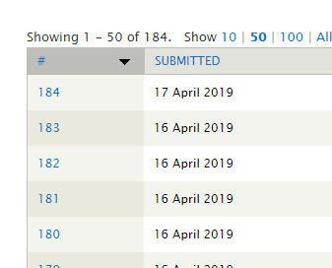
For example, if you have cleared the webform data previously, the number at the top will tell you how many new results there are, and the number of the left-hand side indicates the overall number of submissions for that form that have been received.
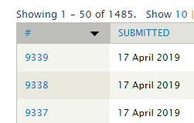

Analysis
This page provides a very top-level snapshot of the data in the webform. This is useful for you to be able to keep an eye on what’s coming in without exporting the data each time.

Table
This page provides the data in a table format for you to look at without downloading. This can be difficult to read if there are a lot of free text boxes in your webform.

Download
Here there are a range of different download options. We recommend that you export this as Microsoft Excel and keep the column header format as ‘label’. This means the headers will be the question labels you have used in the form.
- Select list options
- Included export components
Here you can go through and select or deselect items that you want to export. It may be easier to export them all and then delete the columns you do not need.
- Download range options
This is useful if you only want to select items from a particular date range, a particular number of latest submissions, or submissions since the last download.

Clear
Once you have downloaded and saved your data somewhere secure, you need to clear your webform. Clearing your webform will remove all data. It’s important this is done regularly as your website should not include any information that is not necessary for any length of time to comply with GDPR.
If you accidently clear data without saving it – contact us and we can raise an issue with Circle. As they take daily backups, we should be able to retrieve a recent version for you.

Viewing the webforms on your site.
If you click ‘Content’, filter by type and select ‘Webform’ and then ‘Apply’. You will see all the webforms currently on your site. Under ‘status’ you will see the words ‘open’ or ‘closed’ depending on if you want this form in use.
You can either edit an existing webform or create a new one. To edit an existing webform, click ‘edit’. To create a new webform go to ‘Content add content webform’.

Question types
Below is a list of the question types, and some tips to help you fill in the correct information depending on which question type you select. Your form can contain a mixture of all of the below.

Date
This question is used to collect information from the user where they must select a particular date. Here the user is required to give a date as their response.
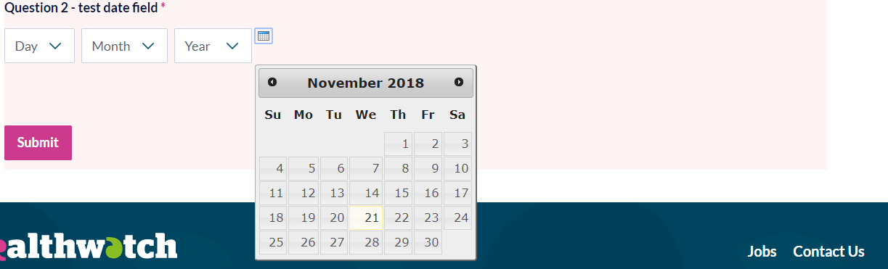
- Label – this is the question that will appear on the webform.
- Description – make sure you include a description of the field. This is useful for accessibility purposes and will ensure a screen reader is able to understand the webform.
- Default value timezone: Here you can select which timezone the webform submission should use, whether it’s the users timezone or the website timezone.
- Hide: Here you can choose to hide the day/month/year. For example, if you only want to collect month/year you can hide the day.
- Validation:
  - If this answer is mandatory, tick the ‘required’ box.
  - You can constrain the date range by selecting a start date and end date relative to today’s date.
- Display – we recommend you leave this as the default to enable the pop up calendar. If you tick the box Use a textfield for the year, the generated date field will use a textfield for the year. Otherwise it will use a select list.
- Label display – you can leave this.

Email
This field will require an email address. Upon submission, the user will be prompted to have the correct format (see example in screenshot below).
- 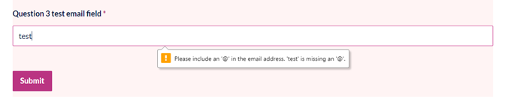
- Label – this is the question that will appear on the webform.
- Description – make sure you include a description of the field. This is useful for accessibility purposes and will ensure a screen reader is able to understand the webform.
- Multiple – if you tick this box, you are allowing users to enter multiple email addresses, separated by commas.
- Format – keep this selected as the default option of ‘short format only’.
- Validation:
  - If this answer is mandatory, tick the ‘required’ box.
  - If you check the ‘unique’ box, it means that only one person will be able to submit using a specific email address (one submission per email address).
- Display:
  - You can leave the width blank.
  - Place holder text – this is included on the form until someone starts entering their information. For this you might want to include something like youremail@example.com. This shows people the type of information you’re looking for.
- Label display – you can leave this

Fieldset
Fieldset is a way for you to group questions together into a logical order.
For example,
- Label: This would be what appears on screen, or on the submissions.
- Description Make sure you include a description of the field. This is useful for accessibility purposes and will ensure a screen reader is able to understand the webform.
- Display
  - Collapsible
  - Collapsed by default
  - Hide label
  - Description above field
  - Private
- Once you have saved the fieldset, you will then need to decide what questions should appear underneath it by dropping and dragging questions using the arrows. They should appear slightly to the right and sit underneath the fieldset.
- Press save.
- 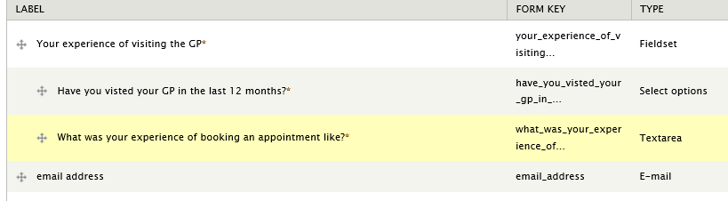
This is how it would appear on view if you had set the label to appear and not be collapsed.
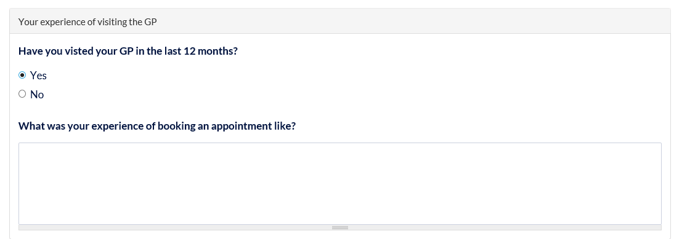
If you set the fields set to show as collapsed or collapsible, this is what it would look like when closed. You would then need to click ‘Your experience of visiting the GP’ to see the questions that sit within that fieldset.

File
This option allows people to upload a file to the survey. This might be a piece of artwork, supporting evidence for something, or a CV for a job application for example. You can select files that you will or will not accept.
- Label – this is the question that will appear on the webform.
- Description – make sure you include a description of the field. This is useful for accessibility purposes and will ensure a screen reader is able to understand the webform.
- Upload directory – here you can specify where you would like the files to be stored. This will help you easily find them and separate them from other files on your site.
- Rename files: You can force files to be renamed into a pattern for consistency.
- Validation:
  - If this answer is mandatory, tick the ‘required’ box.
  - Max upload size – choose how large the file you are willing to accept. You can also then tick the format you will accept. We recommend you keep the max size of about 5MB. Most comment formats you should select would be PDF/docx – depending on what it is you’re asking people to submit.
- Display:
  - You can leave this section.

Grid
This is a useful question type when you want people to be able to rate a series of statement.
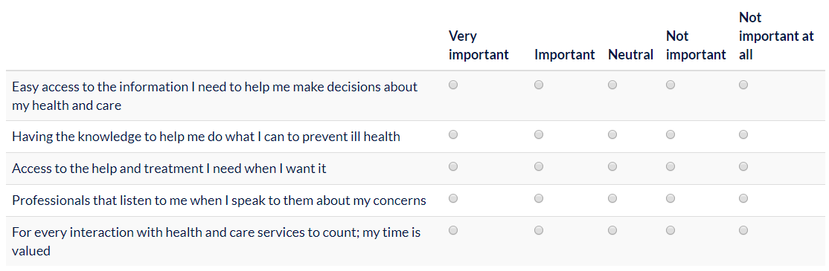
- Label – this is the question that will appear on the webform.
- Options: Here you need to enter the answer options you want people to choose from. A common example of this is would be answers on a scale such as: Very Important, Important, Neutral, Not important, Not important at all.
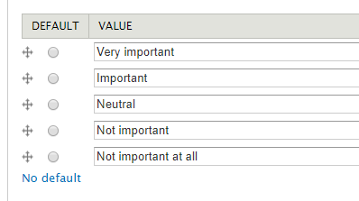
- Questions: Here you will place your questions or statements that you want people to respond to.
- 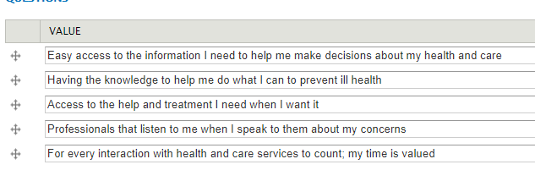
- Description – make sure you include a description of the field. This is useful for accessibility purposes and will ensure a screen reader is able to understand the webform.
- Validation:
  - you will be able to say whether you need an answer to this question or not. This will apply to the whole section.
  - unique – here you can make it so that people are only able to select one option per row.
- Display:
  - Randomise options: Randomises the order of options displayed at the top of the grid.
  - Randomise questions: Randomises the order of the questions displayed at the side of the grid.
  - Sticky table header: Use a sticky (non-scrolling) header.
  - Hide label: Do not display the label of this component.
  - Description above field: Place the description above rather than below the field.
  - Private: Private fields are only shown to users with access.

Mark up
Mark up text is a way for you to be able to include text before and after questions to help introduce a set of questions. You can enter mark up before/after any question you want to.
This does not display as a question. This displays as text only, without an option attached to it. You may use this to provide more information about the past or upcoming question.
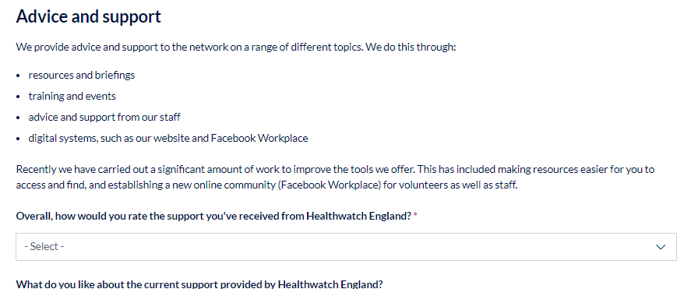
- Label – this is the title that will appear on the webform.
- Value: Here is a rich text box where you can add the text you’d like. You can format text in the same way you usually would, using headings and adding links where appropriate.
- Display – here you need to select whether the mark up should be included only on the webform for those while they’re submitting it, only on the submissions, or on both.

Number
You would use this question type if you are looking for answers that only contain numbers.
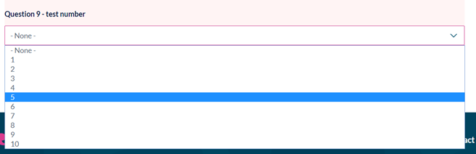
- Label – this is the question that will appear on the webform.
- Description – make sure you include a description of the field. This is useful for accessibility purposes and will ensure a screen reader is able to understand the webform
You can either leave this to be displayed as a text field or you can amend this so that people pick a number of their choice from a list. For example, you might be looking for them to submit their age between 35 and 45.
- Validation:
  - Here you can select whether this field is required or not.
  - There is also an opportunity to input a minimum or maximum value depending your intended output. If you want to include a specific increment, you need to add a figure to the ‘step’ box. For example, you would enter 5 if you wanted values to go up in 5s (5,10,15 etc).
- Display:
  - Here you can decide whether you want to leave it as a text field for people to enter their own value, or to select from a list (based on your minimum and maximum values).
  - Placeholder – this is an example you can put in to show the user the type of thing you’re expecting them to type. This will be shown until people try to type in the box.
  - You can also place a prefix or postfix to appear on your box (for example, if you were asking people to provide a monetary value you may have £ as a prefix, or if you want a percentage you’d include % as a postfix.
  - You can also select whether you want your answer to appear as a decimal, or include a thousands separator.
- Analysis: You can exclude zero from your analysis.

Page break
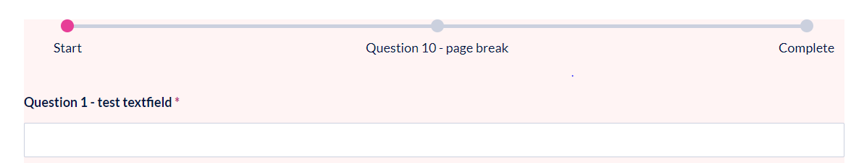
To avoid your survey becoming too long, you can include page breaks to help chunk up your content.
Label – this is the question that will appear on the webform.
- Next page button label – this will show as ‘next’ as standard, but you can change this if you wanted to.
- Previous page button – this will show up as ‘previous’ as standard, but you can change it if you wanted to, to say something like ‘go back’.

Select options
This is one of the most useful and common question types. It enables users to select from a pre-populated list of options.
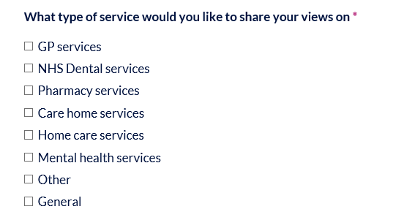
- Label – this is the question that will appear on the webform.
- Description – make sure you include a description of the field. This is useful for accessibility purposes and will ensure a screen reader is able to understand the webform.
- Options: If you only have a few options to add in, you can do these manually be entering a new one in per row. If you have a very long list of options, you can copy and paste this list in, by clicking’ manual entry’ and listing one option per line.
Normal entry
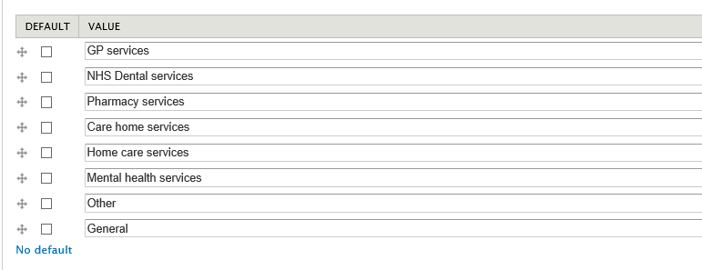

Manual entry
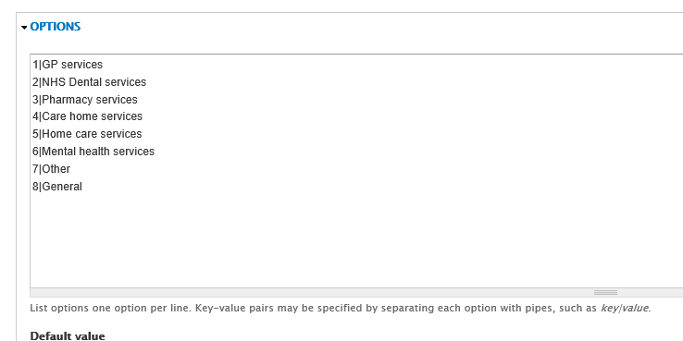
Using the arrows on the ‘normal entry’ you can choose the order of each option, as well as create parent items by moving items underneath and to the right of one another. For example, in this instance, you might create one called ‘primary care services’ and then move GP and NHS Dental services and Pharmacy services underneath this.
- Options settings - Multiple – if you tick this box, people will be able to select more than one item in the list.
- Validation Here you can select whether this field is required or not.
- Display
  - By default, your options will appear as radio buttons or checkboxes. If you tick the ‘listbox’ option, these will show as a dropdown.
- Default display:
- Display as a listbox: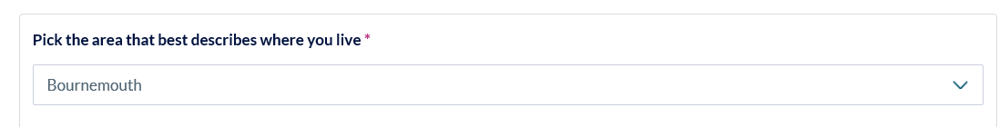

Text area
This question type is used to collect longer text responses. You would use this when you want people to share their opinion or provide more information to a question.
- Label – this is the question that will appear on the webform.
- Description – make sure you include a description of the field. This is useful for accessibility purposes and will ensure a screen reader is able to understand the webform.
- Validation:
  - If this answer is mandatory, tick the ‘required’ box.
- Display:
  - Here you have the option to cater the size of your text field. We recommend you leave this blank, and instead tick the box which says ‘resizable’.
  - Placeholder text. The placeholder text will appear until anyone starts typing in the box. This is useful as it provides an example of the type of response you’re expecting.

Textfield
This question type is used to collect a single line of text. You would use this when you’re expecting a short and straight forward answer.
- Label – this is the question that will appear on the webform.
- Description – make sure you include a description of the field. This is useful for accessibility purposes and will ensure a screen reader is able to understand the webform.
- Validation:
  - If this answer is mandatory, tick the ‘required’ box.
  - You can also select a maximum or minimum answer length.
- Display: Here you have the option to cater the size of your text field, or the characters that accompany the answer e.g. %. You can also choose where the description of the question appears.

Time
This question allows people to enter a time value. This type of question probably won’t be used very regularly.
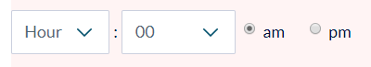
- Label – this is the question that will appear on the webform.
- Description – make sure you include a description of the field. This is useful for accessibility purposes and will ensure a screen reader is able to understand the webform.
- Default value time zone - here you need to select whether you want the user to put the time relating to their time zone, or you want to collect the information based on the website time zone. We would recommend you select user time zone.
- Validation:
  - If this answer is mandatory, tick the ‘required’ box.
  - You can also select a start time and an end time if you need to limit the options available. For example, if you had a webform to find out the times people would be able to volunteer for Healthwatch, you would want to limit this from 9am – 5pm.
- Display: You can choose to have the time show in 12- or 24-hour format as well as choose the time increments. You may wish to do every 15 minutes, or half an hour if you want to find time slots for people.

Pages
We have set up your website with all the basic pages you’ll need to get going. Most new content to your site will be added using the Article content type, but if you’re doing a large piece of work, such as your annual report, or if you have something you need to showcase, such as a youth volunteering programme, you might need to create an additional page.

If you have editor permissions, you can edit existing pages on the site or create your own.
Please note: As the main menu navigation is fixed, if you want to add any sub-menu items you will need to ask Healthwatch England staff to do this for you. We can also help and advise on how best to link to this content from elsewhere on your site and provide ideas on how it could be displayed in an easy and engaging way.

Adding a page
To add a page:
Go to Content → Add content → Article

To create your page, you have a choice of either just filling out the fields below, or adding blocks to your page.

Edit the fields below:
- Title: Your page title should be clear and to the point.
- Lead paragraph: You do not have to fill in this field, but if you do, it will be included in the blue page title field (see below).
- 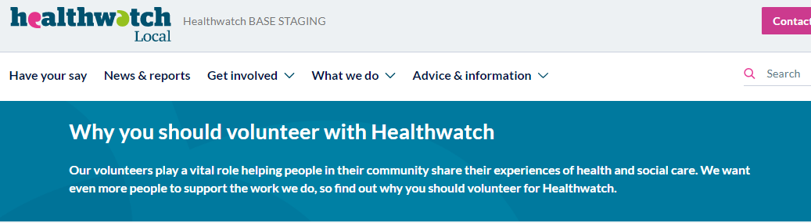
- Paragraph types: In the same way as used in the Article content type, you can add paragraphs to choose how you want your text to be styled.
  - Text
  - Text in grey box
  - Embed video
  - Downloads
  - Image float left (page)
  - Image float right (page)
- Related content block: The related content block works in a similar way to the article content type. If you would like to select up to three articles or events to appear as a row of related items, just start typing the name of the bit of content you want and it will pre- fill.
- Review date: If you’re likely to need to update this page in the future, you can set a review date. It will then send you an email near the time so you remember to update your content.

Using blocks
Blocks help you to build content on your webpage in manageable stylised chunks. You can choose blocks to show on multiple pages, or individual pages. There are three types of blocks that you need to know about:
- Blocks
- Image blocks
- Chart blocks

Region settings
When you create a block, you need to decide where you want it to appear on the page (region). The diagram explains the different region settings on the page. The main ones that you will need to focus on is the Hero banners, paragraphs and rows. However, we have provided a full list below to show you an example.
- 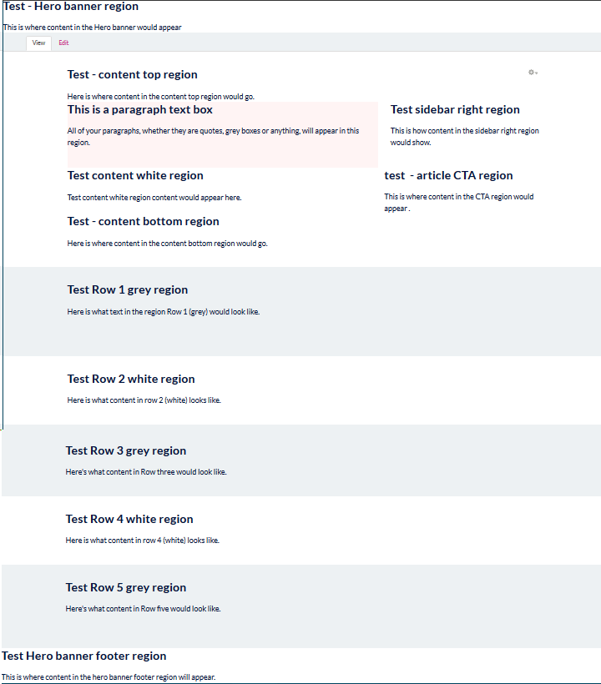

Block types

Block with no theme attributed to it
If you create a block, and do not select a ‘block theme’ it will appear white on a white row region, or grey on a grey row region, as below:
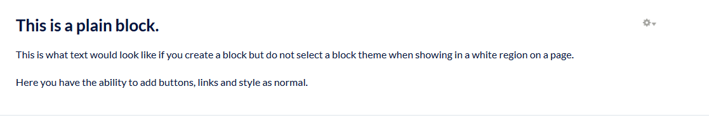
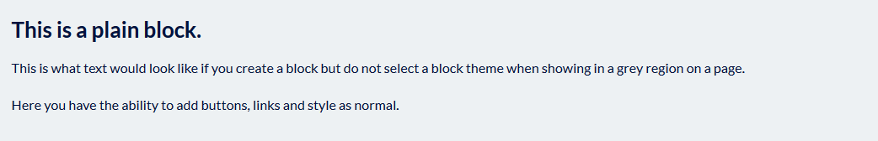

Creating a plain block
- StructureBlocks Add block
- Block title: You can leave this blank.
- Block description: Give a brief description of your block. This will be used on the block administration page, so make sure it’s something you can easily understand and recognise.
- Block body: In this box you can add and format text however you would like.
- Region settings: Select where you want the block to appear.
- Bootstrap: ignore.
- Block theme: Leave this blank.
- Visibility settings: Here you’re choosing where you want this content to show. There are two options:
- All pages except those listed
- Only the listed pages

- Tick ‘only the listed pages’ and then giving the node path of the page, where you want the block to display.
- Click ‘Save block’.

Grey block
Grey blocks can be a good way of making content stand out on a white background, particularly if you have a clear call-to-action to make on that page.

Creating a grey block
- StructureBlocks Add block
- Block title: You can leave this blank.
- Block description: Give a brief description of your block. This will be used on the block administration page, so make sure it’s something you can easily understand and recognise.
- Block body: In this box you can add and format text however you would like.
- Region settings: Select where you want the block to appear.
- Bootstrap: ignore
- Block theme: Grey block.
- Visibility settings: Here you’re choosing where you want this content to show. There are two options:
- All pages except those listed
- Only the listed pages

- Tick ‘only the listed pages’ and then giving the node path of the page, where you want the block to display.
- Click ‘Save block’.
Grey block showing in a white row:
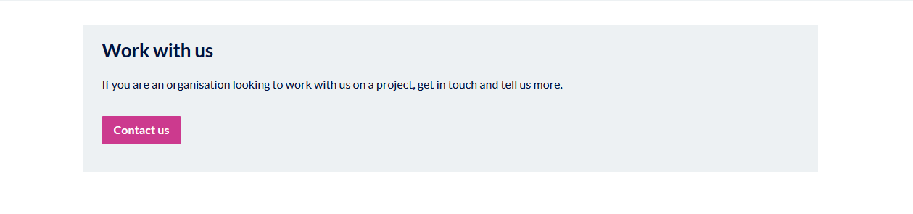
You can also put a grey block onto a Grey region row. If you were to do this, it would show in the same way as using a plain block on a grey row and look like the below:
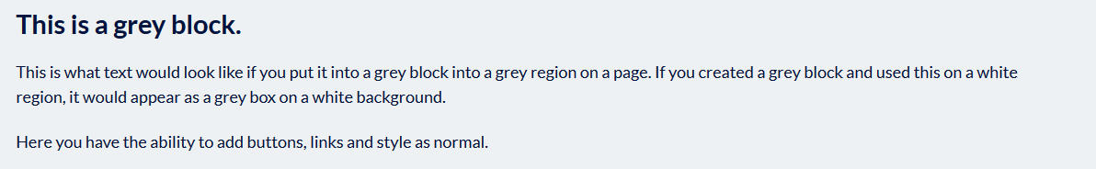

Two columns
The two-column block option is a great way of chunking content up into smaller bits and for directing users to other areas on your website.
- StructureBlocks Add block
- Block title: You can leave this blank.
- Block description: Give a brief description of your block. This will be used on the block administration page, so make sure it’s something you can easily understand and recognise.
For example, Two column box 1 | Volunteer page | Volunteer info
- Block body: We recommend that you format your blocks to include a heading, short sentence explaining the heading, and then an action button.
- Region settings: Select where you want the block to appear.
- Bootstrap: ignore.
- Block theme: Two columns.
- Visibility settings: Here you’re choosing where you want this content to show. There are two options. Tick ‘only the listed pages’ and then give the node path of the page, where you want the block to display.
- Click ‘Save block’.
- Once you have saved the block you need to:
- Go back into the block administration page (Structure –Blocks).
- Find the block you just created and click ‘configure’.
- Scroll down to the bottom of the page where it says ‘Block Theme’. Here, select ‘Two columns’.
- It is important to create two of these blocks, to avoid your page looking lopsided.

Appearance
The region you allocate for these blocks will dictate how they appear.
For example, these two blocks have been assigned to a grey row and appear as white boxes on a grey background.
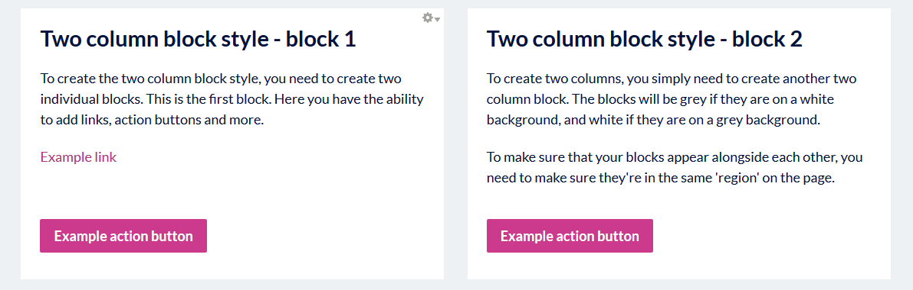
These two blocks have been assigned to a white row and appear as grey boxes on a white background.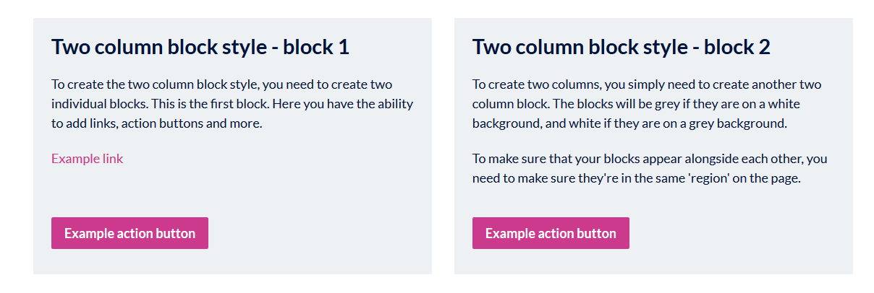

Title block
You can add a title block to help build structure into your page. You can place a title block above other blocks.

Creating a title block
- StructureBlocks Add block
- Block title: You can leave this blank.
- Block description: Give a brief description of your block. This will be used on the block administration page, so make sure it’s something you can easily understand and recognise.
For example, Title block 1 | Volunteer page above twin block.
- Block body: We recommend that you use a clear and short title.
- Region settings: Select where you want the block to appear.
- Bootstrap: ignore.
- Block theme: Title block.
- Visibility settings: Here you’re choosing where you want this content to show. There are two options. Tick ‘only the listed pages’ and then giving the node path of the page, where you want the block to display.
- Click ‘Save block’.
Top tip: Does your title block sit underneath the blocks rather than above? Go to the blocks administration page and drag and drop them in order of how you want the blocks to be displayed on the page within their different regions.
Example here:
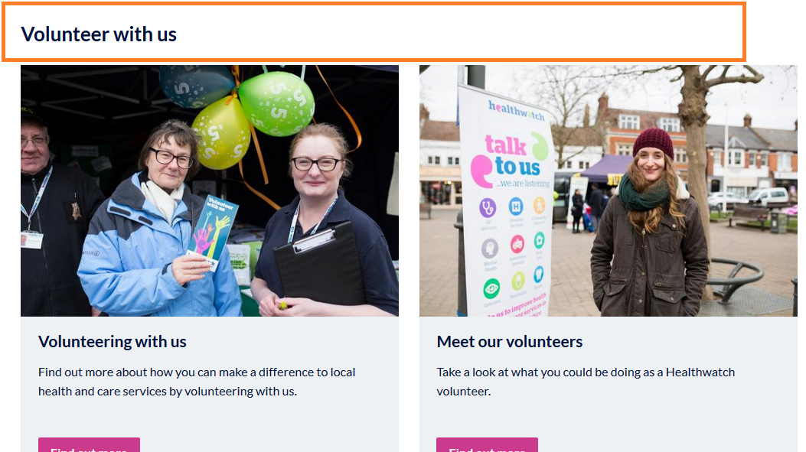

Impact stats
Impact stats are a great way of pulling out key figures. This is a good option when there is no other data to compare against to make a chart.

Creating full width impact stats
- StructureBlocks Add block
- Block title: You can leave this blank.
- Block description: Give a brief description of your block. This will be used on the block administration page, so make sure it’s something you can easily understand and recognise.
For example, Impact stat full width| Impact page| Volunteer numbers.
- Block body: In this box you can format your text however you would like. As all text will be made larger, we recommend you start with a number and then include some text afterwards. For example, “4,700 people gave up their time to volunteer with Healthwatch last year”.
- Region settings: Select where you want the block to appear.
- Bootstrap: ignore.
- Block theme Here you should select either ‘Impact stats – full width’ or ‘Impact stats – half width’. This will decide how far across the page the stats will show.
- Click ‘Save block’.
- Visibility settings: Here you’re choosing where you want this content to show. There are two options:
- All pages except those listed
- Only the listed pages

Tick ‘only the listed pages’ and then giving the node path of the page, where you want the quote to display.
When you save your impact stat, it will, by default be full width and span the page.

If you have two charts that you want to appear side by side, you need to edit both blocks in the blocks administration page, and change the ‘Custom theme’ to be ‘Two Columns’. This means that two charts can be shown side by side.
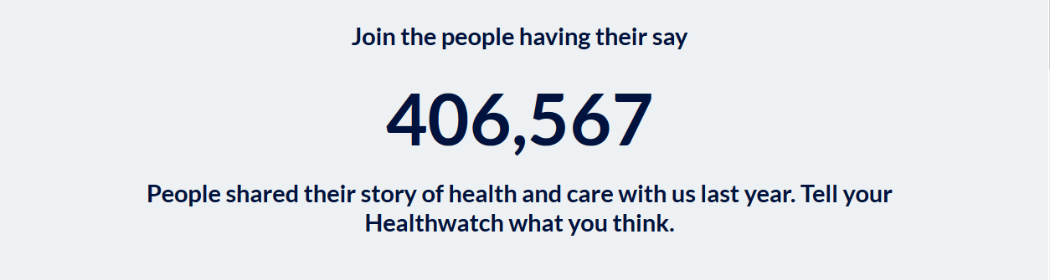

Creating half-width impact stats
To create impact stats that go half way across the page, follow the same process as previously, but select the theme ‘Impact Stats’ – half width.
As with the two column blocks, you should create two half width stats to balance the page properly, like in the example below.
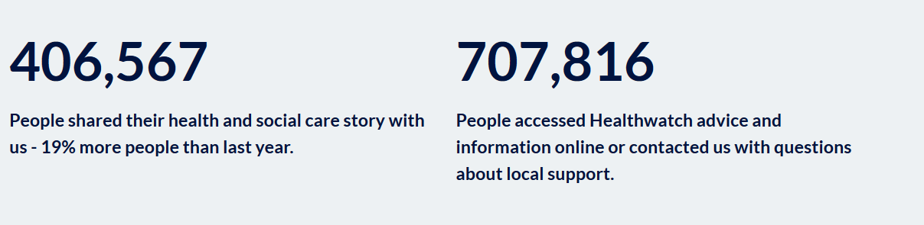

Quote
Quotes are a great way of highlighting people’s voices and experiences in your work. These quotes should be short and have impact.

Creating a quote block
- StructureBlocks Add block
- Block title: You can leave this blank.
- Block description: Give a brief description of your block. This will be used on the block administration page, so make sure it’s something you can easily understand and recognise.
For example, Quote | Volunteer page
- Block body:
- Add your text and use the quote button 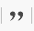 to format the text that you want to include as the quote.
- To include the author of the quote, write the name underneath the quote, highlight the text and then select ‘quote author’ underneath the ‘Styles’ tab.
- 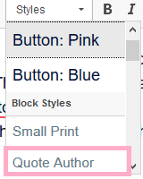
- This is what your quote would look like in edit view:
- 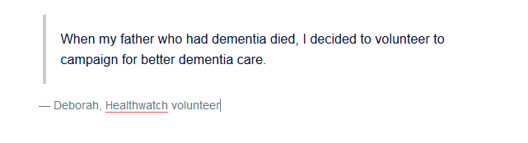
- This is what your quote would look like in publish view:
- 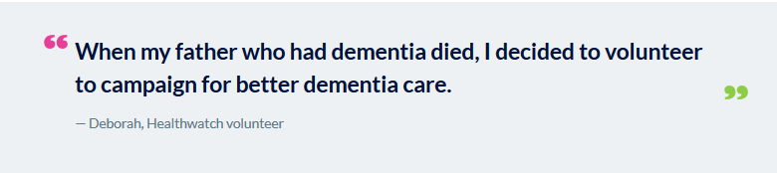
- Region settings: Select where you want the block to appear.
- Bootstrap: ignore.
- Block theme Here you should select ‘Quote’ as the custom theme.
- Visibility settings: Here you’re choosing where you want this content to show. There are two options:
- All pages except those listed
- Only the listed pages

Tick ‘only the listed pages’ and then giving the node path of the page, where you want the quote to display.
- Click ‘Save block’.

Video block types
Video block types
- - None –
- Text with image left
- Text with image right
- Full width
- Two columns
- Grey block
Creating a video block
Structure Blocks Add block
- Block title
If you would like a title to be displayed above your video block, enter this here. You can choose to leave this section blank.
- Block description
Please place a brief description of your block here. This will be used on the blocks administration page so needs to be clear enough to find again should you need to edit later.
- Block body
Here you will need to embed the video by clicking on this symbol.
You will need to copy the embed code in here.
Underneath, you can write some information about the video, or the article that it leads to. Remember, not everyone will watch the video in full, this is extremely unlikely. Provide some context about the video and the information it refers to and link it through to a fuller page or article for people to find out more.
- CSS class(es)
Leave this blank
- Region settings
Select the region based on where you want the block to appear in the same way that you do for all other blocks.
When selecting an appropriate region for your video block, where it sits on the page, you will only be able to select places where the main content appears. These regions include:
- Content top
- Content (white)
- Content bottom
- Row 1 (grey)
- Row 2 (white)
- Row 3 (grey)
- Row 4 (white)
- Row 5 (grey)

- Bootstrap
Leave as – none –
- Custom theme
Select how you want the block to appear based on the options provided above.
- Custom block variables
Leave blank
- Show block on specific pages.
Enter the node of the page that you would like the block to appear.
- Click ‘Save block’

Image block types
Image block types are set up in a similar way to the other blocks.
When going to create an image block, it looks like there are lots of different image size options, there are only a few that you need to consider for blocks.
These are:
- Hero-banner image
- Grid_image_50
- Grid_image_33
The rest are sizes used elsewhere on the site, that we’re unable to hide from view.
There is also a little quirk in Drupal that means each time you create an image block and save it, you’ll need to go back into that block and select the block theme to make it display properly.
Two key steps for creating an image block is:
- Creating the image block (setting the block up)
- Assigning the theme (choosing the image style)

Hero Banners (image/video)
Example hero banner (video image)
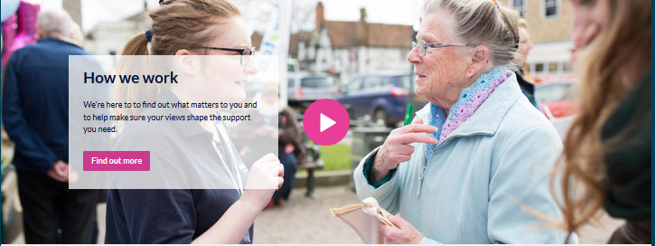
Example of Hero Banner on a page
Hero Banners are a great way to make your page more visually engaging through adding imagery and a clear call to action at the top or bottom of the page.

There are four different variations of the Hero Banner, two which have a simple image and text, and two which also puts a ‘play’ icon on top of the image, to indicate it’s going to play a video.

- Hero banner (text left)
- Hero banner (text right)
- Hero banner video (text left)
- Hero banner video (text right)
There are options for the text to appear on the left or the right. Try each one to see looks better on the image that you’re using. You want people to be able to read the text easily, so opt to have the text on the clearest part of the image without a busy background.

Creating a hero banner
- StructureBlocks Add Image block
- Block title: You can leave this blank
- Block description: Give a brief description of your block. This will be used on the block administration page, so make sure it’s something you can easily understand and recognise.
For example, Block type| Page – Hero Banner – Impact page
- Image: As this is a large image, it needs to be a high-quality image that is suitable for landscape. You may need to crop it before uploading if you’re using a portrait image to select the area you want to focus in on. Either upload a new image or select one from your photo library.
- Image style: Hero_banner_image
- Alternate text: Make sure you include Alt text to describe the image. This will be read aloud by screen readers and so must do this to ensure you’re being accessible.
- Title: It’s best practice to include similar text here as the Alt text. This way, if the image doesn’t load for any reason, people will know what the image is meant to be.
- Link: You can make the whole banner editable by adding a link.
- Link target: This can stay at ‘self’.
- Block body: This space is where you are explaining what you want people to do on that page. It should have a title (H2) and then a short blurb about the subject of the page or what it is you want them to do on the page. Depending on the action you want them to take, you may also want to include an action button here.
- Region settings: Depending on whether you want the hero banner to appear at the top or the bottom, you should select Hero banner or Hero banner footer.
- Bootstrap: ignore.
- Visibility settings: Here you’re choosing where you want this content to show. There are two options. Tick ‘only the listed pages’ and then giving the node path of the page, where you want the block to display.
- Click ‘Save block’.
- Once you have saved the block you need to go back into the block administration page (Structure –Blocks) and:
- Find the block you just created and click ‘configure’.
- Scroll down to the bottom of the page where it says ‘Block Theme’. Here you can pick one of the variations explained above:
- Click ‘Save block’.

Text with image right/left
Example showing both options of image left and image right
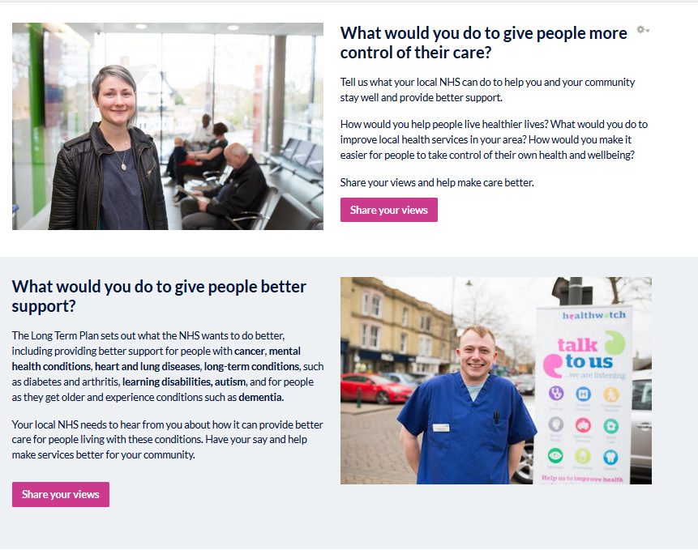

Creating an image left/right block
- StructureBlocks Add Image block
- Block title: You can leave this blank.
- Block description: Give a brief description of your block. This will be used on the block administration page, so make sure it’s something you can easily understand and recognise.
For example, Block type| Page – Image right block Have your say page Main item
- Image: As this is a large image, it needs to be a high-quality image that is suitable for landscape. You may need to crop it before uploading if you’re using a portrait image to select the area you want to focus in on. Either upload a new image or select one from your photo library.
- Image style: grid_image_50.
- Alternate text: Make sure you include Alt text to describe the image. This will be read aloud by screen readers and so must do this to ensure you’re being accessible.
- Title: It’s best practice to include similar text here as the Alt text. This way, if the image doesn’t load for any reason, people will know what the image is meant to be.
- Link: You can make the whole image editable by adding a link.
- Link target: This can stay at ‘self’.
- Block body: Start with a title, then include a few short sentences underneath, followed by an action button. The copy looks best if it’s short and sweet so that it is around the same length as the image.
- Region settings: Select where you want the block to appear.
- Bootstrap: ignore
- Visibility settings: Here you’re choosing where you want this content to show. There are two options. Tick ‘only the listed pages’ and then give the node path of the page, where you want the block to display.
- Click ‘Save block’.
- Once you have saved the block you need to:
- Go back into the block administration page (Structure –Blocks)
- Find the block you just created and click ‘configure’.
- Scroll down to the bottom of the page where it says ‘Block Theme’. Here you can pick either text image left or text image right, depending on what you prefer.

Two columns
Using two columns is a great way to highlight different content on one page.

Creating a two column image block

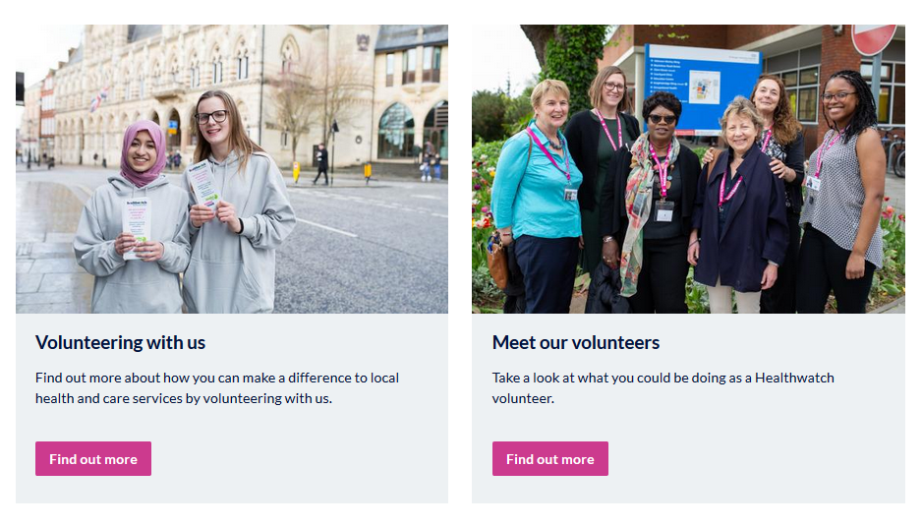
- StructureBlocks Add Image block.
- Block title: You can leave this blank.
- Block description: Give a brief description of your block. This will be used on the block administration page, so make sure it’s something you can easily understand and recognise.
For example, Two column box 1 | Volunteer page | Volunteer info
- Image: As this is a large image, it needs to be a high-quality image that is suitable for landscape. You may need to crop it before uploading if you’re using a portrait image to select the area you want to focus in on. Either upload a new image or select one from your photo library.
- Image style: grid_image_50.
- Alternate text: Make sure you include Alt text to describe the image. This will be read aloud by screen readers and so must do this to ensure you’re being accessible.
- Title: It’s best practice to include similar text here as the Alt text. This way, if the image doesn’t load for any reason, people will know what the image is meant to be.
- Link: You can make the whole image editable by adding a link.
- Link target: This can stay at ‘self’.
- Block body: If you have linked the image, you don’t necessarily need text underneath. However, we recommend that you include a title, and a short sentence underneath, making it clear to the reader what action they should be taking.
- Region settings: Select where you want the block to appear.
- Bootstrap: ignore.
- Visibility settings: Here you’re choosing where you want this content to show. There are two options. Tick ‘only the listed pages’ and then giving the node path of the page, where you want the block to display.
- Click ‘Save block’.
- Once you have saved the block you need to:
- Go back into the block administration page (Structure –Blocks)
- Find the block you just created and click ‘configure’.
- Scroll down to the bottom of the page where it says ‘Block Theme’. Here, select ‘Two columns’.
- It is important to create two of these blocks, to avoid your page looking lopsided.

Charts
Charts and impact stats are a great way of showing your impact or findings from your work in a visually engaging way. A good example of where you may want to do this if you created a page with the highlights from your annual report, or somewhere on your ‘About us’ section.

Charts and impact stats can only be used on a page content type, so you cannot add these to an article content type. Make sure that you have considered where your chart will appear on the page before starting.

Create a chart
To create a chart, you need to do two things.

- Create the chart data
- Create a chart block and choose how and where you want the data to be displayed

Step 1 Creating the chart data

- Content → Add content → Chart

Edit the fields below:
- Title: This is the title of your chart data. Name this something simple and referring to what the data is about.
- Data: Here you’re adding the data you want to be included in your chart. You need to add the value and then attach a label to that value. To add more bits of data click ‘add other item’.
- Find out more link: You might want the chart to link through to a news article or report where someone could find more information. Here you’ll need to complete the Title and URL fields to make this work.
- Revision information: This is only relevant if you’re making changes to an existing chart and you want to document what changes you’re making.
- URL pathway settings: You don’t need to change this.
- Meta tags: The meta tags are already pre-populated.
- Authoring information: This is generated automatically when you save. It will show you who added the content and when.
- Publishing information:
- Published - this needs to be selected for you to create your chart. If you do not publish this, it will not work when you try to create the chart block.
- Promoted to front page - doesn’t need to be selected.
- Sticky at top of lists - doesn’t need to be selected.

Step 2 - Creating the chart block
Structure → blocks → add chart block

- Block title: What you put in this field will display on the page. This isn’t mandatory, but it’s best to put a title to make it clear what the data is showing.
- Block description: This title will be used on the Blocks administration page. Name this something obvious like ‘CHART - Page name - chart title’ This will help you when managing your blocks.
- Chart data source: This dropdown should show you the chart information you’ve just created.
- Chart display type: Pick from the dropdown how you would like your chart to appear. We have illustrated how they will appear below. The best way of displaying your data will depend on the type and amount of data you have included.

Chart types
- Pie chart
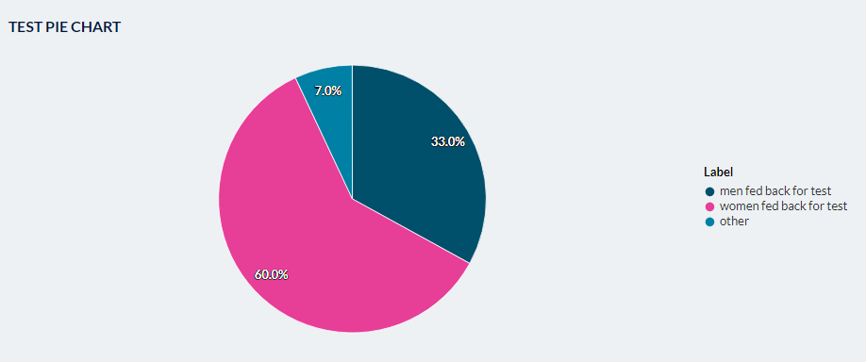
- Bar chart
- 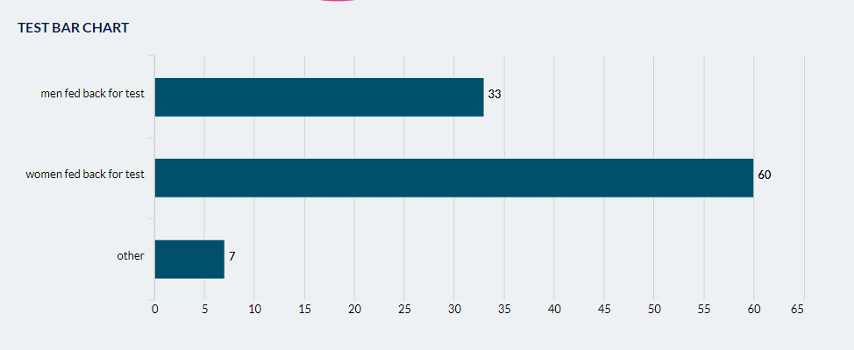
- Column
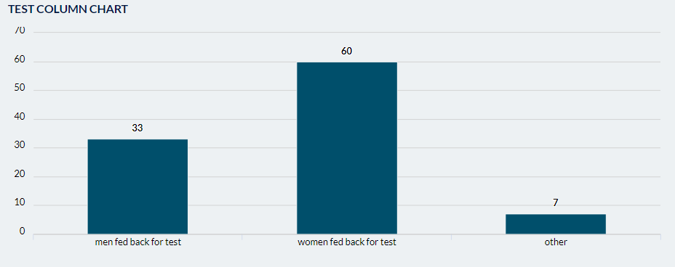
Line chart
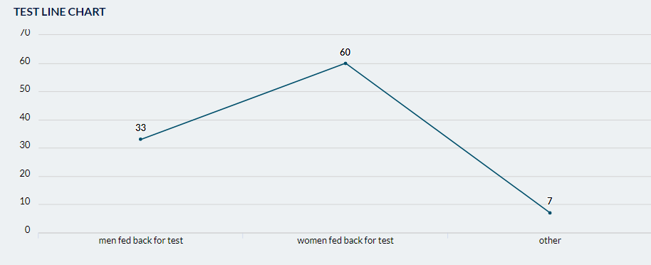
Scatter chart
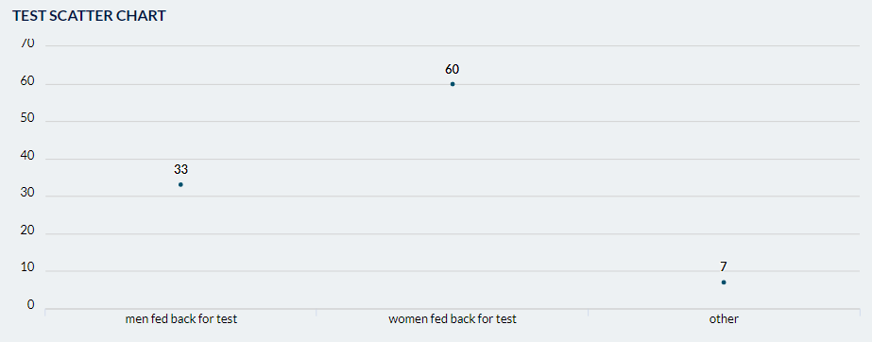
- Area chart
- 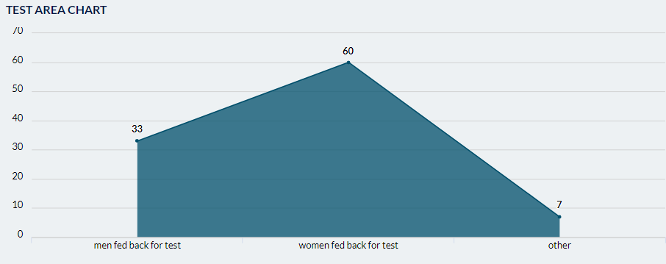
- Region type: Choose where on the page you’d like this to appear. If you’re not sure of the regions, refer to the region help.
- Bootstrap: Ignore.
- Visibility settings: Here you’re choosing where you want this content to show. There are two options:
- All pages except those listed
- Only the listed pages

Tick ‘only the listed pages’ and then giving the node path of the page, where you want the chart to display.

Chart appearance
When you save your chart, it will, by default be full width and span the page.

If you have two charts that you want to appear side by side, you need to edit both blocks in the block administration page, and change the ‘Custom theme’ to be ‘Two Columns’. This means that two charts can be shown side by side.

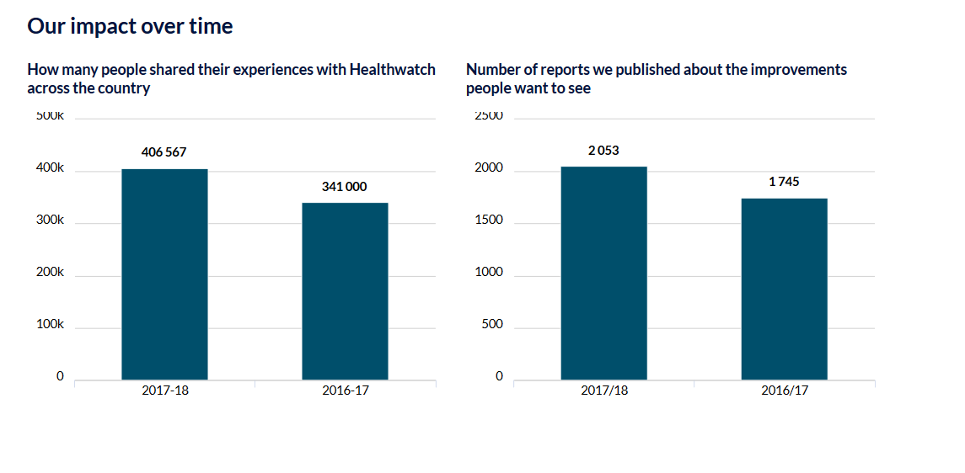

Got a question?
If you’re stuck or have a question, please email digital@healthwatch.co.uk
You should also join our Facebook Workplace website group, where you can talk to and get ideas from other local Healthwatch who are also using the new site.

