Partnering with GP Surgeries to use text message outreach
A how-to guide from Healthwatch Camden

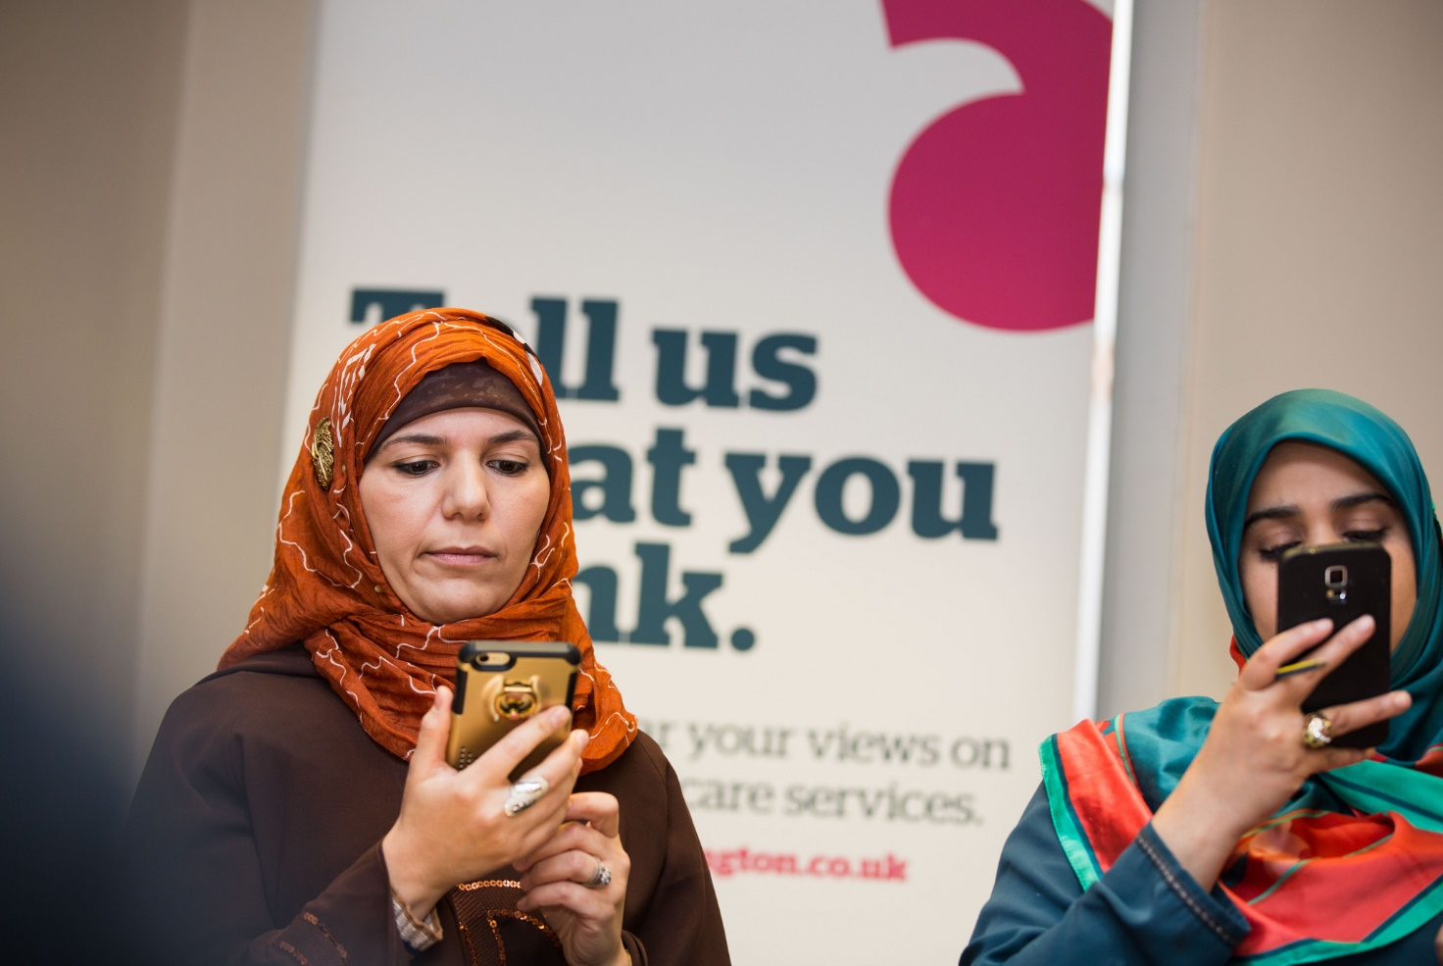

Contents
Introduction 3
When would this outreach method be appropriate? 3
The difference this approach can make 4
Value of the approach 4
Risks 4
Approach to Equality and Diversity 4
Case study: COVID-19 Survey 5
Costs and resources 6
Step-by-step guide 7
Top tips for success 8
GDPR considerations 9
Appendix 10
Example message to GP Practice Manager or other GP contact 10
Text message template example (less than 160 characters) 10
Example survey questions on the impact of COVID-19 on health and wellbeing 10

Introduction

In an ever-changing and fast-paced world, it is a challenge for local Healthwatch to get real-time insight from people. Often, insight gathering takes time and is at risk of becoming outdated if not analysed and published quickly enough. This is especially a challenge for small teams juggling different priorities.
For many, the COVID-19 pandemic accelerated the need for high-quality remote engagement strategies as face-to-face engagement was not possible.
Whilst these types of online or digital methods do not work for everyone, there are also many benefits, and their use will likely remain post COVID-19. As the world becomes increasingly digitised, it is important for Healthwatch teams to adapt to these changes and pioneer creative and forward-thinking ways to increase patient engagement.
For example, GP Surgeries send text messages to their patients for many reasons including appointment reminders, surgery closure announcements, patient surveys, and to share health information.
This guide from Healthwatch Camden explains in detail one digital engagement method: how to partner with GP surgeries and send an online survey through the existing GP text messaging system.

When would this outreach method be appropriate?
This checklist can help you decide if an online survey sent via text message by a GP surgery is the best method for your project.
☐ Is an online survey an appropriate engagement method for this topic?
(For example, a project trying to reach digitally excluded adults and/or a project trying to reach members of the homeless population who are not registered with a GP would not be appropriate topics for this outreach method).
☐ Is your research topic of interest to local GPs?
(GPs are more likely to partner with you if you can prove that the research topic is of importance and interest to local GPs).
☐ Does your topic impact a lot of people, or only a small amount of people?
(Your survey would be sent out to entire GP patient lists. If you are only trying to reach a small, specific population for example women under 35 or people with disabilities, then this method might not be appropriate).
☐ Are there any pre-requisites to participating in your survey, which will make a large proportion of the patient list ineligible?
(The survey will be sent to entire patient lists so there shouldn’t be age restrictions, ethnicity requirements, or any other conditional requirements that would make a large percentage of people ineligible).
☐ Do you need to gather rapid insight about a fast-changing subject?
(One strength of this method is that is collects rapid insight, which may or may not be necessary depending on your research topic. For example, if the research topic is about a long-standing issue, then this engagement method might not be appropriate).

The difference this approach can make

Value of the approach
- Speed: Gain rapid local insight when other engagement methods would not be possible or would take too long.
- Simplicity: Hear from residents remotely, without having to organise meeting spaces, transportation, or other face-to-face logistics.
- Volume: Reach large amounts of patients you otherwise would not be able to reach with smaller-scale methods (patient lists usually range from 2,000-10,000 and you should expect a 2-6% response rate).
- Diversity: Messages will reach diverse groups of people in terms of age, ethnicity, and existence of long-term conditions.
- Awareness: Connect with new residents who were previously unfamiliar with Healthwatch and spread awareness about the organisation.
- Relationships: Improve relationships with local GP surgeries and showcase the value of Healthwatch.
- Efficient: Cost-effective strategy (once partnership is set up, results come within minutes).

Risks
- Requires willing GP participation.
- Does not guarantee diverse response among those who complete the survey.
- Not everyone has access to a mobile phone / smart phone and so it will not reach digitally excluded people (weigh this risk based on project goals and objectives).
- This approach most likely has a financial cost to Healthwatch.

Approach to Equality and Diversity
This engagement method should be made as accessible as possible by taking these steps:
- Within the text message, include the link to your survey and your local Healthwatch phone number with the offer for people to call and complete the survey over the phone. This way, people can still participate if they have a mobile that is not a smart device and/or they don’t have a contract that allows them to use the internet.
- In most cases, this type of engagement method should be done in addition to other non-digital engagement methods to include those who are digitally excluded or those who might not be able to complete the survey online. This should be decided on a project-by-project basis depending on the topic and who you are trying to reach.
- This engagement method will be less accessible for non-English speakers. If reaching non-English speakers is a priority for your research topic, you should partner with local organisations or use other outreach methods to deliver the survey in other languages and enable participation from non-English speakers.
- For some projects it may be perfectly acceptable if your survey does not include everyone, you can still produce an insightful report. However, it is important to monitor who completed the survey and accurately report results. It will be important to include comprehensive demographic questions in the survey (see page 12 in Appendix for examples).

Case study: COVID-19 Survey

The COVID-19 pandemic presented an unprecedented challenge to all, including front-line practitioners and NHS staff.
The NHS closed their doors to all but the most urgent cases and concentrated efforts on responding to the COVID-19 crisis. Residents were confined to their homes and it prompted a substantial shift to remote access to work, education, and care.
In addition to the serious health risks of COVID-19, the pandemic was impacting people in many ways including their mental health, schooling and education, food, job security, and more.
Healthwatch Camden launched an online survey to hear from residents about the impacts of the COVID-19 pandemic on their health and wellbeing. To reach a large number of Camden residents, we partnered with four GP practices to send a survey link to patient lists via existing GP text messaging systems. Two out of the four GP surgeries covered the cost of the text message because of the perceived importance of the project.
This engagement method elicited an additional 908 responses to the survey. In addition, approximately 50 people called us to complete the survey over the phone after receiving the text message with our phone number.
This outreach method was appropriate for this topic because:
- The COVID-19 pandemic impacted everyone around the world.
- Other than being a Camden resident, there were no pre-requisites to participating in our survey (no age restrictions, ethnicity requirements, or any other conditional requirements). This meant that our survey was relevant to all GP patients.
- The topic of our survey was of interest to local GPs since the pandemic was novel and GP services were being severely impacted.
- The project was an online survey which included both qualitative and quantitative questions.
Quote from GP practice manager:
“We felt it was very important to give our patients an opportunity to have a voice and express their opinion of how they were coping in a major pandemic so that we could identify areas that needed improvement. It also formed part of our ongoing patient feedback process for example the patient survey, NHS GP survey, friends and family etc.
It was a great opportunity to work with Healthwatch and collaborate for the patients of Camden. We look forward to working with them again in the future.”
Healthwatch Camden’s final ‘Life in Lockdown’ report can be viewed on their website.

Costs and resources

An indication of the costs and staff time involved in this activity are outlined below.
Expenditure | Cost (£)
Funding for text message technology | £200-£300 per mass-text message (you will send one mass-text message per GP surgery). This will be paid either to the GP surgery directly or to the technology provider.  This price may vary. Some providers might charge you one lump sum, or some might charge per patient on the patient list (for example £0.025 per patient).  Some GP surgeries may offer to cover this charge for you, don’t be afraid to ask!
SurveyMonkey (or other survey provider) subscription  Many local Healthwatch already have a subscription to an online survey provider, so this engagement method will not incur additional cost. | Plans starting at £300 per year. Review plans for SurveyMonkey here.  (SurveyMonkey has a free option but only allows 10 questions per survey and 40 responses per survey, which would be insufficient for this method.)  There are other survey providers you can consider such as Google Forms, Smart Survey, Engagement HQ, and others.
Total | £500+ (depending on factors above)
Task | Staff hours
Introduction email to GPs and introduction meeting | One hour per GP surgery
Developing survey | Five hours (includes initial draft, editing, piloting and finalisation)
Admin (writing text message script, scheduling when the text with go out, liaising with GP digital provider, creating unique links, etc.) | Two hours
Survey analysis and write-up | 10 hours (depending on the project, number of questions in the survey, and amount of qualitative analysis required).
Total | 19+ hours

Step-by-step guide
Determine which GPs to reach out to and partner with
Develop online survey that is compatible with a smart phone
Develop project plan and decide if this engagement method is appropriate

- Map which GPs you already have good relationships with.
- Determine who at the GP surgery you already have good relations with.
- Choose GP surgeries with catchment areas that closely match your target audience (demographics, geographical area, etc.).
- It’s likely that the GP will use an external company to manage this technology.
- Pricing may vary based on patient list size and other factors.
- Ask if the GP surgery is willing to pay this cost.
- If not, confirm that the total cost is within your budget.
Work with your GP contact to determine total cost of the mass text message
- Weekend morning (before 11AM) works best.
- Send reminder email to GP on the day before text message is going out to make sure there are no issues.
- Keep it short and within the character limit (it costs more to have a longer message).
- Include your brand ‘Healthwatch _____’ in the message to gain trust and get more recognition.
- Include survey link and phone number. Offer option to call and complete the survey over the phone.
- Include the word ‘anonymous’ to build trust.
- Explain your project and its importance to GPs.
- Explain why the text message would be a successful method.
- Show the draft of the survey and ask for input/ offer to include additional questions of interest.
- If possible, create a unique survey link for each GP and offer a personalised mini- report at the end of the project with data from their patients.
- Use SurveyMonkey, or other online survey provider.
- Make sure survey responses will be anonymous.
- Pilot your survey and get feedback.
- Include comprehensive demographic questions.
- Is an online survey appropriate for your topic?
- Is the topic relevant to GPs?
- Is the topic relevant to most patients?

- Send mini reports to individual GP surgeries using only their survey responses (if possible).
- Include special thanks to GP surgeries in the final report.
- Use analysis tools in SurveyMonkey or other survey provider.
- Analyse qualitative data through theming.
- Pick out interesting quotes for the final report.
- Look at final report demographics to see if you need to do any further outreach.
Close survey about one week later and do analysis
Plan the date and time of your text message to go out
Write report(s)
Develop the text message script
Contact practice manager or other GP contact and set up a meeting to ask to use the text messaging

Top tips for success
- If possible, schedule text message to go out over the weekend (preferably Saturday) and in the morning (before 11 AM).
- Choose GP surgeries with diverse patient lists and/or patient catchment areas that best suit your project goals.
- Choose a familiar GP practice to partner with first (one that you already have good relations with). If you choose to partner with additional surgeries, you can then tell them that one GP has already committed to the partnership and others might be more willing to follow suit.
- Choose a familiar contact once you have decided which GP surgery to approach. This could be a practice manager, senior admin staff, GP partner, or PPG lead. Be flexible and follow the path of least resistance.
- Don’t be afraid to ask the GP surgery to cover the cost of the text message. If you can prove that the project is of value to local GPs, they might be willing in the name of good partnership.
- If the online survey tool allows, develop a unique survey link for each GP surgery (linked to the same survey). This way, you can track responses separately and create mini GP-specific reports once the survey has closed.
- Depending on the research question, decide if you want your survey to be mostly quantitative or qualitative. Qualitative research provides rich insight but is also more time consuming to analyse. Many online survey providers like SurveyMonkey do a lot of the quantitative analysis for you.
- Your point of contact in the GP surgery might not be an expert on the text messaging technology. It will be up to you to put them at ease that this engagement method will work and other Healthwatch have done it before.
- Make sure there is a blurb about what Healthwatch does at the beginning of your survey, and information on how to get in contact/stay involved at the end of the survey (a link to sign up for your newsletter works well). This will broaden your reach and help get the Healthwatch name out there.
- Keep the text message script short and succinct (this will make it easy for patients to read and costs less to send). Make sure to put your brand name ‘Healthwatch _______’ in the text message script so that you gain recognition.

GDPR considerations
Before taking part in this outreach method, the local Healthwatch team should confirm with GP surgeries that they adequately follow GDPR policies and have previously obtained consent to store patient mobile phone data for text messaging purposes. This is standard protocol, but it will be important to check with the GPs.
Local Healthwatch should never ask for, or receive, patient information or data, including phone numbers. All contact with patients is done via the GP surgery, not by Healthwatch. Within the body of the text message, it will be essential to specify that completing this survey is optional, and all responses will be anonymous. Patients will then have the choice to either click on the link provided in the text message, call the phone number provided, or do nothing at all. There should be no follow-up text message or any consequence of ignoring the text and choosing not to participate in the survey.
Healthwatch should make sure that the survey settings are set up for anonymous responses, and no IP addresses or other personal information should be stored in the online survey provider. Additionally, all survey questions should be optional (except for the consent question). There should be a mandatory privacy statement at the beginning of the survey which gains consent before the individual can continue. This should outline how data is safely stored on password protected Healthwatch systems and will only be shared with the health and care system after it is aggregated. Only those who tick ‘yes’ to the consent statement will be allowed to carry on with the rest of the survey.
Below is an example of a privacy statement to gain consent before online surveys.
Healthwatch ______ would like to hear from you about [purpose of survey].
Healthwatch ______ amplifies the views and experiences of local people in order to influence health and social care services.
Anything you share with us is anonymous. The information will be stored on [online survey provider name] and is password protected. This data will also be downloaded and safely stored by Healthwatch ______.
Your responses will be anonymous and aggregated results will be reported to local health and social care decision makers to help improve communications and health services in _________. Results from this survey will also be published on our website.
All questions are optional, and you may stop the survey at any time. The survey should take you about ____ minutes to complete.
*Q1. I consent to Healthwatch ________ using my data as stated above.
Yes ☐
No ☐

Appendix

Example message to GP Practice Manager or other GP contact
Dear [insert name here],
Healthwatch [ ] is planning to do a project looking at [put purpose of project here]. We are developing an online survey to gain local insight and experience around this topic. A draft of the question set we are intending to ask is attached for your review.
This is a topic of importance to local people because [ ]. We believe this is relevant to local GP surgeries because [ ].
We are hoping to get your support on this project by helping us reach your patients so that their experiences can be included. We want our research to be as representative and useful as possible.
One option for this would be to send our online survey through your text messaging system, as successfully done previously by other local Healthwatch. After data collection, we would be able to provide your surgery with a mini report which included only responses from your patients, as well as the full comprehensive report at a later date.
Would you be willing to have a brief phone call or meeting to discuss this further?
Thank you,
[Your name and sign-off here].

Text message template example (less than 160 characters)

Please tell Healthwatch [ ] how COVID-19 is impacting your wellbeing. Click on www.PUTYOURSURVEYLINKHERE or call PUTYOURPHONENUMBERHERE.

Example survey questions on the impact of COVID-19 on health and wellbeing

Healthwatch [_________] would like to hear how you have been able to access COVID-19 information and guidance.

Q1. Where do you get information about COVID-19, changing government guidelines, and how to stay well? [check all that apply]

☐Television
☐ National or Local Newspaper
☐ Friends, family, neighbours
☐ Radio
☐ Twitter (Social Media)
☐ Instagram (Social Media)
☐ Facebook (Social Media)
☐ WhatsApp groups
☐ Online (websites)
☐ By post
☐ National Government
☐ Local Council
☐ Faith-based group
☐ Local voluntary organisations

Q2. Have you used a health and/or care service since the COVID-19 outbreak (including digital / online services)?
☐ Yes
☐ No
☐ I can’t recall

Q3. If you haven't used a health and/or care service, why not?

☐ Did not need to
☐ Services were closed
☐ My appointments were cancelled
☐ Felt my needs could wait / weren't a priority
☐ Didn't know how to access health or care services
☐ Not comfortable with online / telephone offer
☐ Fear of contracting virus outside my home
☐ Other

Q4. If you have used a health or care service since COVID-19 (including online or digital services, tell us about your experience with this service.)
For example:
- If it switched to online/telephone, how did this work for you?
- Was it a worse or better experience than before COVID-19?
- How did the service help support your health or wellbeing?

Q5. What concerns you most about the COVID-19 outbreak? [Please select all that apply]

☐ I don’t have any concerns
☐ Access to food and essentials e.g. not able to shop for food/ essentials online or in-person
☐ Access to medications
☐ Fear of contracting the virus
☐ Feeling bored
☐ Feeling lonely or isolated
☐ Feeling worried about the future
☐ Finding working from home difficult
☐ Household or personal finances
☐ Job security
☐ Life events being affected e.g. weddings and funerals
☐ My education or my children’s education
☐ Maintaining my physical health
☐ Strain on caring responsibilities
☐ Strain on personal and/or work relationships
☐ The health and wellbeing of loved ones
☐ I am unable to make plans

Example demographic questions (make these optional and customise based on research topic)

Healthwatch [_________] would like to know a little bit more about you.

Q1. How old are you?

☐ Under 18
☐ 18-24
☐ 25-34
☐ 35-44
☐ 45-54
☐ 55-64
☐ 65-74
☐ 75+

☐ I’d prefer not to say

Q2. Is English your first language?

☐ Yes
☐ No
☐ I’d prefer not to say

Q3. Please select your ethnic background from the dropdown list:

☐Arab
☐ Asian / Asian British: Bangladeshi
☐ Asian / Asian British: Chinese
☐ Asian / Asian British: Indian
☐ Asian / Asian British: Pakistani
☐ Asian / Asian British: Japanese
☐ Any other Asian / Asian British background
☐ Black / Black British: African
☐ Black / Black British: Somali
☐ Black / Black British: Caribbean
☐ Any other Black / Black British background
☐ Gypsy, Roma or Traveller
☐ Mixed / Multiple ethnic groups: Asian and White
☐ Mixed / Multiple ethnic groups: Black African and White
☐ Mixed / Multiple ethnic groups: Black Caribbean and White
☐ Mixed / Multiple ethnic groups: Black African and Asian
☐ Mixed / Multiple ethnic groups: Black Caribbean and Asian
☐ Any other Mixed / Multiple ethnic background
☐ Polish
☐ White: British/English/Northern Irish/Scottish/Welsh
☐ White: Irish
☐ Any other White background
☐ I’d prefer not to say
☐ Other ethnic background (please specify: ____ )

Q4. Please tell us which gender you identify with:

☐ Female
☐ Male
☐ Transgender
☐ Non-binary
☐ Other
☐ I’d prefer not to say

Q5. Please tell us which sexual orientation you identify with:

☐ Bisexual
☐ Heterosexual/Straight
☐ Lesbian
☐ Gay
☐ Asexual
☐ I’d prefer not to say
☐ Other

Q6. Please tell us about your religion or beliefs:

☐ Buddhist
☐ Christian
☐ Hindu
☐ Jewish
☐ Muslim
☐ Sikh
☐ No religion
☐ Other
☐ I’d prefer not to say

