Enter and View training
Elfwood Park case study (classroom session)

As part of the yearly work programme, your Healthwatch has planned several Enter and View visits to local older people’s care homes. The reason for the visits is to find out what services and quality of care are being provided locally.
You are due to visit Elfwood Park, a large care home, at 10am this Friday.

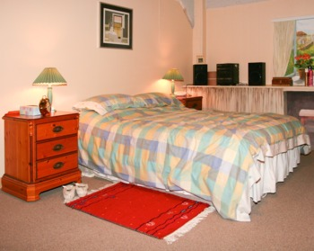 | The main building has 87 (single and double) rooms with private bathrooms, two shared lounges, five large, shared bathrooms, a dining room, and a conservatory.
 | Residents also have access to an onsite restaurant which is open to residents and the public every lunch time.
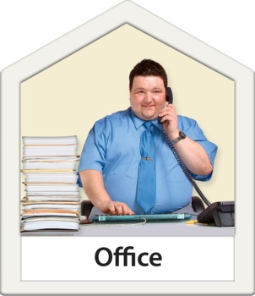 | There is a building for office workers and staff meetings.
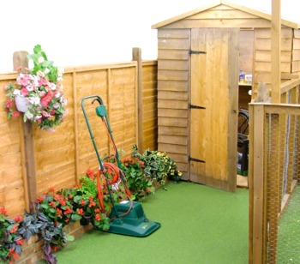 | There are several storage buildings and a shared garden which the residents enjoy.

