Enter and View training
Enter and View situations.
Think about what the issues are and what you should do in each situation.

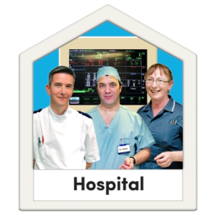 | You have arrived at your local hospital ready to do an Enter & View visit in the A&E department. Staff are very busy dealing with a major incident involving 50 people.  Do you:  - Carry on with the visit making sure that you don’t get in the way.  - Stop the visit.  - Ask if there’s anything you can do to help.
You and another Authorised Representative are trying to organise a visit to a local dental surgery next Wednesday.
The dentist closes at 1pm every Wednesday and the other Authorised Representative can only make an afternoon appointment.

What would you do?
You arrive at a residential care home, ready to begin a planned Enter & View visit with two other Authorised Representatives.
One of your colleagues has forgotten their ID badge but thinks that it’s not a problem as their name has already been given to the care home.

What would you do?
Your Healthwatch has received several concerns from visitors to a local children’s home about their poor communication with relatives.

What would you do?
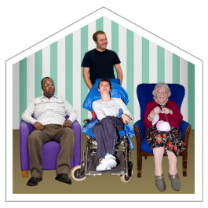 | You are due to visit a domiciliary care agency.  As part of your visit the manager tells you they have organised for you to go out on some home visits with one of their care workers as part of your Enter & View.  Do you:  - Go along without a second thought.  - Ask the manager to explain a little more about what the home visits will include.  - Check that the service users you will be meeting have agreed to you being there.  - Refuse to go.
You are visiting a care home. The staff are very helpful and offer to take you on a tour of the facilities.
They show you the dining room, shared lounge, kitchen, a resident’s room who is out at the time, the office and sleep-over room.
What would you do?

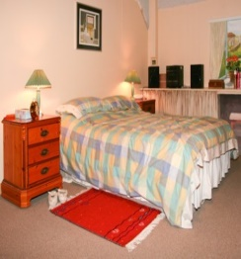 | You are visiting a care home and ask to talk to a service user.  The manager agrees and tells you to chat with them in their room while they get ready for bed.  What would you do?
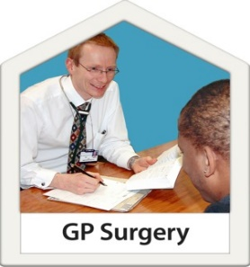 | You are due to visit a GP surgery that is being refurbished.  The surgery is open, but all GP appointments are being sent to another temporary building across the road.  What would you do?

