|  |  |
| --- | --- |
| P1031 HWE Brand project - Report template_V2_1.jpgData Sharing Platform Guidance | |
| Healthwatch-logo_RGB.png |

Contents

Contents 1

About this guidance 2

Saving your dataset in the correct format 2

Where to share your data 2

Sharing your data using an existing data pairing 3

Creating a new data pairing 5

Page 1: Mandatory fields 5

Page 2: Other Key Fields 8

Page 3: Additional Fields – Demographics 10

Page 4: Additional Fields – People 12

Page 5: Additional Fields – Feedback 12

Page 6: Preview your data 13

Saving your data pairing 13

If you are uploading data on behalf of multiple Healthwatch 13

Problems and solutions 14

DSP won’t allow a file to be selected or fails to map any elements of the file 14

You get an error message on the date field that not all the records have been matched 14

The match up your data screen doesn’t load the pairing 15

Getting an error message on submitting your data 16

What if I have any problems with uploading data in future? 17

About this guidance

[The law](https://www.legislation.gov.uk/ukpga/2007/28/section/221#:~:text=221Health%20services%20and%20social%20servicesF1...&text=(1)Each%20local%20authority%20must,carried%20on%20in%20the%20area.) requires Healthwatch to share their feedback and signposting data with Healthwatch England.

This is a step-by-step guide to complying with this statutory duty by uploading and mapping your feedback and signposting data to the Healthwatch England data sharing platform.

This guidance assumes that Healthwatch England has set you up to use the data sharing platform. If you need access to it, please email datasharing@healthwatch.co.uk.

Saving your dataset in the correct format

You must save your feedback and signposting dataset **as a CSV UTF-8 file**. Open your dataset in the Excel desktop app. **Click File > Save a Copy**. Under the file name, change the file format to **CSV UTF-8 and click save**.

Where to share your data

Link to the live data sharing platform: [sharing.healthwatch.co.uk](https://sharing.healthwatch.co.uk/)

After logging into the platform, you should see your Healthwatch name and a ‘Submit your data’ button. Click this button

**Note:** If you upload data on behalf of more than one Healthwatch, the other Healthwatch will be in the drop-down list. Choose the correct Healthwatch name for the dataset you are uploading before moving to the next page. Unless previously agreed upon in your meeting where you uploaded to the live site for the first time, you must upload datasets from each Healthwatch separately. If you have a question about this, please email datasharing@healthwatch.co.uk.

On the next page, **click the white box to upload your dataset from your computer files**. The platform will automatically redirect you to the next page.

Sharing your data using an existing data pairing

Before uploading the new dataset, **please make sure that**:

* You’ve used the same report from your CRM/database with the same fields you’ve already mapped
* You ensure that the name of the csv file is **different from the first file you uploaded**

Click **‘Use existing data pairing’** on the right side. In the drop-down that appears, you should see the **name of the pairing you saved at the end of the first upload**. Select that.

If you scroll down, the **fields will auto-populate with the mapping you created during the first upload**. The date field should already have the correct format **selected. Look under the date field for the green bar that states all your records have been matched**.

For every upload from this point forward, the **only changes** you will need to make are related to the three tabs – **‘Require Manual Matching’, ‘Suggested Matches’, and 'Automatically matched'** – that appear under many fields (e.g., services).

Scroll to the ‘Services’ field and click on one of the three tabs. You will see a **green check mark on the right-hand side** of each item in that tab. Those were all mapped during your first upload. You need **to scroll to the bottom of the list** **under each tab**. Anything new to the dataset will have an **orange question mark or a red X** rather than a green check mark.

You need to **check if those are correct and fix the mapping (if necessary**).

**Repeat this for every field you mapped on the first upload with these three tabs** (e.g., age, gender, ethnicity, disability, etc.). You do not need to follow this step for any fields for which you do not collect data. You can still ignore these fields entirely and scroll past them.

After submitting your data, **save the mapping** to ensure you capture any changes. You can save the mapping under the same name or with a new name.

Creating a new data pairing

If you need to create a new data pairing, for example, if your Healthwatch is using a new CRM system or you’re collecting new types of data, you need to create a new data pairing.

Log in and upload your data normally. At the **Match up your data** screen, choose **Create new data pairing.**

Page 1: Mandatory fields

Date information collected by local Healthwatch

This first field relates to the **date you received the feedback or enquiry**. You can find a drop-down list on the right-hand side underneath ‘Suggested match in file’. The drop-down contains every column heading in Row 1 of your uploaded dataset. You must **choose the column heading related to the date information from the drop-down**. This tells the platform which column contains the desired data (Date information collected by local Healthwatch).

Just below, there is another drop-down list labelled **‘Data formatting’**. This drop-down has options for formatting the date in your uploaded dataset. **Choose the option that exactly matches the date format in your dataset**. The first screenshot on the next page shows all possible types of date formats (e.g., DD-MM-YYYY or DD/MM/YYYY). You may need to open your dataset in Excel to check. Once you have chosen the date format, the **bar below should** A screenshot of a computer
**upload”**.

**Note:** If the bar is **red with an ‘X’, you have chosen the incorrect date format**. You should, therefore, recheck your dataset. If the bar is orange/yellow and says some of the records have been matched, see the FAQs at the end of this guidance, as there may be a couple of different reasons for this.

Once you have a green bar, scroll down to the following field.

Feedback

This field relates to the **details of the feedback or enquiry received**. This field is crucial as we analyse the feedback details for key themes and issues from the entire network to identify new and continuing health and social care challenges.

The data in this column of your uploaded dataset should ideally be **anonymised** before uploading the dataset. Like the steps for the date field, on the right-hand side underneath **‘Suggested match in file’**, there is a drop-down list. You must **choose the column heading related to the feedback/enquiry details from the drop-down menu.**

If the **correct column heading is already displayed** for all fields on the platform, you **do not need to do anything**, even if the field is still orange rather than green. After you choose the correct column heading from the drop-down (if necessary), you can scroll down to the next field.

Services

This field collects information about the **service categories mentioned in the feedback or enquiry** (e.g., GP, dentist, community mental health, etc). If you have multiple columns in your uploaded dataset for service types (note: this is not the field for the name of the service provider or hospital), **you can map all relevant columns to this field.**

Once you choose all relevant column headings, scroll down to the **‘Data formatting’** drop-down. From this drop-down, you should **select how individual services in the same cell on your dataset are separated**. For example, if someone provides feedback about GPs and A&E, how is that represented in your uploaded dataset? In the services column, would that row of data say “GP, A&E”, “GP; A&E”, or “GP| A&E”. For most people, the ‘Data formatting’ can be left as ‘Comma separated’. Note: the **IMP system is ‘Pipe separated’.**

Below the data formatting are **three tabs – ‘Require Manual Matching’, ‘Suggested Matched’, and ‘Automatically matched’**. In each of these three tabs, the services listed on the left-hand side are the services in that column of your uploaded dataset (i.e., these are the service categories you received feedback or an enquiry about). Next to each service, there is a drop-down. This drop-down contains all the service categories outlined in the [Healthwatch England taxonomy](https://network.healthwatch.co.uk/guidance/2022-06-27/new-taxonomy).

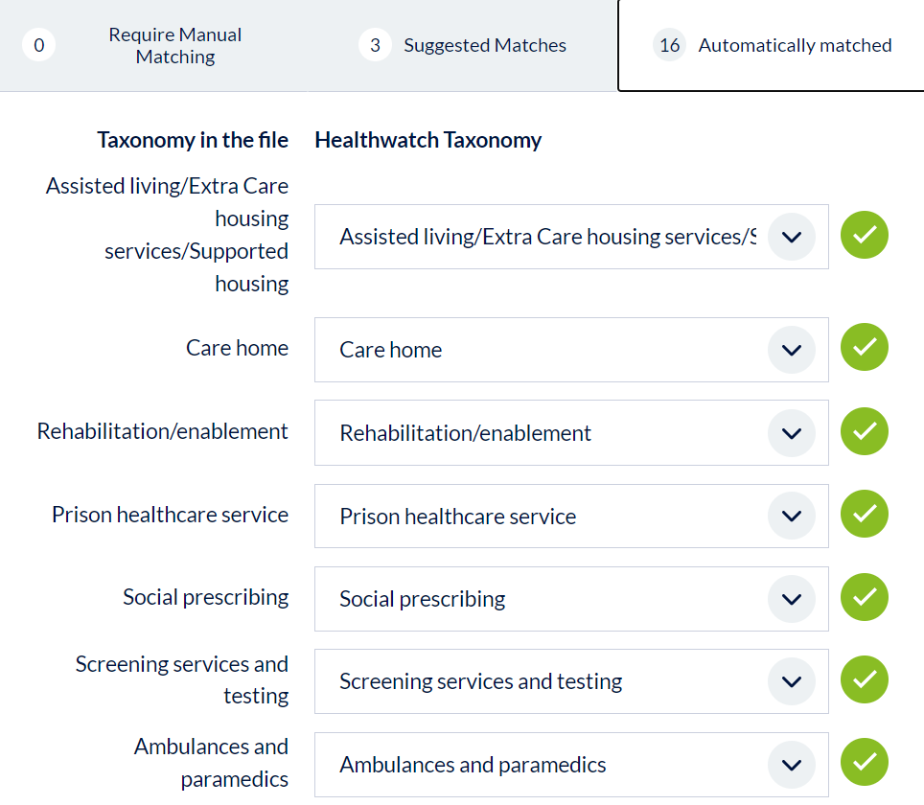

You need to **go through the list underneath each tab and match the services in your dataset to the best match in the taxonomy.** If the suggested match in the drop-down is correct, you do not need to do anything; continue to move down the list.

Once you have gone through all three tabs and mapped the services, making changes when necessary, you can **continue to Other Key Fields** by pressing the green button at the bottom of the page.

Page 2: Other Key Fields

The three fields on Page 1 (Date, Feedback, and Services) are mandatory to upload the document. Please share all other fields on Page 2 onwards if you collect this data. If you do not collect this data, you can ignore the field and scroll past it. However, it is critical to collect demographic data as it allows us to identify groups disproportionately affected by worse health experiences. More details are below.

Summary

This field maps to the column in your dataset **summarising the feedback detail** (the field mapped on Page 1). After choosing the correct column heading from the drop-down (the same step as each field on page one), **click the ‘Add’ button below**. Clicking this button adds the field to the saved mapping.

**Click the' Add' button** underneath each field for every field you have in your uploaded dataset. You can scroll past any fields you do not collect. You do not need to choose a column heading and do not click the 'Add' button. **Ignore the field entirely**.

Age

This field collects **age demographic information**. Like the steps of the other fields, **choose the relevant column heading** (if you collect age information) from the drop-down under ‘Suggested match in file’. Below this, you will see the same **three tabs – ‘Require Manual Matching’, ‘Suggested Matched’, and ‘Automatically matched’**. Click on each of the three tabs. On the left side, you will see the age groups in that column of your uploaded dataset. **Following the same steps as the 'Services' field, match each age group to the Healthwatch England taxonomy** using the drop-downs. Be sure to go through the list under all three tabs. Then click the ‘Add’ button below to add this to the saved mapping (if you collect this data).

You will follow these steps for every field moving forward.

Gender

This field matches the **column that contains data about gender categories**. Follow the same steps as the ‘Age’ field.

Ethnicity

This field matches the **column that contains data about ethnicity categories**. Follow the same steps as the ‘Age’ field.

Disability

This is the **first of two disability fields** in the Healthwatch England taxonomy. We will map the second field on Page 3 of the platform. This first field is ‘**Yes/No/Prefer not to say/Don’t know’**. **If you only have one disability field** in your dataset and **it includes more detail** than ‘Yes/No’, that will map to the second field on the next page, and **you can ignore this one**. If you have a column in your uploaded dataset that matches this, choose the correct column heading and follow the same steps as the 'Age' field for the mapping.

Long-term conditions

This is the **first of two long-term condition fields** in the Healthwatch England taxonomy. We will map the second field on Page 3 of the platform. This first field is ‘**Yes/No/Prefer not to say/Don’t know’**. **If you only have one long-term condition** **field** in your dataset and **it includes more detail** than ‘Yes/No’, that will map to the second field on the next page, and **you can ignore this one**. If you have a column in your uploaded dataset that matches this, choose the correct column heading and follow the same steps as the ‘Age’ field for the mapping.

Organisation that the feedback is about

This field matches the **column containing the service provider's name** (e.g., name of the GP, hospital, etc.). Under the **‘Data formatting’**, choose the correct option. Follow the same steps as the ‘Age’ field to select the correct column heading. Note: there are no tabs under this field. You need to choose the correct column heading and click 'Add'.

Sentiment of the information

This field matches the **column containing data about the feedback's overall sentiment** (e.g., positive, negative, mixed, neutral). This field is helpful for us because we can use it to quickly determine the proportion of positive or negative data about a particular service area. This allows us to monitor trends, for example, whether there is an increase in negative feedback about GPs. Follow the same steps as the ‘Age’ field.

Themes

This field relates to the **themes of the feedback/enquiry** (e.g., the attitude of staff, accessibility, etc.). As with the previous fields, choose the corresponding column heading in your uploaded dataset (if you have this information). Under the **‘Data formatting’**, choose the correct option. Under the three tabs, **match the themes in your data to the closest match in the Healthwatch England taxonomy**, just as you have been doing. Click the 'Add' button underneath (only if you collect this data).

Continue to Additional Fields – Demographics.

Page 3: Additional Fields – Demographics

The fields on this page are optional. If you do not collect this data, you can ignore the field and scroll past it. Be sure you do not click the 'Add' button under any field not included in your uploaded dataset.

Is the person's gender identity the same as recorded at birth?

This field matches the column that contains data about whether gender identity is the same as recorded at birth. Follow the same steps as the previous fields.

Sexual Orientation

This field matches the **column that contains data about sexual orientation**. Follow the same steps as the previous fields.

Disability (part 2)

This is the **second of the two disability fields** in the Healthwatch England taxonomy. We mapped the first field on Page 2 of the platform. This second field is more detailed. If the person answered ‘yes’ to the first field, **this is where they provide more information (e.g., long-term condition, mental health condition, etc.).** **If you only have one disability field** in your dataset and **you mapped it on the previous page**, **you can ignore this one**. If you have a column in your uploaded dataset that matches this, choose the correct column heading and follow the same steps as the 'Age' field for the mapping.

Under the **‘Data formatting’**, choose the correct option. This is most likely the **same as** what you chose for the **‘Services’ field**.

Long-term condition (part 2)

This is the **second of the two long-term condition fields** in the Healthwatch England taxonomy. We mapped the first field on Page 2 of the platform. This second field is more detailed. If the person answered 'yes' to the first field, **this is where they provide more information (e.g., learning disability, cancer, etc.).** **If you only have one long-term condition field** in your dataset and **mapped it on the previous page**, **you can ignore** it. If you have a column in your uploaded dataset that matches this, choose the correct column heading and follow the same steps as the 'Age' field for the mapping.

Under the **‘Data formatting’**, choose the correct option. This is most likely the **same as** what you chose for the **‘Services’ field**.

Religion or belief

This field matches the **column that contains data about religion or belief**. Follow the same steps as the previous fields.

Marital and civil partnership status

This field matches the **column containing marital or civil partnership status** data. Follow the same steps as the previous fields.

Pregnancy and maternity

This field matches the **column that contains data about pregnancy and maternity**. Follow the same steps as the previous fields.

Under the **‘Data formatting’**, choose the correct option. This is most likely the **same as** what you chose for the **‘Services’ field**.

Nationality

This field matches the **column that contains nationality data.** Note **this** **differs from the ethnicity field** matched on the previous page. There are no tabs under this field. You need to choose the correct column heading and click 'Add'.

Seldom heard

This field matches the **column that contains data about whether the person is from a seldom-heard group**. This field is just ‘Yes/No’. Follow the same steps as the previous fields.

Continue to Additional Fields – People.

Page 4: Additional Fields – People

The fields on this page are optional. If you do not collect this data, you can ignore the field and scroll past it. Be sure you do not click the 'Add' button under any field not included in your uploaded dataset.

Caller details

This field matches the **column that contains data about the relationship to the person giving the feedback/enquiry** (e.g., the person is enquiring for themselves, on behalf of a family member, etc.). Follow the same steps as the previous fields.

Indicate which key staff categories are included in the information

This field matches the **column that contains data about staff roles mentioned in the feedback/enquiry** (e.g., doctor, nurse, social worker, etc.). Follow the same steps as the previous fields.

Under the **‘Data formatting’**, choose the correct option. This is most likely the **same as** what you chose for the **‘Services’ field**.

Continue to Additional Fields – Feedback.

Page 5: Additional Fields – Feedback

The fields on this page are optional. If you do not collect this data, you can ignore the field and scroll past it. Be sure you do not click the 'Add' button under any field not included in your uploaded dataset.

Nature of enquiry/feedback

This field matches the **column that contains data about the nature of the feedback/enquiry** (e.g., compliment, concern, request for information, etc.). Follow the same steps as the previous fields.

Under the **‘Data formatting’**, choose the correct option. This is most likely the **same as** what you chose for the **‘Services’ field**.

Select feedback or information type

This field matches the **column that contains data about the source of the feedback/enquiry** (e.g., telephone, email, website, etc.). Follow the same steps as the previous fields.

Under the **‘Data formatting’**, choose the correct option. This is most likely the **same as** what you chose for the **‘Services’ field**.

Is this a safeguarding issue?

This field matches the **column that contains data about whether there is a safeguarding issue in the feedback/enquiry.** Note this is just a 'Yes/No' field, not detailed information. Follow the same steps as the previous fields.

Continue to Preview your data.

Page 6: Preview your data

This page lets you **preview the first 20 rows of your data** to check that the correct data is displayed underneath each column heading. For example, ensure the feedback /enquiry details are in the 'Feedback' column of the displayed chart. This is important because the **chart displayed on this page shows how the data is populated in the National Data Store**.

The chart displayed on this page **should look similar to your uploaded dataset**, with the wording now matching the Healthwatch England taxonomy rather than the taxonomy your Healthwatch uses (if different). If something looks incorrect, click the 'Update matching' link in pink just above the chart. This will take you back to the fields on the previous pages to make changes.

You **can also download your dataset at this stage**. Again, the data you download will be the same as your uploaded version, with the wording altered to match our taxonomy. Once you have checked over your data, click the ‘Submit data’ button.

Saving your data pairing

At this point, **your data has now been sent** to the National Data Store.

You should **click the option on the left, 'Save data pairing for future uploads’**. This will make all future uploads quicker and simpler. It is good practice to save the pairing every time.

If you **upload data on behalf of more than one Healthwatch**, be sure to **type all Healthwatch in your group** in the box with the Healthwatch name. This will save you from redoing this process in the first upload for the others.

**In the boxes, type a name and description for the pairing**. This does not need to be particularly specific. For example, you could name it the date of the upload or simply "Pairing 2023."

Click Save pairing.

You should be redirected to the home screen with your Healthwatch name and the ‘Submit your data’ button. Your **upload is now complete**. You can log out of the platform by clicking your name in the top right corner.

If you are uploading data on behalf of multiple Healthwatch

You’ll need to **upload separate .csv files for each Healthwatch**, selecting the appropriate Healthwatch name from the picklist to ensure that the data-sharing platform picks up the name of each Healthwatch. If you upload it in one file, it will just attribute the data to one Healthwatch.

Problems and solutions

This section contains some system errors and suggested workarounds and solutions.

DSP won’t allow a file to be selected or fails to map any elements of the file

Make sure the file is in CSV UTF-8 format, and try again.

You get an error message on the date field that not all the records have been matched

If you have failed to match some of the records (as shown below), you must reopen the file and make some changes.

****

**Look for any blank rows or columns and ensure you delete the**m (as opposed to clearing the column or row).

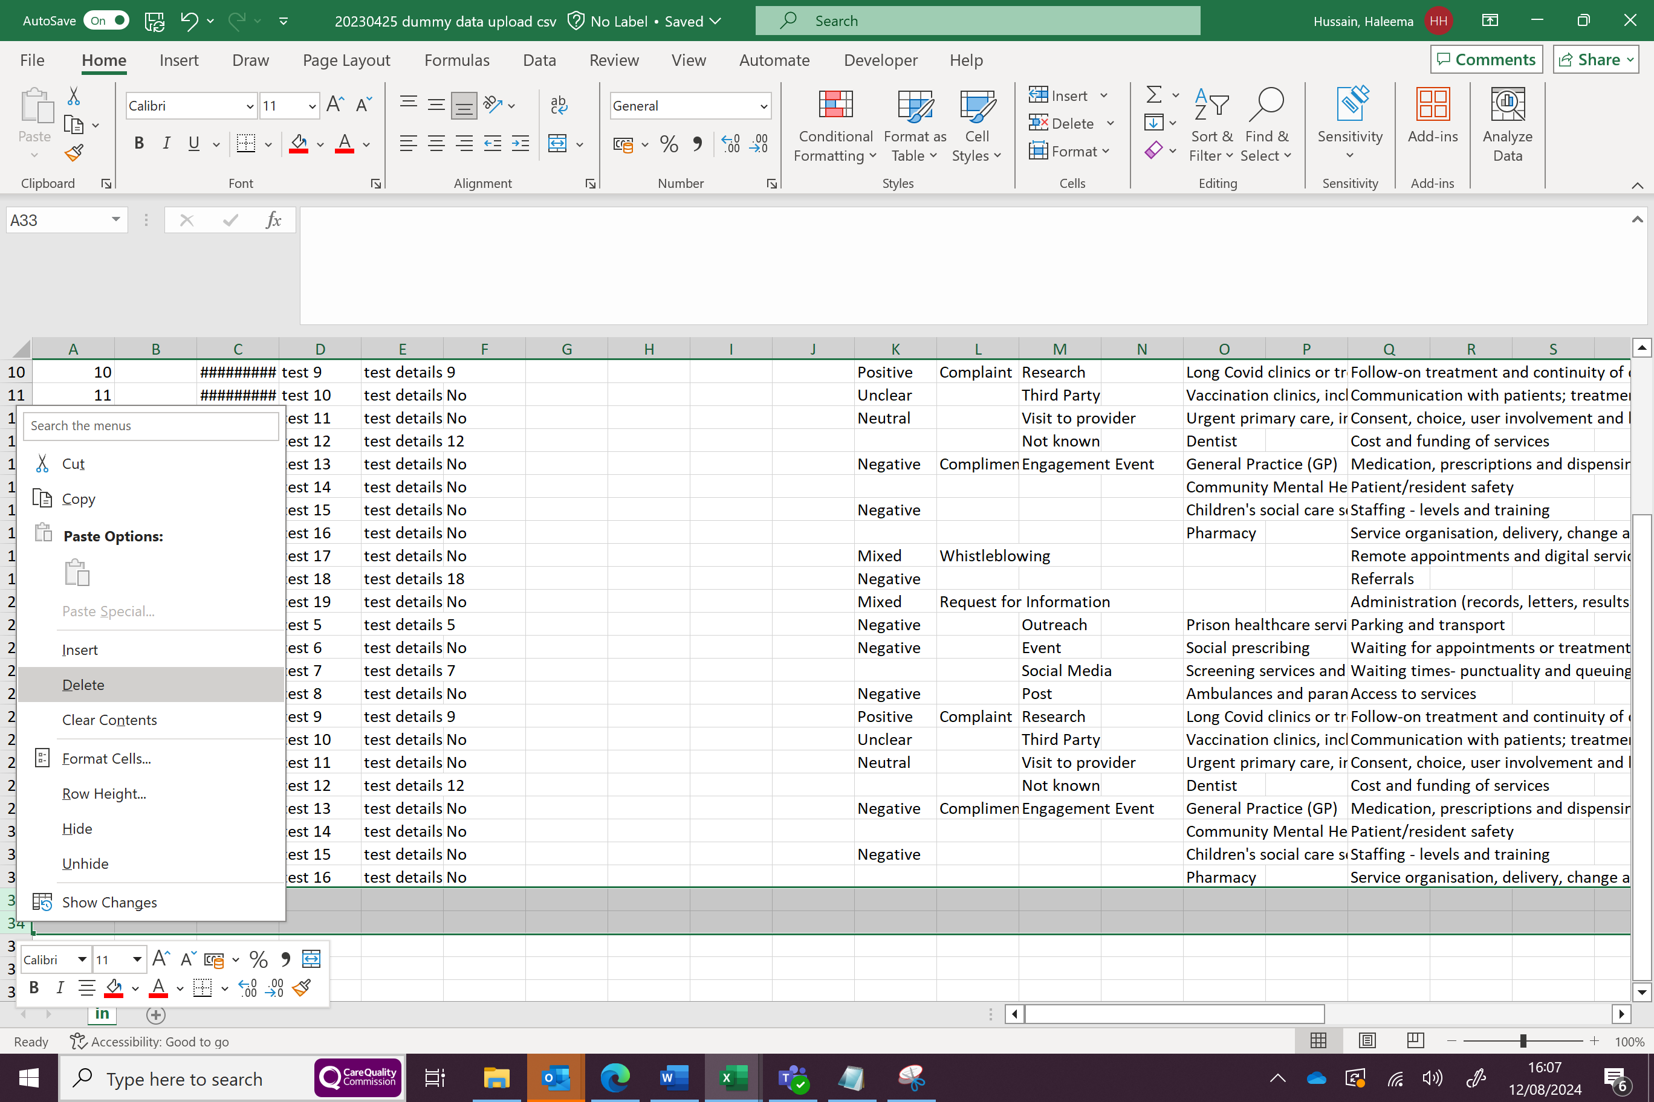

**Check the date formatting**. The date should be formatted exactly as recorded in the mapping. If there are spaces in the date field, differently formatted dates, or alternative text, the system will fail to match the data in those cells. In the example below, one date is formatted differently.

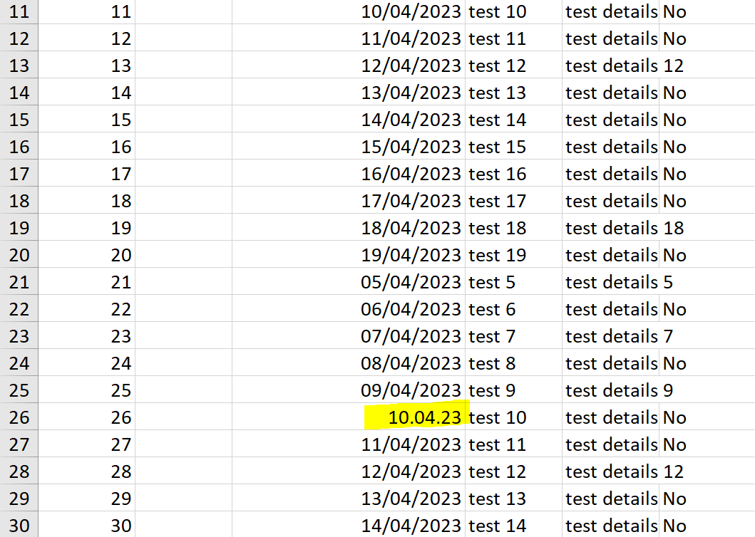

Once you remove or edit these and reupload the saved dataset, the system should match all the records successfully.

The match up your data screen doesn’t load the pairing

If you’re trying to upload data using a saved pairing, the loading screen appears, and the quote marks don’t stop spinning; you've probably got at least one extra row before the column headings that form the match in the mapping.

Your data may be formatted like this or have several blank rows:

Delete the blank rows, resave them, and upload them again.

Getting an error message on submitting your data

You may get the following message when you try to submit data.

This could be caused by several issues, which you'll need to work through:

**Wrong csv format** – change the file format into .csv UTF-8 and then upload again.

**The format of the date field within** the CSV file is General rather than Short Date. Change the date format, save the file, and then upload again.

**Different column headings than in the pairing**—You can check the mapping based on the previously submitted data. Ensure the column headings are worded exactly the same way. If this is the case, you may need to create a new pairing.

**Apostrophes and quote marks** - The name or the description of the pairing that you have tried to use again includes an apostrophe or quote marks, or there are apostrophes or quote marks in column headings in the .csv you’ve tried to upload. You can amend the name of the pairing to remove the apostrophe or quote marks.

Remember to remove the apostrophe or quote marks from the dataset or amend field descriptions/questions in their CRM system/online survey to avoid this happening again.

What if I have any problems with uploading data in future?

Please contact [datasharing@healthwatch.co.uk](mailto:datasharing@healthwatch.co.uk), and someone will get in touch with you.

Healthwatch England

National Customer Service Centre

Citygate

Gallowgate

Newcastle upon Tyne

NE1 4PA

www.healthwatch.co.uk 

t: 03000 683 000

e: enquiries@healthwatch.co.uk

 @HealthwatchE

 Facebook.com/HealthwatchE