Smart Survey

Getting started
Updated December 2025


Contents
Contents 1
About this guidance 2
Accessing Smart Survey 2
How many people can access each account? 2
Creating surveys 3
Adding questions to your survey 5
Question settings 7
Skip logic 8
Formatting surveys 9
Sending surveys and collecting responses 9
Taking steps to minimise potentially fraudulent responses 10
Analysing your results 10
Sharing survey results 12
Sharing surveys with other Healthwatch or with other accounts for your Healthwatch 13
Who to contact at Healthwatch England about SmartSurvey? 15

About this guidance
Healthwatch England provides Healthwatch with free SmartSurvey accounts from its Business Enterprise Account. Each Healthwatch can have up to six free accounts.
This guidance is for new users of Smart Survey - a standard survey, questionnaire and feedback tool. In this guide, we cover:
- Creating surveys
- Adding and editing questions
- Controlling responses
- Distributing your survey
- Viewing and analysing survey responses
- Sharing your survey
.

Accessing Smart Survey
If you have already contacted us to request an account, you will have received an invite from Smart Survey prompting you to finalise an account via your preferred email address.
All local Healthwatch accounts are under the parent Healthwatch England account, so if you need assistance with your licence or access, contact digital@healthwatch.co.uk.
If you forget your password, use your account email address to set it yourself via the 'Forget your password' link on the login page (we cannot set passwords for you directly, and it is not secure for us to do so).

How many people can access each account?
SmartSurvey only allows two devices registered per account. You can change users up to 10 times a year.
For this reason, we can provide your Healthwatch with up to six free accounts under our Business Enterprise account.

Creating surveys
There are four options:
- Start from scratch
- Copy existing survey
- Use a template
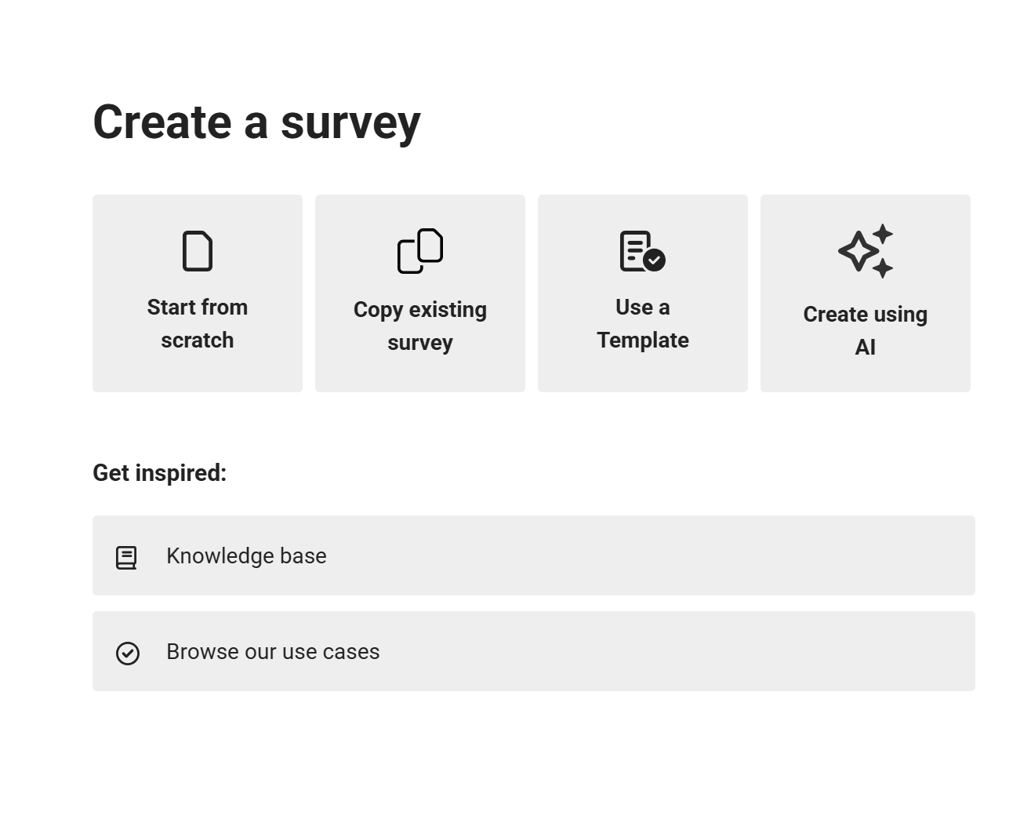
- Create using AI

A word of warning about using the SmartSurvey template and AI-generated surveys
We’ve found that you cannot rely on the questions in these surveys being free of bias. For example, some surveys use leading questions or unbalanced Likert scales. If you need to use one, please review each question carefully and amend it as necessary. For further guidance on writing good survey questions, see our guidance.

Creating a survey from scratch
Click Start from scratch.
Type a descriptive Survey Title.
Under Language, the default language is English. To change the survey language, click on the drop-down menu. If your preferred language is not listed, please submit a support ticket to request the language you would like to use. Smart Survey supports all languages; however, those listed have built-in templates with core functionality already translated (such as the Next Page button and Submit). Our subscription allows you to customise all the text for the language used in your survey, including these elements. However, it does not let you to translate the whole survey into that language.
Click the blue ‘Create Survey’ button.
From here, you can start adding questions to your survey.

Copy existing survey
This allows you to copy and customise an existing survey. Healthwatch England shares template surveys with network users in this way.
Click Copy an existing survey. This opens a pop-up box where you can select the survey to copy from a drop-down list of all the surveys in ‘My Surveys’.
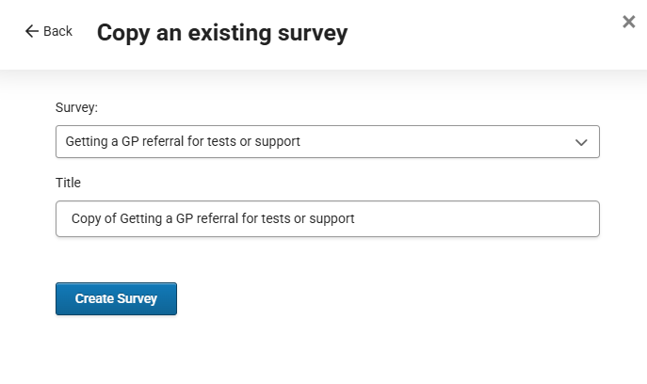
You can then amend the title for the copied survey in the box below the original survey title.
Then click the blue “Create survey box”. You can then edit the copy of the survey.

Creating a survey from a template

Smart Survey comes with survey and questionnaire templates. Using these can save you time when creating your own surveys. This guidance tells you more about creating a survey from a template.

Creating a survey using AI
This guidance tells you more about creating a survey using AI.

Note on sources of data used by SmartSurvey to train this feature
SmartSurvey has informed us that they utilise GPT AI as a text interpreter to create questions and determine which question category is most suitable for the questions being asked. They do not use existing surveys that other SmartSurvey users have created.

Adding questions to your survey
Click the green Add Question button within your survey to open the Select Question type pop-up.

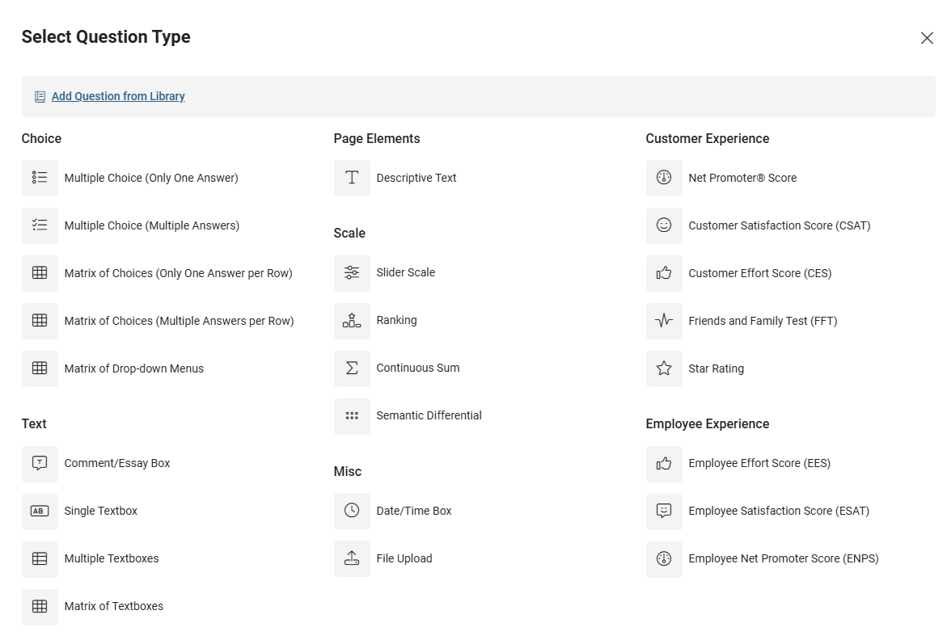
You can select the appropriate question type from the list or select Add Question from Library. See this guidance on different question types.

Question libraries
Healthwatch England has developed a shared question library that includes all demographics and other questions from the question bank. Click on Add question from library to see the Healthwatch England Question Bank demographics library. The question library pop-up lets you view questions before adding them to your survey.
You can also create your own question library. We recommend doing this for questions you frequently use in surveys, such as local postcodes or areas.

Using template answers
You can populate the answer field with template answers. When you have created your question, click on the Answer Template box to see the options.
We don’t advise using the demographic answers provided; instead, use the ones in the Healthwatch England Question Bank demographics question library.
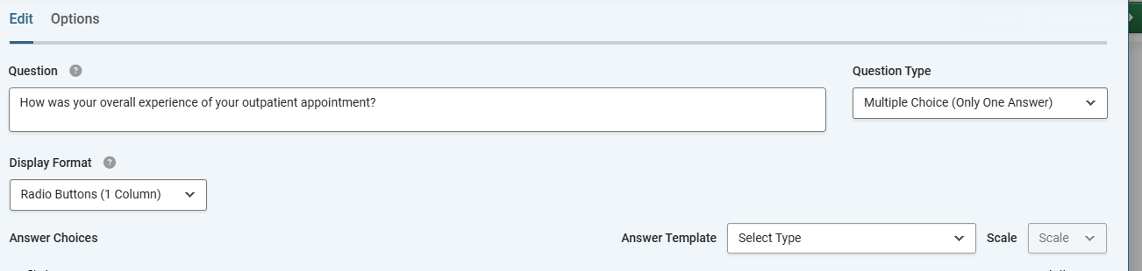

Question settings

Making responses mandatory
You can force users to provide an answer to a question. This avoids a situation where the respondent can submit a blank response or skip the question.
It is best practice not to make all your survey questions mandatory, as this can result in people abandoning your survey halfway through. Use them only where you really need an answer to your question.
See this guidance on making questions mandatory.

Adding an ‘Other’ or ‘Comment’ field
If you are adding a multiple-choice question where the answer choices you provide are not exhaustive, having an ‘Other’ field is useful. It allows you to list the most common options but ensures that respondents have the option to provide their own answer.
See this guidance on how to add another or comment field.

Adding a “none of the above” field
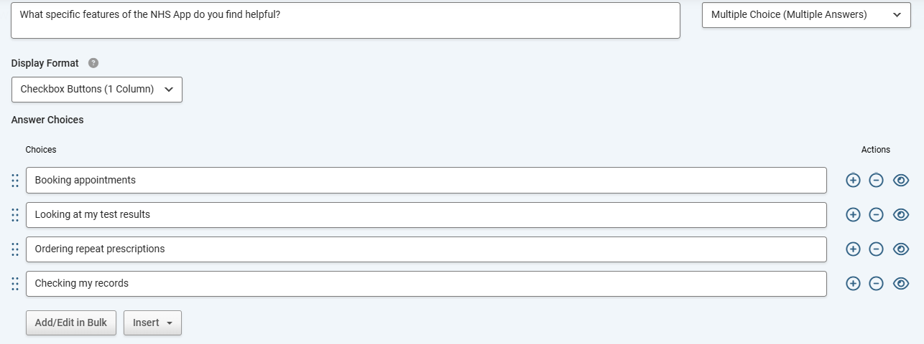
An alternative to an “other, please comment” answer option to a question where people can select multiple options is a “none of the above” answer option.

Click on the Insert Button beneath the answer options you have typed. Select 'Add "none of the above" Option’.

When this option is clicked, all other options on this question are unticked. You can only add one of these per question.

Selecting a maximum number of responses
Sometimes, you may want to ask respondents to select their top three or five options from a list. To limit the number of responses, click the Validate Answer Format box under the question. Change the first box to "At most", then select the maximum number of choices you want people to answer.
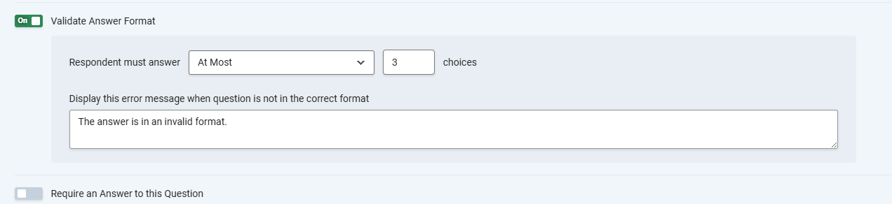

Restricting the length of answers in a text box
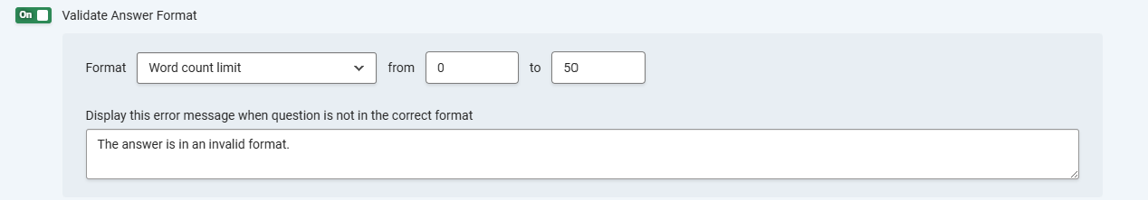
To restrict the length of answers in an open text, select Validate Answer Format. In the format box, select Word Count limit. Two further text boxes then appear: from and to. We suggest setting the upper limit to 250 or 300 words.

Skip logic
If you need to exclude people from answering a survey or send different groups to different questions, you’ll need to add skip logic to your survey. SmartSurvey has extensive guidance on using skip logic here.
For example:
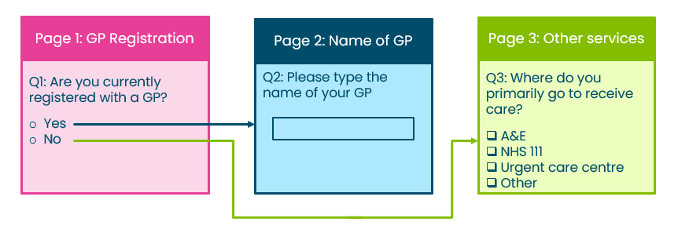

Formatting surveys
Formatting surveys are controlled by Smart Survey’s themes. We have already created a ‘Healthwatch’ theme for you to use that features our brand colours and font. See this guidance on changing themes.

Sending surveys and collecting responses
Smart Survey offers several methods for collecting survey responses, providing flexibility in determining the best approach to reach your target audience.
However, unless you have a specific user journey in mind, we recommend always embedding a survey into your website as a first option. This is because it looks better for the user, provides greater insight (as shown in your Google Analytics page views), and also encourages the user to interact further with the site and your content after they have completed the survey.
For further information on embedding surveys on a website, see this guidance.

Minimising potentially fraudulent responses
SmartSurvey has several features which can help minimise fraudulent survey responses:
- Using skip logic to screen out respondents who don’t qualify
- Adding hidden questions to your survey (bots will answer these, but humans won't)
- Restrict survey completion to one per device
- Customising survey links to include an X (e.g. https://www.smartsurvey.co.uk/s/x-ABC.) at the start of the survey ID section will add an additional security screening process to check for bot responses.
We have further detailed guidance on identifying and dealing with fraudulent research participation.

Analysing your results
SmartSurvey offers several reporting tools to help you analyse your data, including the creation of charts and AI analysis of qualitative data. However, these need to be used with caution.

Charts
You can create charts, which you can download as .jpg or .png files to add to a report.
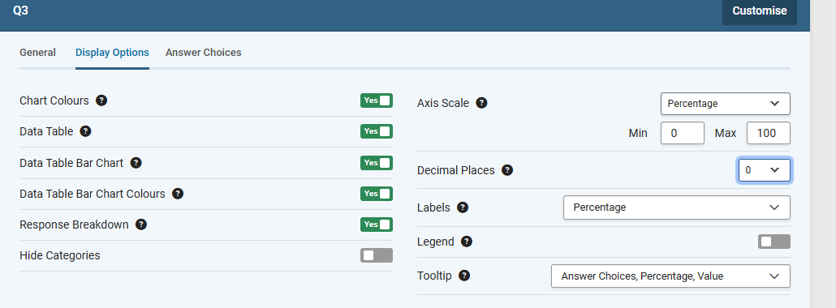
You can edit the displays in relation to colours, the number of decimal places, response breakdown and hiding categories.
However:

The charts don’t use our brand colours. You can change the colours on charts but only per chart. The codes for our brand colours are:
- Navy blue - #004F6B
- Pink - #E73E97
- Green - #96DF46
- Yellow - #F9B93E
- Teal - #00B38C
- Light Blue - #7FCBEB
The charts don’t use our brand font, and you cannot change it before downloading the chart.
We, therefore, don't recommend using this function of SmartSurvey for professional-looking data visualisations.

A better alternative
Instead, we recommend exporting the data into Excel and analysing it within that program. We offer e-learning on Excel, including a module on creating graphs. Once you’ve created a graph in Excel, you can copy and paste it into one of the report templates in BrandStencil. This will mean that your graphs and charts will appear in brand colours and fonts.

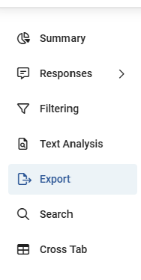
Exporting the data into Excel
To export the data, select Analyse and then Export.
You then have a choice of different formats, including .xlsx and .csv
Select the format you want and then click on the green Export button.

Multi-select questions
You may have a question(s) in your survey where respondents could select multiple answers. When you download this data into Excel, the question and answer options appear on two separate rows: the question on row 1 and the answer options on row 2. Creating a pivot table to analyse the data won't be possible unless they are in one row.
There are two options here. You could copy the figures from the SmartSurvey graph to create your own graph or table.
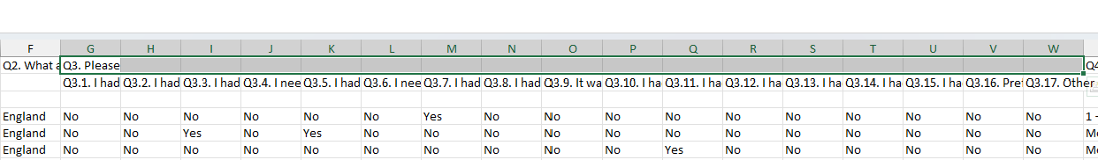
Alternatively, you could edit the spreadsheet to remove the empty spaces in row 1.
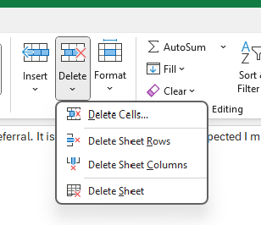
In the example above, the question is a multi-select answer about people's conditions. Select the empty spaces from cell G1 to W1. Then select Delete Cells.
In the example above, you'll also need to delete Row 3, which is empty, before you create a pivot table to analyse the data.

Qualitative data analysis tools
SmartSurvey has tools to analyse qualitative data:
- Sentiment analysis – there is guidance here on how it works. We've found that it doesn’t work well for long responses or responses which cover more than one topic.
- Text analysis – there is guidance here on how it works.
There is also a feature to auto-categorise responses using AI. Healthwatch England, which has the master account, can only enable this feature. We've decided not to turn it on as it will incur additional costs that we can't control.

Sharing survey results
This is where you can create sharing links so that people you wish to view the report can do so without needing a SmartSurvey Account. You can find out more about this feature here.
You should consider whether it would be lawful to share survey links under GDPR. Before doing so, seek advice from your Data Protection Officer.
You can password-protect data-sharing links.

Sharing surveys with other Healthwatch or with other accounts via SmartSurvey
Our SmartSurvey account enables each Healthwatch to share surveys with other Healthwatch, should they wish, or with other accounts that people in your Healthwatch have access to.
Consider whether it would be lawful to share surveys with other users under GDPR. Before doing so, seek advice from your Data Protection Officer.

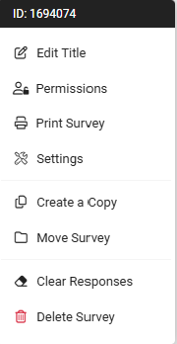
To do this, go to My Surveys and click on the three dots to the right of the name of the survey.
From the pop-up, select Permissions. This will provide you with a list of the account holders in the Healthwatch England SmartSurvey account.
Find the accounts you want to share and select them by holding down the Control key and clicking on the users you want to share the survey with.

Access options
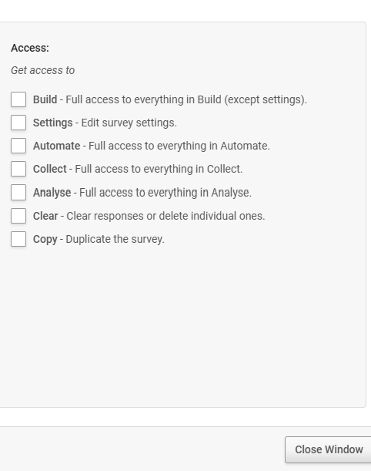
To the right of the list of users is a list of access options.
Think carefully before giving access to all of these options:

Build
This means that users can delete or edit existing questions, add new ones and add or edit skip logic.

Settings
Users can amend the survey title, change the survey's appearance, enable saving and continuing, and randomise pages.

Automate
This is about integrations with CRMs, so it is of little use.

Collect
This allows users to close and open surveys and customise weblinks

Analyse
Users have access to all the analysis features. This means that they will be able to access the data collected.

Clear
This allows users to clear all survey responses.

Copy
This will enable users to copy the survey and then customise the copy.
We recommend granting users access to Collect and Copy only to avoid data loss or changes to the survey once it is live. You should only give other SmartSurvey account users access to Analyse if it is lawful under GDPR to do so. See our data protection guidance for more information.

Who to contact at Healthwatch England about SmartSurvey?
If you need more accounts or have problems with your SmartSurvey account, contact digital@healthwatch.co.uk
If you need advice on how to use SmartSurvey to build a survey, please contact research@healthwatch.co.uk.

Healthwatch England
National Customer Service Centre
Citygate
Gallowgate
Newcastle upon Tyne
NE1 4PA



www.healthwatch.co.uk
t: 03000 683 000
e: enquiries@healthwatch.co.uk

@HealthwatchE
Facebook.com/HealthwatchE

