Question bank
February 2026



Contents

About this guidance 2
Demographic questions – commonly used 2
Health conditions and caring status 6
Living standards 10
Personal situation 12
Proficiency in English, IT skills 13
Education and employment status 16
Impact 17
Communications 18
Location 20
Emotions 20
Other ways to identify people whose experiences aren't heard 22
If you need further help 23

About this guidance
This guidance includes a number of questions you can use in surveys. It includes:
- Our standard demographic questions
- Additional demographic questions
- Other questions
If you have any SmartSurvey licences under the Healthwatch England Business Enterprise Account, you can find most of these questions in a shared question library.
See our guidance on SmartSurvey for further information.

Demographic questions – commonly used
Demographics is data about people that describes characteristics such as age, ethnicity, marital status, education, gender, and income. We have included the commonly used ones in this section, and other types of information that might come under the generic term "demographics” in later sections.
There is more than one way to ask a question, but we recommend that everyone uses the recommended taxonomy to enable comparisons and combine data from different local Healthwatch. We have further guidance on collecting and using demographic data, available here.

Age
Age categories approximately reflect life stages. When analysing the data, you may need to recode them into broader categories, but there is value in using narrower classifications that align with Healthwatch England guidance, as this will enable cross-borough aggregation and comparison..
What age group are you in? [Single select]
- Under 13
- 13 to 15 years
- 16 to 17 years
- 18 to 24 years
- 25 to 49 years
- 50 to 64 years
- 65 to 79 years
- 80+ years
- Prefer not to say
- Not known

Gender/sex/gender identity
Currently our taxonomy focuses on gender and gender identity rather than biological sex. Our rationale for this was that our research is not based on people's biology but on how they perceive themselves and are treated. We know from our insight that trans people feel that they are often not taken seriously by health providers in their new gender identity.
In March 2025, the government published the findings of an independent review of data, statistics and research on sex and gender. It recommended that data on sex should be collected separately from gender identity. It proposed testing new questions on gender identity. We are awaiting the government’s response to this review.
We are also awaiting the publication of the Equality and Human Rights Commission's updated statutory guidance on how public bodies should comply with the Equality Act in light of the Supreme Court judgment on the meaning of sex in the Equality Act.
We will consider updating our demographic taxonomy and guidance once this code is published. As the EHRC states, this does not prevent individual organisations from seeking their own legal advice to decide how to comply with the ruling.

Gender
Are you? [Single select]
- A woman
- A man
- Non-binary
- Prefer not to say
- Not known
- Prefer to self-describe (please specify)

Gender identity
Is your gender identity the same as your sex recorded at birth? [Single select]
- Yes
- No
- Prefer not to say
- Not known

Alternative questions to capture biological sex and gender identity

Sex
What is your biological sex? By biological sex, we mean your sex recorded at birth. [Single select]
- Female
- Male
- Prefer not to say

Gender identity
Do you consider yourself to be transgender or non-binary? [Single select]
- Yes, Trans woman
- Yes, Trans man
- Yes, Non-binary
- Yes, Agender
- Yes, other (please specify if you wish)
- No
- Don’t know
- Prefer not to say

Sexual orientation
What is your sexual orientation? [Single select]
- Asexual
- Bisexual
- Gay man
- Heterosexual / Straight
- Lesbian / Gay woman
- Pansexual
- Prefer to self-describe (please specify)
- Prefer not to say
- Not known

Pregnancy and maternity
How would you describe your pregnancy or maternity status? [Multi select]
- Currently pregnant
- Currently breastfeeding
- Given birth in the last 26 weeks
- Prefer not to say
- Not known
- Not applicable

Ethnicity/race
The Ethnicity question is very detailed, but you can use overall groupings for analysis when the data volume in an individual category is too low. Some of these categories require a free-text box for "other".
Our taxonomy is based on the GSS standard. If you want to collect more details, e.g. Latin American or Turkish, add them to the answer options.
How would you describe your ethnic group? [Single select]
- Arab
- Asian / Asian British: Bangladeshi
- Asian / Asian British: Chinese
- Asian / Asian British: Indian
- Asian / Asian British: Pakistani
- Asian / Asian British: Any other Asian / Asian British background
- Black / Black British: African
- Black / Black British: Caribbean
- Black / Black British: Any other Black / Black British background
- Mixed / Multiple ethnic groups: Asian and White
- Mixed / Multiple ethnic groups: Black African and White
- Mixed / Multiple ethnic groups: Black Caribbean and White
- Mixed / Multiple ethnic groups: Any other Mixed / Multiple ethnic groups background
- White: British / English / Northern Irish / Scottish / Welsh
- White: Irish
- White: Gypsy, Traveller, or Irish Traveller
- White: Roma
- White: Any other White background
- Any other ethnic group (please specify)
- Prefer not to say
- Not known

Religion
What is your religion or belief? [Single select]
- Christian
- Muslim
- Hindu
- Sikh
- Jewish
- Buddhist
- No religion
- Prefer not to say
- Not known
- Other (please specify)

Health conditions and caring status

Carer
There are two options here. One is to ask a separate question. The other is to combine it in a question about whether people are disabled or have a long term condition (see below)
A carer is anyone, including children and adults, who looks after a family member, partner or friend who needs help because of their illness, frailty, disability, a mental health problem or an addiction and cannot cope without their support. The care they give is unpaid.
Do you look after a family member, your partner or a friend who needs help because of their illness, health condition or disability? [single select]
- Yes
- No
- Prefer not to say
- Not known

Combined disability/long term condition/carer question
Please select any of the following that apply to you: [multiple select]
- I have a disability
- I have a long term condition
- I am a carer
- Prefer not to say [Single select if selected]
- None of the above [Single select if selected]

Disability and long term conditions
If you need to know details of the type of disability or long term conditions that people have:
Which of the following disabilities or long term conditions do you have? [Multiple select]
- Mobility problems
- A physical disability
- Deafness or severe hearing problems
- Blindness or severe sight loss
- A learning disability
- Asthma, COPD or respiratory condition
- Cancer
- Chronic kidney disease
- Dementia
- Diabetes
- Epilepsy
- Hypertension/high blood pressure
- Mental health condition
- Musculoskeletal conditions
- Neurodivergent (autism/ADHD/dyslexia etc)
- Neurological conditions (ME/CFS/fibromyalgia)
- Other, please specify
- None of the above [Single select if selected]
- Prefer not to say [Single select if selected]

Neurodivergence
Neurodiversity is increasingly being given greater consideration within our society – and rightly so, considering an estimated one in seven people in the UK are neurodivergent. Debate exists around terms such as "condition" or "disability" about neurodiversity, and getting this wrong can offend people who are diagnosed or consider themselves neurodiverse.
For that reason, we have created a couple of questions to take neurodiversity out of other umbrella terms. Although this is not one of the named nine protected characteristics, it would fall within disability under the Equality Act 2010.

If you want detail on the type of neurodivergent condition people have:
Have you been diagnosed with any of the following? [multiple select]
- Autism (ASD)
- Dyspraxia
- Dyscalculia
- Dyslexia
- Dysgraphia
- ADHD/ADD (attention deficit hyperactivity disorder, attention deficit disorder)
- Tourette’s
- Prefer not to say [Single select if selected]
- Other (please specify)
- I haven’t been diagnosed with any neurodivergent condition [Single select if selected]

If you want to know whether people are neurodivergent or not
Do you have a neurodivergent condition (such as ADHD, autism, dyslexia, dyscalculia, dysgraphia, Tourette’s or other neurodivergent condition)? [single select]
- Yes
- No
- Don’t know
- Prefer not to say

General health
How would you describe your current state of health? [Single select]
- Very good
- Reasonably good
- Fair
- Quite poor
- Very poor
- Prefer not to say
- Not known

Wellbeing choices
Using statements with an agree/disagree scale is a quick way to cover a range of attitudes in one grid question. You can adapt statements to the research topic, but here are some examples on wellbeing.
To what level do you agree or disagree with each of the following statements? [Single select one per row]
 | Disagree completely | Disagree slightly | Neither agree nor disagree | Agree slightly | Agree completely | Unsure or don’t know
I take an active interest in maintaining my physical health
I exercise at least once a week
I consider my diet to be healthy
I am concerned about my current health
I take active steps to look after my mental health
I believe I am physically fit
I believe I am a healthy weight

Health literacy
This question has been used to determine the level of people’s health literacy:
How comfortable, if at all, are you filling out medical forms by yourself? [Single select]
- Not at all
- A little bit
- Somewhat
- Quite a bit
- Extremely
- Prefer not to say

Living standards

Financial situation
Wealth/poverty can be influenced by many factors, such as care needs, disability, housing, and family. Disposable income is a good proxy for this, but asking for a specific monetary figure is problematic, as context can make this meaningless.. Often, respondents don't want to provide this information. We, therefore, recommend using a subjective measure. This is quite a wordy set of answers, so using underlining, bolding, or capitalisation can draw the respondents' eyes to key words that differentiate the answers.
Which of the following best describes your current financial situation? [Single select]
- Very comfortable (I have more than enough money for living expenses, and a LOT spare to save or spend on extras)
- Quite comfortable (I have enough money for living expenses, and a LITTLE spare to save or spend on extras)
- Just getting by (I have just enough money for living expenses and little else)
- Really struggling (I don't have enough money for living expenses and sometimes run out of money)
- Prefer not to say
Alternatively, you can ask a question about sources of income:
From which of the following sources do you receive income? [multi select]
- Wages/salary
- Income from self-employment
- Disability benefits (e.g., Attendance Allowance or Personal Independence Payment)
- Means-tested benefits (e.g., Universal Credit or Pension Credit)
- State retirement pension
- Other benefits
- Student loan
- Occupational/private pension
- Other income (please specify – free text box)
- Prefer not to say

Housing situation
This may be relevant for specific surveys covering topics like the impact of the environment on health, or for talking to a particular group, like homeless people.
Which of the following best describes your housing situation? [single select]
- Own outright
- Buying using a mortgage
- Living with family members
- Renting privately
- Renting from the council, housing association or another social landlord
- Informal living arrangement (no-contract sublet, staying with friends)
- Supported living scheme
- Care home
- Temporary accommodation/ hostel
- Homeless/Sleeping rough
- Prefer not to say
- Not known
- Other (write-in)

Poverty indicators
This question can provide further indicators of poverty over and above financial situation, and it includes specific indicators that have implications for health (cost of medication, dental care).
In the last 12 months, to help you keep your living costs down, have you done any of the following? [Multiple select]
- Reduced the amount of food you eat or bought cheaper types of food
- Used a food bank
- Changed shopping destinations, for example, using charity shops
- Spent less on medication/prescriptions
- Avoided doing things you enjoy, like going to the cinema or going out with friends
- Avoided visits to the dentist
- Used less heating or made other choices to reduce energy bills
- Had to make difficult decisions about which bills to pay
- Took out credit
- None of the above
- Other [ please specify]
- Prefer not to say

Personal situation

Partnership status
This is a protected category, but only for employment purposes.
How would you describe your marital or partnership status? [Single select]
- Single
- Cohabiting
- In a civil partnership
- Married
- Separated
- Divorced / Dissolved civil partnership
- Widowed
- Prefer not to say
- Not known

Household composition
These questions work together. For example, a single parent would have dependents living in the home and be the only adult.
How many dependent children live in your home (under 18)? [Single select]
- None
- 1-2
- 3-4
- More than 4
- Prefer not to say
Besides you, what other adults (18 or over) live in your home? [Single select]
- I’m the only adult (18 or over)
- My partner only
- I live with other adults who are not related to me and who are not my partner (e.g., co-tenants)
- I live with members of my family (e.g., parents, siblings, other relatives)
- I live with my partner and other adults
- Prefer not to say
- Other (write-in)

Proficiency in English, IT skills

English language skills
English fluency (and IT skills) may directly impact users' access to services.
How well can you understand, speak, read and write English? [Single select per statement]
 | Not at all well | Not well | well | very well | Unsure or don't know
I understand spoken English
I speak English
I read English
I write English

Devices and internet access
When researching digital access, it's helpful to know which devices people have access to.
Which of the following devices do you own or have regular access to? [multi select]
- Personal or work computer (desktop/laptop)
- Tablet (e.g., iPad or similar)
- Smartphone
- Smart TV
- Games console (e.g., Nintendo, PlayStation, Xbox)
- Basic phone
- None of the above
Do you have access to the internet on a regular basis? [multi select]
- Yes, on home wi-fi/ broadband
- Yes, on public wi-fi (e.g., in a café)
- Yes, at work
- Yes, on a mobile network (e.g., smartphone, tablet) with a SIM
- No, I have no access to the internet
- Other (please specify)
- None of the above

Digital confidence
Having a device and internet access does not always equate to digital confidence or abilities. Someone may be able to use WhatsApp for communicating with family, but not be able to download and effectively use a banking app.
To what level do you agree or disagree with each of the following statements? [Single select per row]
 | Disagree completely | Disagree slightly | Neither agree nor disagree | Agree slightly | Agree completely | Unsure or don't know
I am confident in using apps to carry out day-to-day tasks (e.g., banking, booking travel)
I am confident in using online search tools to look for information (e.g., Google)
I am confident using written communication such as email, WhatsApp or text
I am confident using on-screen/video communication such as FaceTime, Zoom or Teams

Confidence in using the NHS App
Overall, how confident are you using the NHS app for any purpose (e.g., to manage your appointments, to manage repeat prescriptions, to get health information and advice)? [Single select]
- Very confident
- Somewhat confident
- Not that confident
- Not at all confident
- Don't know/prefer not to say

Education and employment status

Education level
Levels of education may help understand social class and its intersection with health inequalities. You should ideally word answer options to be inclusive of those who completed their education outside the UK.
What is the latest educational level you have achieved? [Single select]
- None
- Primary (left school before/ at 11)
- Secondary (left school before/at 16)
- A-levels, high school or equivalent
- Post-secondary vocational/ technical
- University (1st degree)
- Postgraduate (2nd or further degree)
- Not known
Prefer to self-describe (please specify)

Employment status
There can be an argument for making this question multiple-choice. Many retired people and students have paid or volunteer jobs. The following question has been worded as a single-select question
Which of the following best describes your main employment status? [Single select]
- Working full time (employed or self-employed)
- Working part-time (employed or self-employed)
- Unemployed and looking for work
- Unemployed and unable to work (health issues/ disability)
- Retired
- Stay at home parent
- Carer to a member of the household with additional needs
- Student
- Doing unpaid work/ volunteering
- Other (please specify)
You can use a free-text box for occupation, but this might be problematic for those not working in a specific role or working at all, and it could yield a very diverse dataset that could be time-consuming to code.
What is your occupation?
(Write-in) [free-text box]

Impact

Impact on day-to-day living
To what extent are your day-to-day activities limited because of a health problem or disability which has lasted, or is expected to last at least 12 months? [Single select]
- Limited a lot
- Limited a little
- Not limited at all
- Prefer not to say
- Unsure or don't know
In what way has…[insert topic] has impacted the following aspects of your life?
 | Very negative impact | Quite a negative impact | Neither positive nor negative impact | Quite a positive impact | Very positive impact | Unsure or don’t know
Ability to work (voluntary or paid)
Ability to carry out daily household tasks
Ability to care for others
Ability to socialise
My ability to stay physically fit
My mental health and wellbeing
My relationship with my partner, close friends, or family
My financial situation

Communications

Accessibility
Accessibility of information in a medical context has recently been an essential focus for Healthwatch. For example, you could use this question as a screening question, where your target sample is solely people who need support to access the information they need.
Do you have a disability, impairment or sensory loss that can make accessing information challenging? [Single select]
Yes
No
Don’t know
Prefer not to say
Only ask the following question if a person has an impairment, which you can establish by using the previous question.
To what extent do you agree that the communications you received from the NHS about your care or treatment were accessible, i.e. appropriate for your needs (language, braille, print size etc.)? [Single select]
- Disagree completely
- Disagree slightly
- Neither agree nor disagree
- Agree slightly
- Agree completely
- Unsure or don’t know

Amount of information
How would you describe the amount of information you were given when [insert topic].? [Single select]
- I was given more than enough information
- I was given enough information
- I was not given enough information
- I was given no information
- Unsure or don’t know
- Prefer not to say

Quality of information

To what level do you agree or disagree with each of the following statements? [Single select]
“The communications I received from the NHS about [insert topic] were…?” | Disagree completely | Disagree slightly | Neither agree nor disagree | Agree slightly | Agree completely | Unsure or don't know
Clear
Easy to understand
Contained all the information I needed
Accurate

Location
Depending on your research topic, you may want to consider a question that identifies a location. It could be where an individual lives (first half of postcode maybe), local authority or ward, region, GP practice, hospital etc. Collecting more granular location information can help you analyse results across different types of geographical areas, for example, the key areas/towns your Healthwatch covers. You may also be able to analyse it against other datasets.
Note that postcode data is personal data. You will need to tell people how you intend to use it.

Emotions
Despite qualitative methodologies being the "go-to" for feelings and emotions, you can use survey questions to provide some indication of these “softer” measures. One way you can do this is to provide a list of words and ask the respondent to pick any that apply, their top three or even their top one, for example. Using an "other (please specify)” allows you to capture emotions you may not have considered.
When using a list of words, it's better to provide a mixture of positive and negative words that could reasonably apply to that situation. For example, visiting a hospital clinic is highly unlikely to be "fun", but it might be "reassuring".
If you are looking for a more nuanced view, use a disagree/agree scale.
How did you feel when [insert situation]? [Multi select]
- Protected
- Vulnerable
- Cared for
- Ignored
- Empowered
- Helpless
- Safe
- Scared
- Excited
- Worried
- Relieved
- Annoyed
- Happy
- Demotivated
- Motivated
- Sad
- Optimistic
- Let down
- None of the above [Single select if selected]
- Other (please specify)
- Unsure or don't know [single select if selected]
When you received your letter about [insert topic] from your consultant, to what level do you agree or disagree that you felt…? [Single select per row]

 | Disagree completely | Disagree slightly | Neither agree nor disagree | Agree slightly | Agree completely | Unsure or don't know
Protected
Vulnerable
Empowered
Annoyed
Relieved
Let down
Optimistic

Other ways to identify people whose experiences aren't heard
At Healthwatch, one of the challenges is often to reach people in certain groups. You can use a bank of statements to allow people to identify themselves as belonging to those groups, but it’s vital to include a “none of the above” and/or “prefer not to say” option. Always consider whether these categories are appropriate for the audience you are targeting.
Which of the following statements apply to you? [multiple select]
- I don’t have a support network (friends and/or family)
- I consider myself to be neurodivergent (e.g., autism, dyslexia, dyspraxia, Tourette’s etc.)
- I am an armed forces veteran (have been in the armed forces)
- I am homeless
- I live in a rural/isolated area
- I am an ex-offender
- I am a refugee or asylum seeker
- I am a serving member of the armed forces
- I have experienced domestic abuse (e.g., violence, psychological or financial)
- I am a sex worker
- None of the above
- Prefer not to say

If you need further help
Please contact the Research Helpdesk if you need any help with survey questions or any other aspect of research. You can contact us at research@healthwatch.co.uk.

Healthwatch England
National Customer Service Centre
Citygate
Gallowgate
Newcastle upon Tyne
NE1 4PA



www.healthwatch.co.uk
t: 03000 683 000
e: enquiries@healthwatch.co.uk
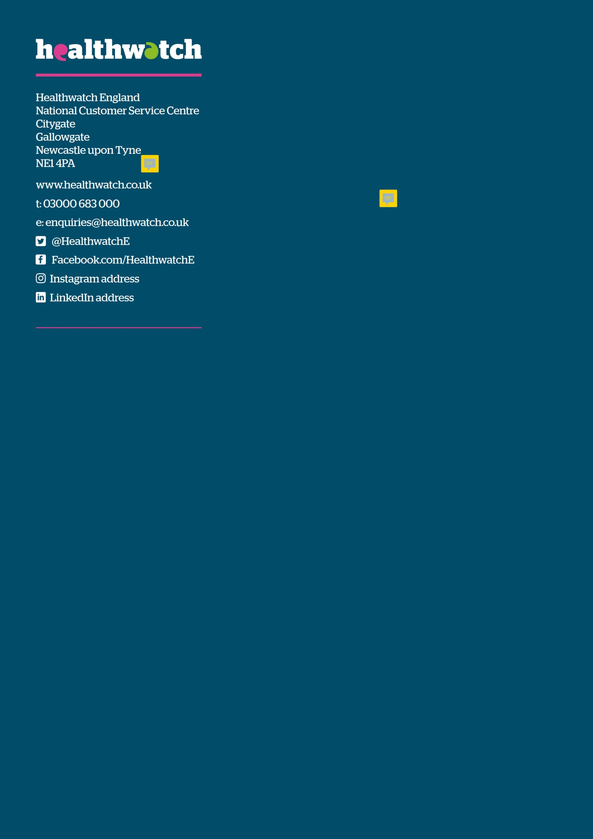
@HealthwatchE
Facebook.com/HealthwatchE

