Quantitative data analysis
July 2025



Contents
Contents 1
About this guide 2
What programs can you use to analyse quantitative data? 2
Before you start analysing 3
Analysing your data 4
Reporting quantitative data 4
Further reading 7

About this guide
As part of your work at Healthwatch, you routinely collect large amounts of data which you need to sort through to understand what it means and make clear evidence-based decisions. This guidance will help you recognise the steps you need to follow when analysing quantifiable data so that you can improve your data analysis skills and produce impactful reports. There are top tips for analysing quantitative data and how best to visually represent your analysis.

What programs can you use to analyse quantitative data?
Excel is the most commonly used program to analyse quantitative data. We have five e-learning courses on how to use Excel for you to brush up your skills. These are:
- Understanding the basic principles of Excel
- Creating basic formulas and graphs
- Analysing survey findings by demographic data using pivot tables and charts
- Using formulas as an alternative to pivot tables
- Aggregating datasets and data visualisations
Other programs you can use include SPSS, STATA and R.
The rest of this guidance assumes that you are using Excel to undertake quantitative data analysis.

Before you start analysing

Ensure your data lines up
Put your data into one spreadsheet and make sure that your data matches the correct fields. For example, you ensure that all data about the age of respondents is in one column headed “Age”.

Clean your existing data
You must also ensure that the format of the data in each column remains consistent in your spreadsheet. For example, in the gender field you might have used both “man/woman” and “M/W”. If you don’t clean your data before you start the analysis, you’ll end up with incorrect analysis.
Clean the data by applying a filter to spot discrepancies. For example, if you apply a filter on the gender field and spot “W” instead of “woman”, you can use click and drag to update the data.

Identify blank fields
Not everyone completes every survey question, so ensure that you can identify blank answers. When you download the data from a survey platform like SmartSurvey into Excel, blank answers are often shown with a dash (-). This will help you understand the base for each question.

Understand the variables in your data
Before you start analysing the data, it’s important to go through it and understand what the different variables are. Variables are the questions and answers in your survey. This will enable you to work out what you can and cannot measure.
For example, if you have collected data about service areas and the ease of access to help and support, you can tell which services people have struggled to access most. However, if you haven’t collected the age of the respondents, you will not be able to find out if access was more difficult for certain age groups.

Analysing your data

Carry out descriptive analysis
Descriptive analysis or descriptive statistics help you to describe the basic features of a data set. This involves analysing the answers to each question.
This in turn, helps you to summarize the information in the data and present it in a simple and meaningful way. This is the most common type of quantitative analysis used in Healthwatch research.
Descriptive analysis involves analysing the results of each question.

Carry out comparative analysis where relevant
Comparative analysis helps you to compare two or more variables in your dataset. You can also compare similar variables over time. Comparative analysis is carried out to find differences in experiences of people belonging to different demographic groups, such as age, gender and ethnicity.
For example, you undertake a survey to find out people’s experience of paying for dental care. By collecting demographic data and carrying out comparative analysis, you can find out whether people’s experience differs by gender, age, ethnicity and income.
See our guidance on collecting and using demographic data for further information.

Reporting quantitative data
Representing your data visually – for example, through graphs and charts – is a great way of making it easily and quickly understandable for the reader. It helps them easily interpret your findings and connect them to the conclusions you draw in the text of your report.
Regardless of what type of data is being used, good data visualisation always tells a story, has a clear meaning or purpose, and is easy to interpret, requiring no context.
You can use data visualisations to inform your audience of specific data points, highlight a comparison, demonstrate change over time/location, compare different categories, or highlight relationships.

Using graphs
However, there are some guidelines to follow to ensure that your data visualisations are as effective as possible.
If you are using a graph to communicate, think about your audience.
- If they don’t have a lot of background knowledge, make sure that you use a data visualisation they can easily understand.
- Make sure you avoid using jargon when labelling axes and writing titles, and use simple graphs such as bar charts, line graphs and pie charts.
- If you are using a graph for analysis, for example, by showing a trend over time, make sure that the variables are relevant to your research question.
Remember – a graph can be for both communication and analysis!

Designing effective graphs
There are a several things to remember when designing effective graphs.

When using colour to illustrate your graphs and charts:
- Keep grids, axis labels, borders, etc in shades of grey, to bring attention to coloured data.
- Don’t use different shades of one colour – use contrasting colours to ensure your graph is accessible to those with visual impairments such as colour blindness.
- Keep to the Healthwatch brand colours to ensure your report is on brand.
- Make sure the colours are meaningful and consistent across your graph. If there is a finding that you want to draw attention to, think about making this one a different colour.

When to use which type of graph
Different types of visualisation have different uses and guidelines:
- Bar charts – Used this to compare and highlight different categories, either horizontally or vertically. Always have a zero baseline to avoid getting a false visual comparison. For labels and categories, try to order them alphabetically or by value for uniformity in appearance. Present the bars horizontally if you have longer name labels as it gives you more space.
- Line graphs – Used to display series of data e.g. changes over time. Try to use solid lines instead of dotted lines as they are easy to follow the trend. Where possible, have a zero baseline. Having multiple lines can be confusing, so try to group where possible.
- Pie charts – Used to illustrating proportions of data. It is best not to use 3D pie charts as people find them hard to read the proportionality. Always include labels or a legend as well as percentages for each slice.
For more information on how to create graphs in Excel, see Parts two and three of our Excel e-learning courses.

Other ways of representing quantitative data
You don’t always need to use a graph to represent numerical data. Often, using a simple statistic in your sentences or using infographics can make your point just as well.
When reporting statistics, there are several ways you can do this:

Use percentages in the text
If you do this make sure you have stated how many people this is a percentage of to give context to the finding.
For example: “56% of 376 people who took part in the survey stated that they had had a GP appointment in the last month. “
Remember to round your percentages to the nearest whole number rather than use decimal places. Round down if 0.4 or less, round up if over 0.5. You should report a fraction only when it is 0.5 exactly.

Reporting numbers
If you have a small sample (for example, less than fifty people), it’s better to use whole numbers instead of percentages to avoid misleading your reader.

Use proportions
Use proportions, for example “half of the people we spoke to could not find a dentist during the pandemic”, or “one in ten people had bad experiences at A&E”. The following proportions are fine to use:
- Halves
- Thirds
- Quarters
- Fifths
- Tenths
If you are using proportions, then include the actual statistic in brackets.
For example: “Just over four out of five people (81%) were satisfied with the care they received.
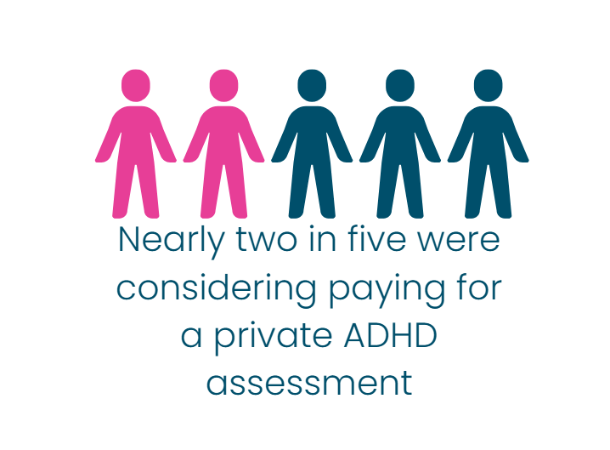

Use infographics
Use icons to make key statistics stand out without using graphs. For example, you could use Canva to make an infographic to illustrate a key survey result like this one to the left. Remember to include alt text so that people using screen readers can understand what the infographic is conveying.

Further reading
At Healthwatch, it is common to undertake mixed-methods research. It means you collect both quantitative and qualitative data. To find out how to carry out qualitative data analysis, read our guidance.

Healthwatch England
National Customer Service Centre
Citygate
Gallowgate
Newcastle upon Tyne
NE1 4PA



www.healthwatch.co.uk
t: 03000 683 000
e: enquiries@healthwatch.co.uk

@HealthwatchE
Facebook.com/HealthwatchE

