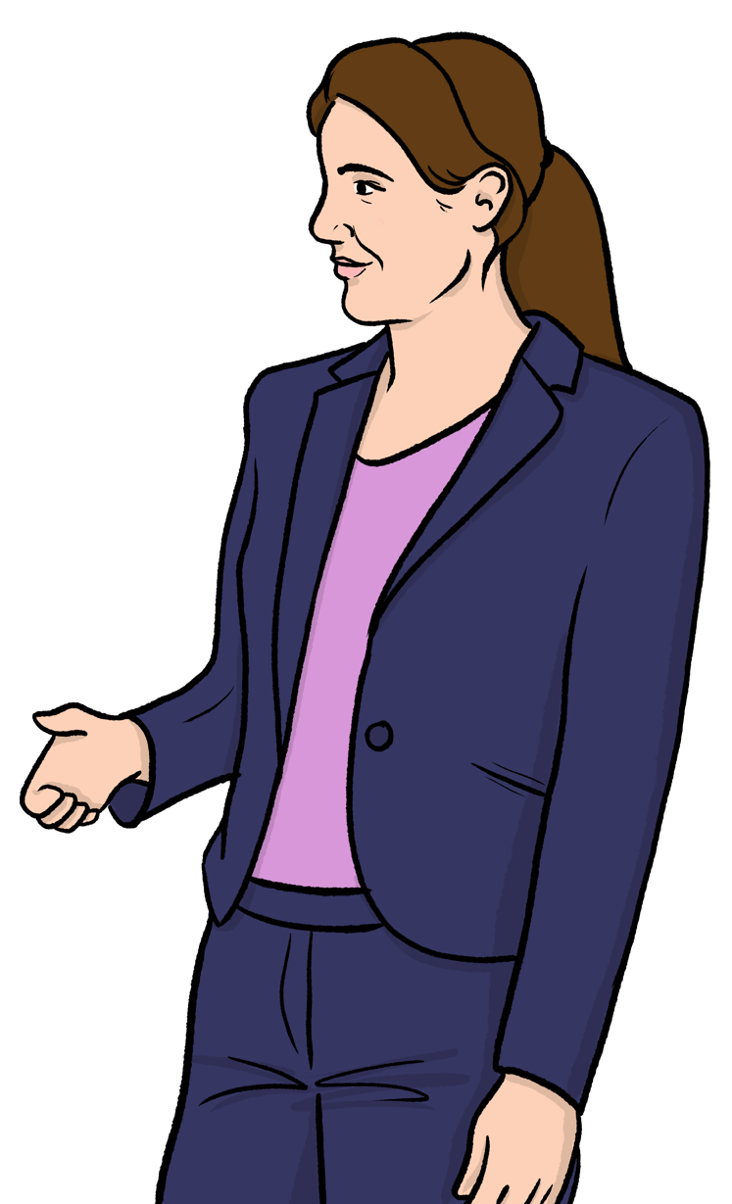
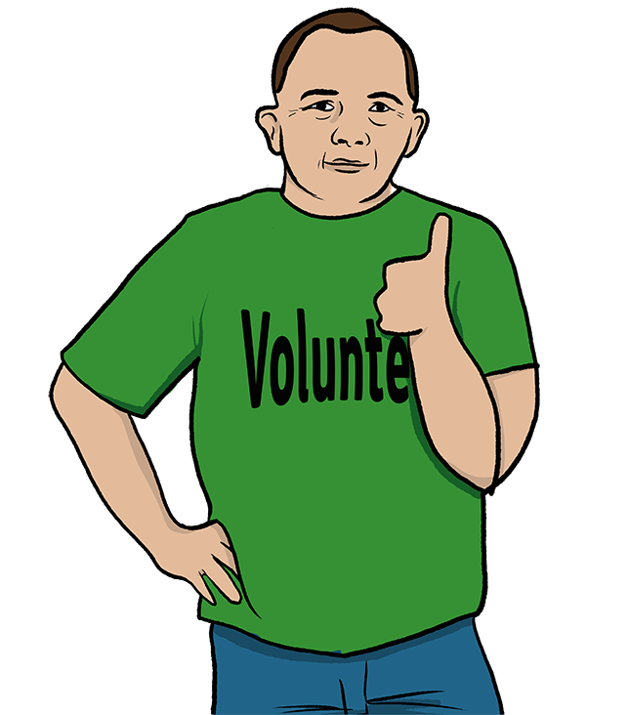
Volunteer Agreement

Contents
Page

Introduction 3
The agreement 4

links

Bold

words

In this easy read document, difficult words are in bold. We explain what these words mean in the sentence after they have been used.

Some words are blue and underlined.
These are links which will go to another website which has more information.

Introduction

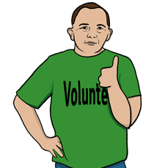
Healthwatch works to make sure health and care services are the best they can be for the people who use them.

We are able to do this with the help of volunteers.

Volunteers are people who give their time to help without getting paid for it.

This is an Easy Read version of our Volunteer Agreement. It explains:
- what you can expect from us if you volunteer with us.
- what we would like from you as a volunteer.

The agreement

We will do our best to:
- help you understand your role as a volunteer and give you any training you might need.
- have meetings with you to talk about how your volunteering is going.
- respect you and meet your needs.
- pay you back any money you have to spend while volunteering with us - like travel costs.

Change
- tell you of any changes to your volunteer role.
- make sure you are safe and help you if you are injured while volunteering with us.
Safe

- treat all volunteers fairly.
- follow our policies.

Policies are plans and rules for the way our organisation does things.

As a volunteer with Healthwatch you agree to:
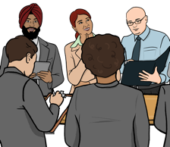
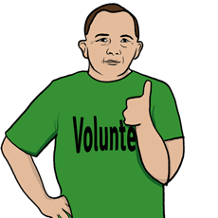
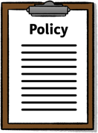
- have a meeting after 3 months of volunteering to talk about how it is going.
- help Healthwatch do its work.
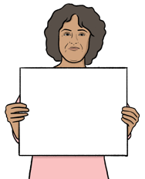
- do your volunteer role as well as you can.
- follow all Healthwatch policies.
Policies

- keep people’s personal information private.
- go to meetings when asked.

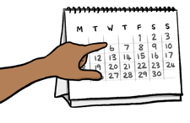
Please sign below to show you have read and understand this information.

Your signature:

Today’s date:

Healthwatch signature:

Today’s date:

