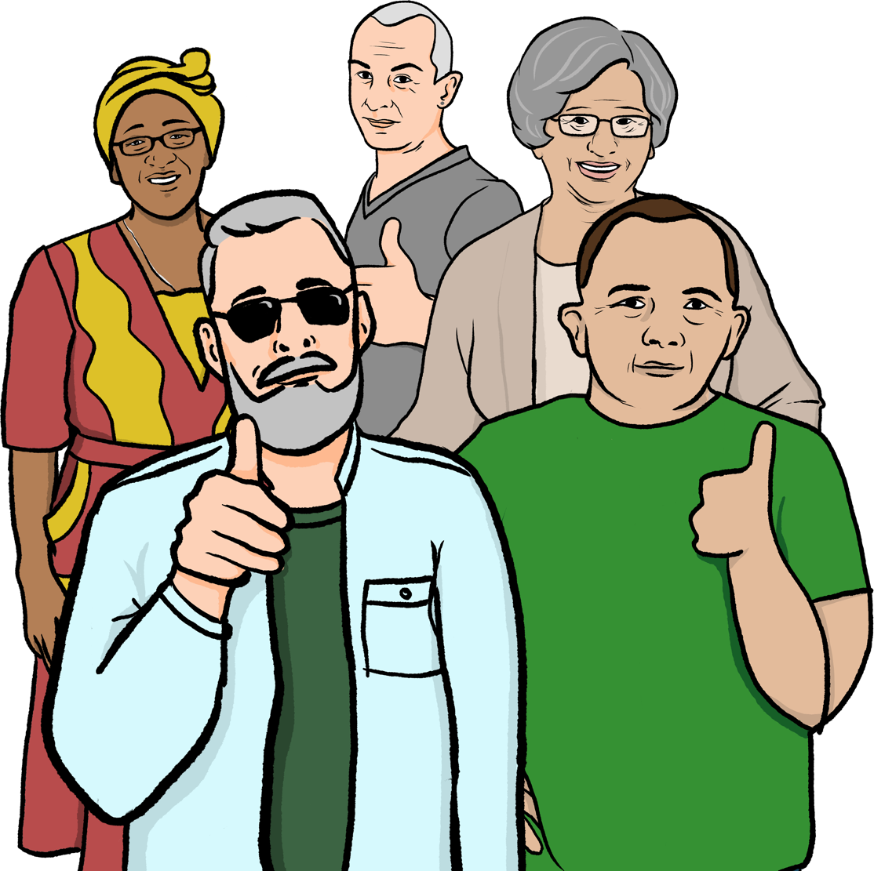
Volunteering with Healthwatch

Contents
Page

Introduction 4
About us 5
How we make health and care services better 7
Volunteering with us 9
Important policies 12
How we deal with problems and complaints 19
Stopping volunteering with us 22

In this easy read document, difficult words are in bold. We explain what these words mean in the sentence after they have been used.

links

Bold

words

Some words are blue and underlined.
These are links which will go to another website which has more information.

Introduction

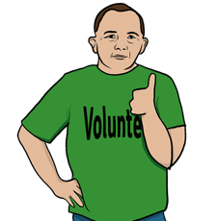
Healthwatch works to make sure health and care services are the best they can be for the people who use them.

We are able to do this with the help of volunteers.

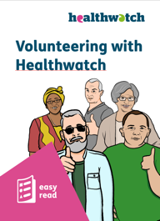
Volunteers are people who give their time to help without getting paid for it.

This is all the information you need about being a volunteer with us.

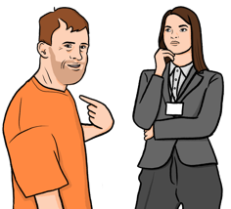
About us

We make sure NHS and social care services listen to your feedback to improve care.

What we are allowed to do

We are not part of the Government but we are allowed to do some actions which help make services better.

We are allowed to:
- visit and look at places that are providing health and care services.
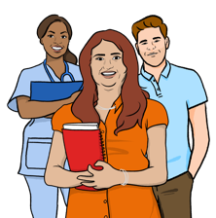
- report issues we find to groups and organisations who can make health and care services better.
- be a part of important health and care groups in England.

Change
- ask health and care services to make changes after we have noticed an issue.

Health and care services

Health and care services that we help to make better include:
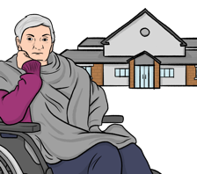
- health services in hospitals and local areas.
- care services in care homes.
- personal care services, like when a carer comes to a person’s home to help them with every day tasks.
- services that are a mix of health services and care services.

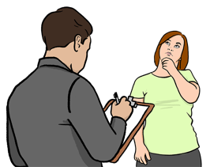
How we make health and care services better

We make health and care services better by:
- finding out what people who use the services want.
- sharing what people want with groups and organisations who can make services better.
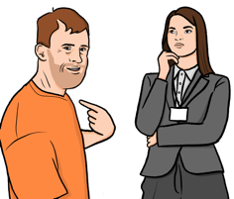
- making sure groups and organisations are working to make services better.
- sharing information about services with the people that need to use them.

Finding out what people want

We try to hear the voices of as many people as possible.

We do this by:
- communicating with local groups in the local community.
- using local groups to share information and learn what local people want.
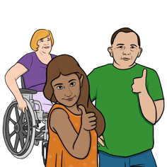
- creating our own groups of volunteers who find out what local people want.
- making sure we hear the voices of people who are often ignored or left out.

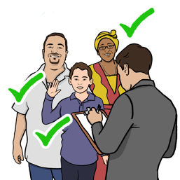
Volunteering with us

Our volunteers

Our volunteers are very important to us. They help us hear the voices of as many people as possible.

We have different types of volunteer roles:
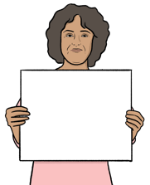
- Collecting feedback online from people who use health and care services.
- Helping people get the information they need about health and care services.
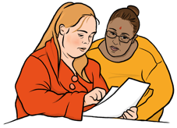
- Using our website and social media to let more people know what we do and share information.
- Making sure everyone can get and understand our information.
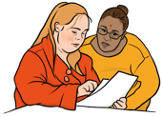

You may be able to do more than 1 of these roles when you volunteer with us.

What we will do to support you

To help support you we will:
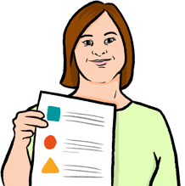
- have a member of staff who is in charge of looking after our volunteers - they are called your Volunteer Supporter.
- treat you with respect.
- make sure you understand what your volunteer role is and give you information to help you.
- give you information about training you can do to help with your volunteer role.
- have meetings with you to talk about your needs and what you have done so far.

What we would like you to do

As a volunteer you will:
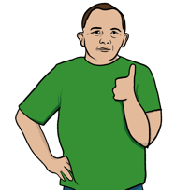
- treat other volunteers and any members of our staff with respect.
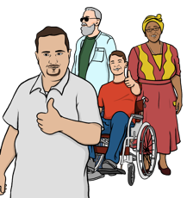
- behave well in public when you are doing your volunteer role.
- treat everyone fairly and not leave anyone out.
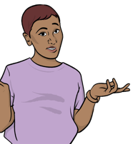
- tell us as soon as possible if you need a day off from being a volunteer, or if you no longer want to be a volunteer at all.
- ask your Volunteer Supporter if you do not understand your volunteer role or if you need help.

Important policies

Policies are plans and rules for the way our organisation does things.

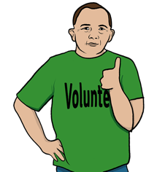
As a volunteer you will need to know about some of our important policies.

Money

We will pay you back for any money you have to spend when you volunteer with us.

We will pay you back for things like:
- travel costs.
- food and drink you need when you are volunteering.

£

It is important you keep a record of everything you spend so that we can pay you.

Behaviour

We have policies for how you should try to behave when you are volunteering with us:
- You should not take gifts from or give gifts to members of our staff or people who are using our services.

Hello
- You should talk clearly and in a way that is easy to understand.
- You should try and wear clothing that is suited to your volunteer role.

Treating everyone fairly

It is important you treat all staff and volunteers fairly, even if they are your personal friend.

We will treat all our staff and volunteers fairly. We would like you to do the same.

Health and safety
Safe

We will try to make sure you are healthy and safe when you are volunteering with us.

These are things you can do to help your own health and safety:
- Do not put yourself or others in danger when you are doing your volunteer role.
- Follow all of our safety rules and instructions.
- Tell someone if you have any health and safety needs.
- Wear the volunteer ID badge we will give you.
- Do not give out your personal contact details, like your telephone number.

We will tell you of any safety issues there might be when you are volunteering with us.
Safe

All of our volunteers will do safeguarding training.

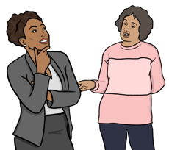
Safeguarding training will teach you the skills you need to keep yourself and others safe.

If someone tells you they are at risk of being harmed you must tell your Volunteer Supporter.

Working on your own

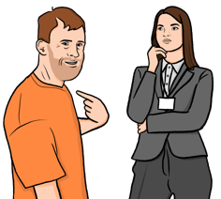
You may be asked to meet with someone one-to-one as part of your volunteer role.

This does not happen often, but if it does:
- your Volunteer Supporter must be told.
- we will make sure the place of the meeting is safe.
Safe
- you should keep in contact with your Volunteer Supporter during the meeting and tell them about any issues.
- you must not go into a person’s home without a member of staff.

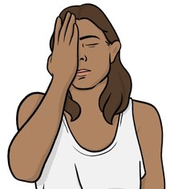
Accidents and issues

If there is an accident or issue when you are doing your volunteer role you must tell your Volunteer Supporter as soon as possible.

If it is a serious emergency you should call 999.

Keeping personal information private

We will keep all personal information you share with us safe and private.

Only some members of staff will be able to look at your personal information.

As part of your volunteer role you may be working with other people’s personal information.

You must keep other people’s personal information safe and private.

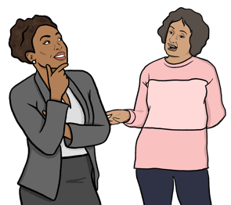
How we deal with problems and complaints

If you have a problem with your volunteer role please talk to your Volunteer Supporter as soon as possible.

We follow this plan when we try to solve your problem:

Change
- We will discuss with you how it is best to solve the problem - we may make changes to your volunteer role.
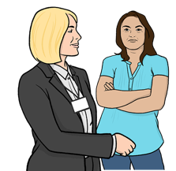
- If the problem is still not solved we will offer you a meeting with our Lead Officer.
- In the meeting we will talk about the problem and give you some more ways we can solve it.
- If you do not agree with the decisions made after the meeting you can take the problem to our Board of Directors.

A Board of Directors is a group of important people who make sure an organisation is run properly.
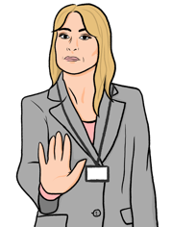
- The Board of Directors will offer you a meeting and will try to solve the problem.

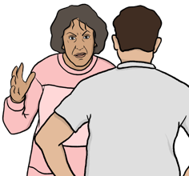
If we cannot agree on how to solve the problem you may be asked to stop volunteering with us.

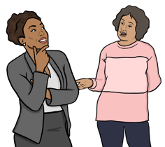
We will not be able to help you with your problem if you are rude to our staff.

If you would like to make a complaint please talk to your Volunteer Supporter.

It is important that you tell us if you feel another volunteer or member of staff are not following our policies.

Stopping volunteering with us

You can stop volunteering with us at any time.

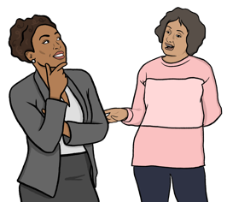
You must tell your Volunteer Supporter if you would like to stop volunteering with us.

We would like to know your reasons for stopping being a volunteer, but you don’t have to tell us if you don’t want to.

Reference

If you have been a volunteer with us for over 6 months, you can ask us to give you a reference.

Reference

A reference is a written statement that confirms you have been a volunteer. It can help when you get another volunteering role, or a job.

