Volunteer Agreement

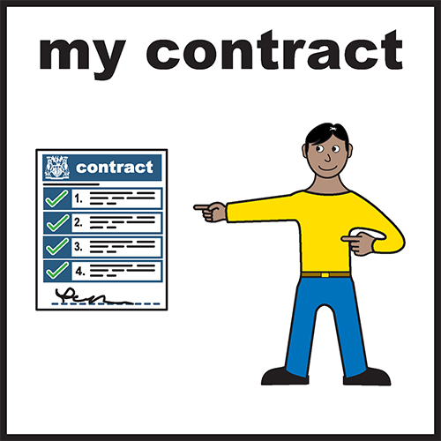 | This Volunteer Agreement is a description of the arrangement between Healthwatch Essex and you.  It is similar to a contract for volunteers.
This agreement will help you understand how we appreciate your volunteering with us.

We will do the best we can to make you feel supported and rewarded.

Part 1: Healthwatch Essex

Your role is that of Forum member, details are shown in your Role Description.

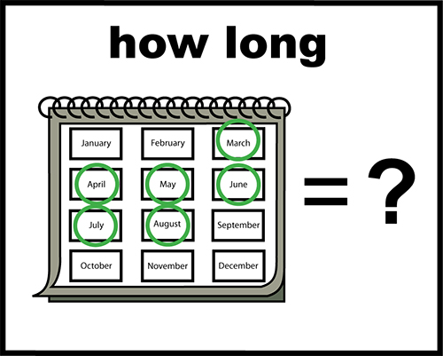 | Duration of role:  1 Year (review)
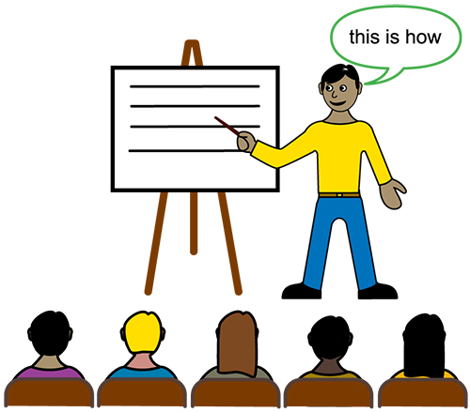  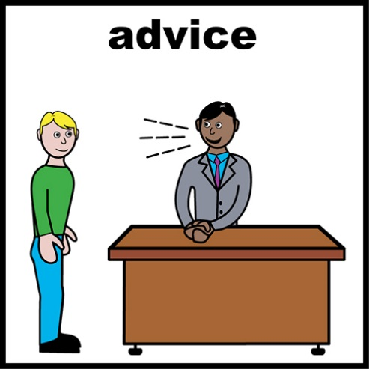 | Healthwatch Essex commits to the following:  Induction and training  Supervision and support
Expenses

Travel to and from home to meetings and events during your work

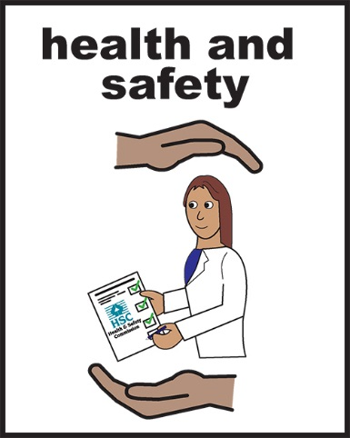  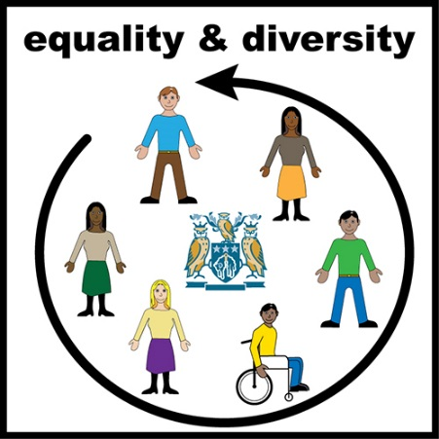 | Health and safety  Give information and support on our health and safety policy.  Equal opportunities  To make sure that all volunteers understand our equal opportunities policy.
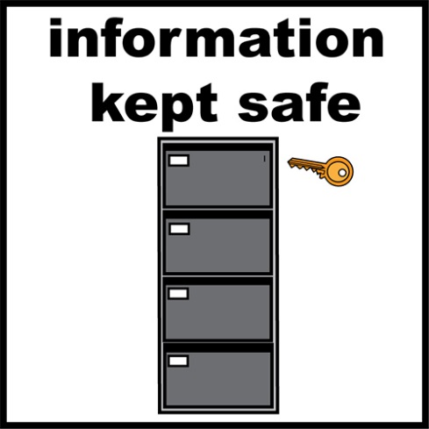 | Privacy  To keep your personal information safe and stored securely.

Part 2: The Volunteer

I agree to be a volunteer with Healthwatch Essex and agree to the following:

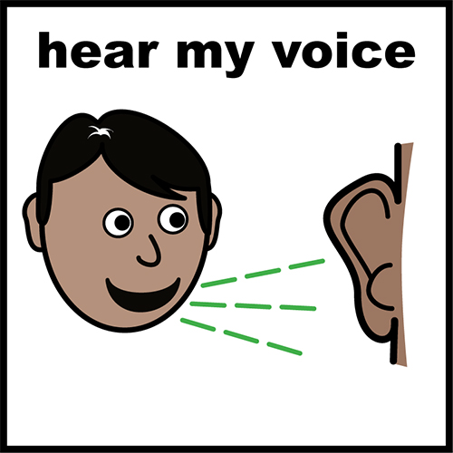 | To help Healthwatch Essex collect views and experiences of people across Essex.
 | To perform my volunteering role to the best of my ability.
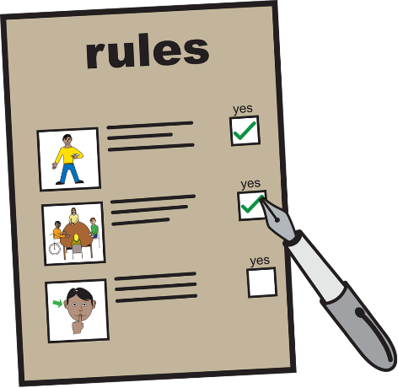 | To follow the rules and equal opportunities policy for staff, volunteers and clients.
 | To keep information confidential
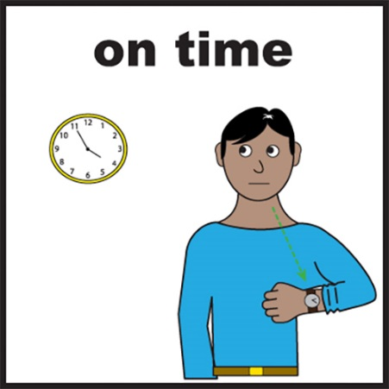 | To manage my time well and let somebody know if I need any help or support.
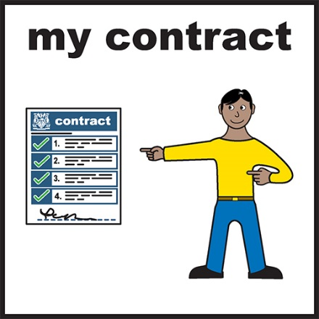  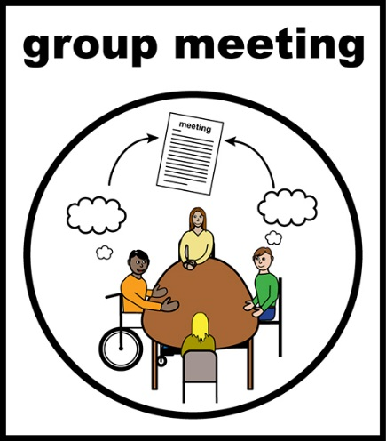 | This agreement may be cancelled at any time by either party. This is not an employment relationship.  Role:  Forum Member
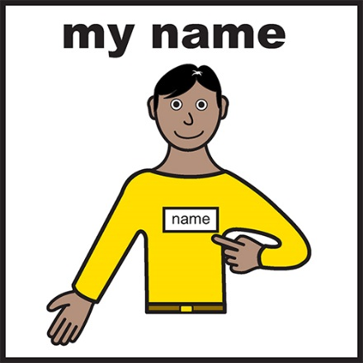 | Full Name:
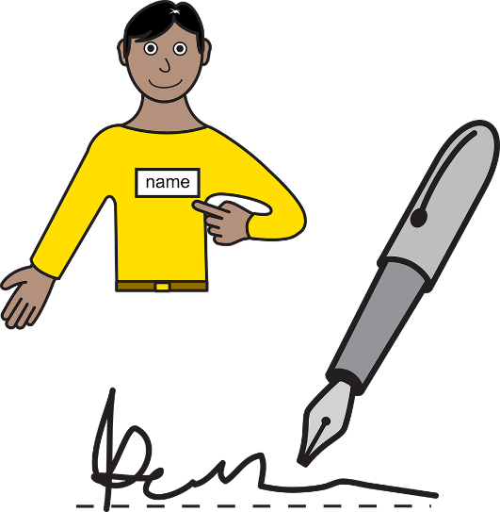 | Signature:  Date:  Volunteer & Engagement Officer  Full Name:
Signature:

Date:

